# Broken Links Report

• Broken link on <https://www.utep.edu/cs/news/computer_science_announcements.html> on **Main Content** section, the broken link is displayed as: **here** and the link is pointing to : <https://www.utep.edu/cs/course-schedules/summer-fall-2021-course-schedule.html>

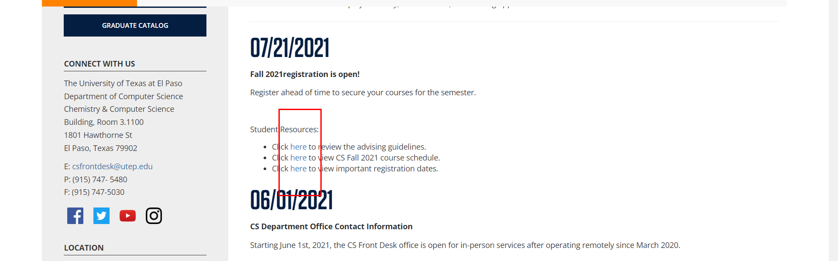

• Broken link on <https://www.utep.edu/cs/news/computer_science_announcements.html> on **Main Content** section, the broken link is displayed as: **Learn more** and the link is pointing to : [https://utepn.ws/3kjpK7z](https://www.utep.edu/resuming-campus-operations/news/november/su-course-grading-policy.html)

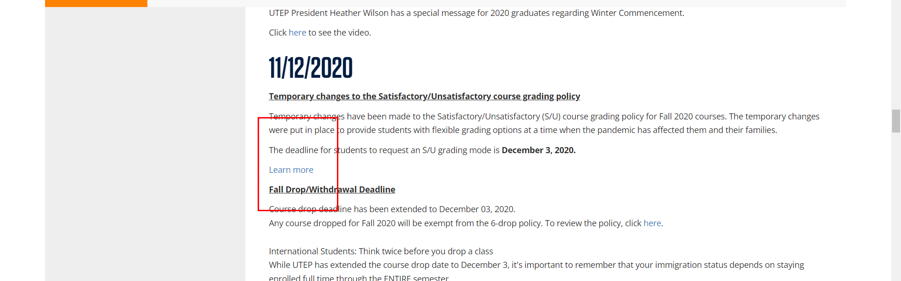

• Broken link on <https://www.utep.edu/cs/news/computer_science_announcements.html> on **Main Content** section, the broken link is displayed as: **here** and the link is pointing to : <https://www.utep.edu/cs/advising/index.html>

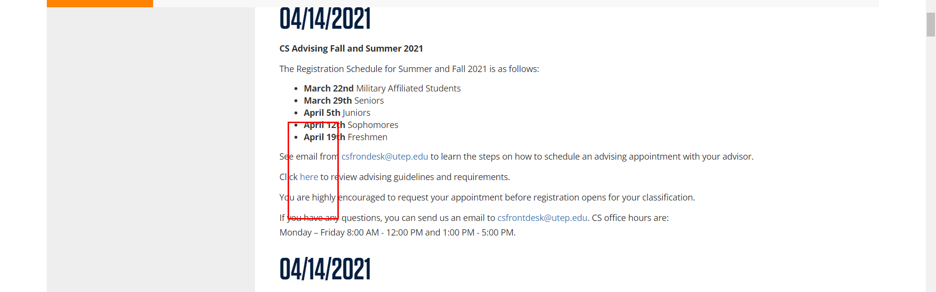

• Broken link on <https://www.utep.edu/cs/news/computer_science_announcements.html> on **Main Content** section, the broken link is displayed as: **vaccinequestionnaire.utep.edu** and the link is pointing to : [http://vaccinequestionnaire.utep.edu](https://adminapps.utep.edu/vaccineregistrationcommunity)

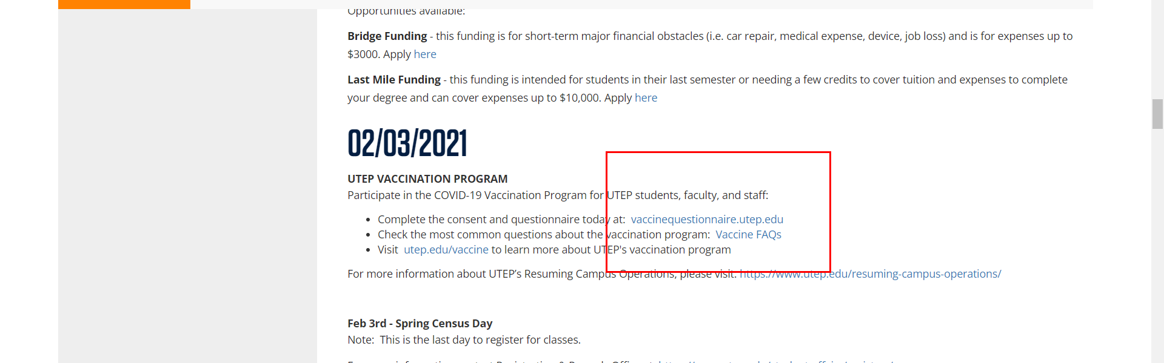

• Broken link on <https://www.utep.edu/cs/news/computer_science_announcements.html> on **Main Content** section, the broken link is displayed as: **here** and the link is pointing to : <https://www.utep.edu/resuming-campus-operations/news/november/commencement-announcement.html>

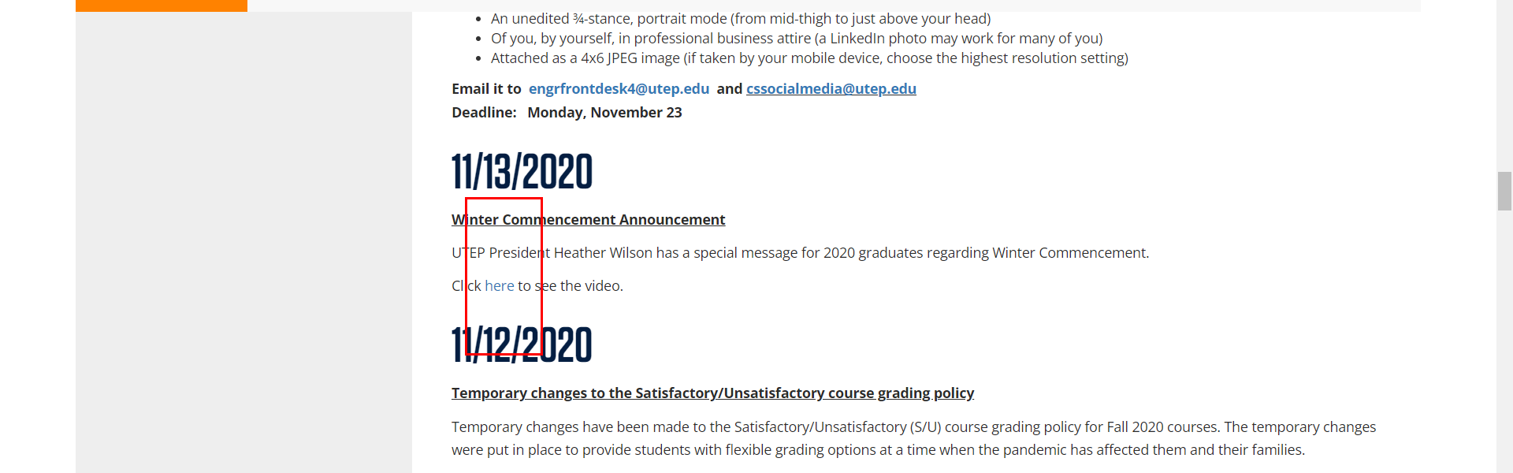

• Broken link on <https://www.utep.edu/cs/news/computer_science_announcements.html> on **Main Content** section, the broken link is displayed as: **here** and the link is pointing to : <https://www.utep.edu/resuming-campus-operations/news/october/new-course-drop-date-for-fall-2020-courses.html>

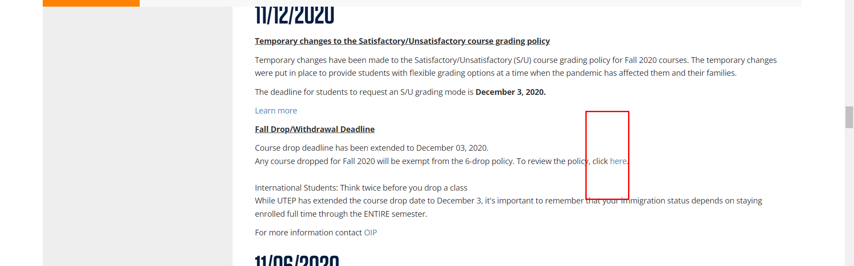

• Broken link on <https://www.utep.edu/cs/news/computer_science_announcements.html> on **Main Content** section, the broken link is displayed as: **Vaccine FAQs** and the link is pointing to : <https://www.utep.edu/resuming-campus-operations/faqs/vaccine.html>

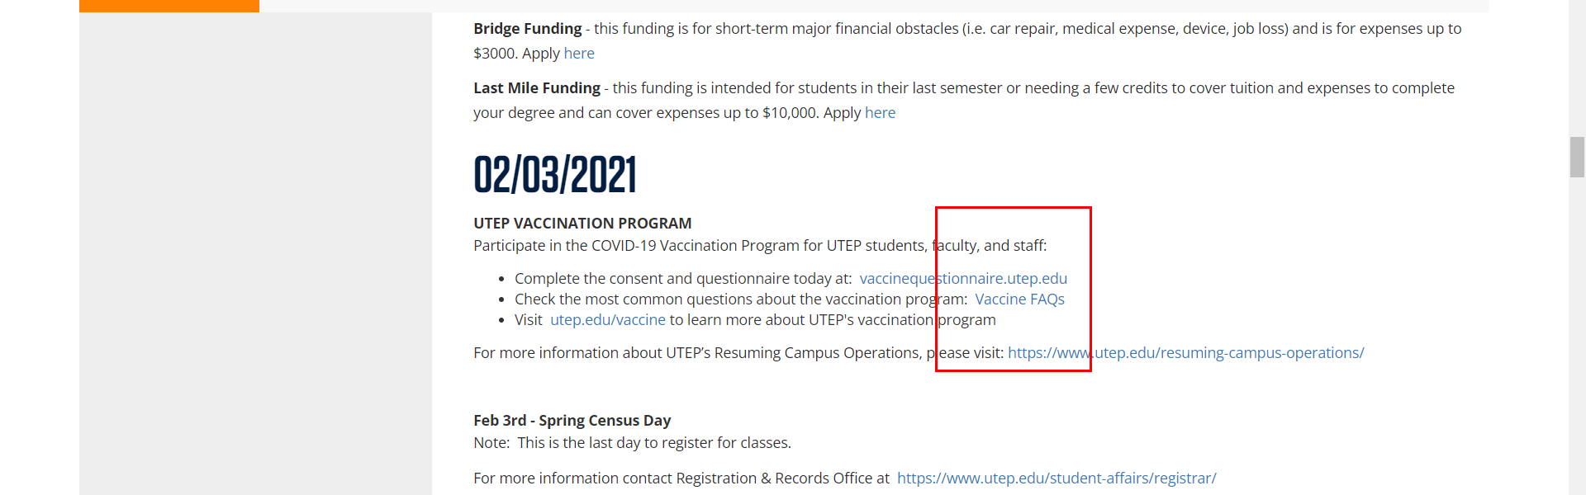

• Broken link on <https://www.utep.edu/cs/news/computer_science_announcements.html> on **Main Content** section, the broken link is displayed as: **https://www.wicys.org/initiatives/emergency-fund/** and the link is pointing to : <https://www.wicys.org/initiatives/emergency-fund/>

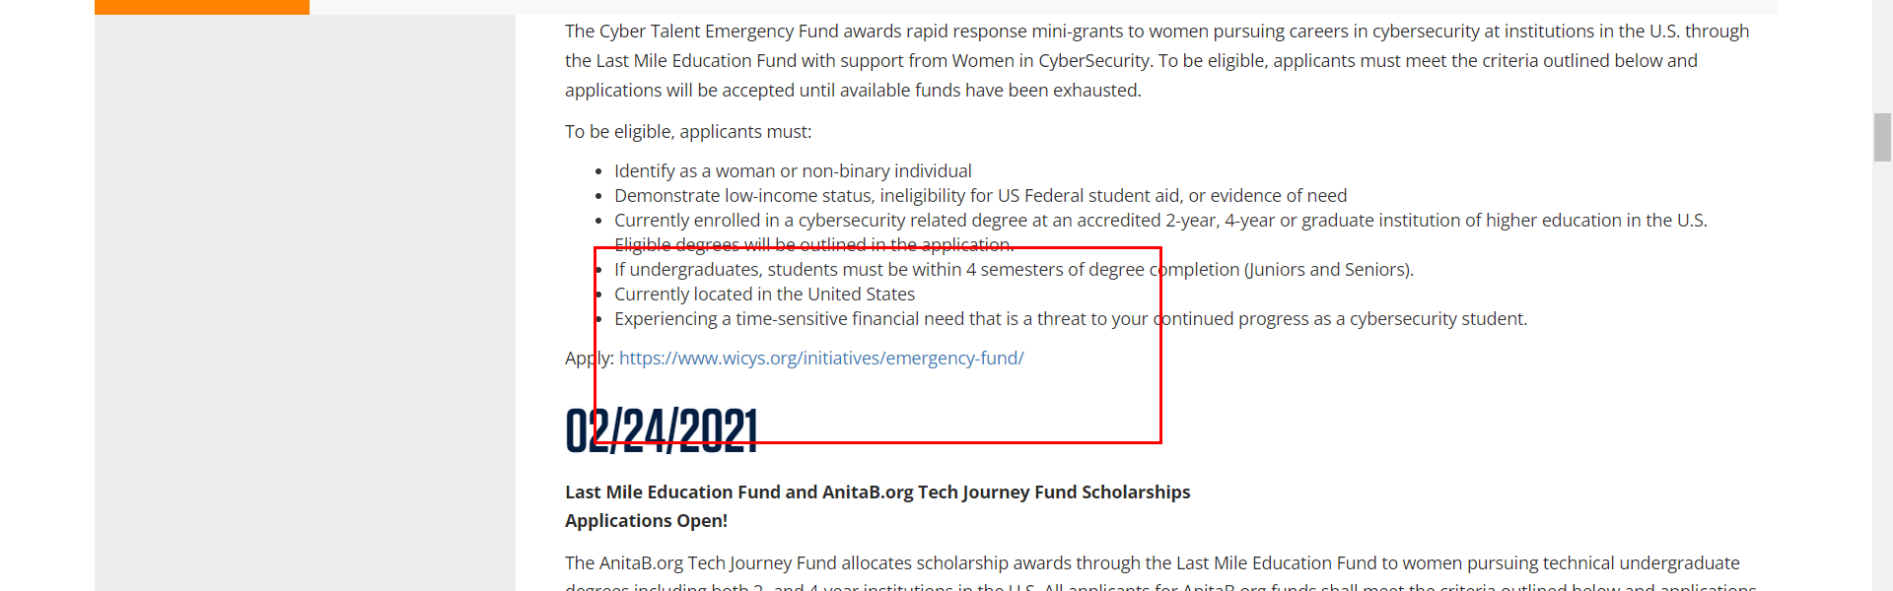

• Broken link on <https://www.utep.edu/cs/news/computer_science_announcements.html> on **Main Content** section, the broken link is displayed as: **https://teams.microsoft.com** and the link is pointing to : [https://teams.microsoft.com](https://teams.microsoft.com/)

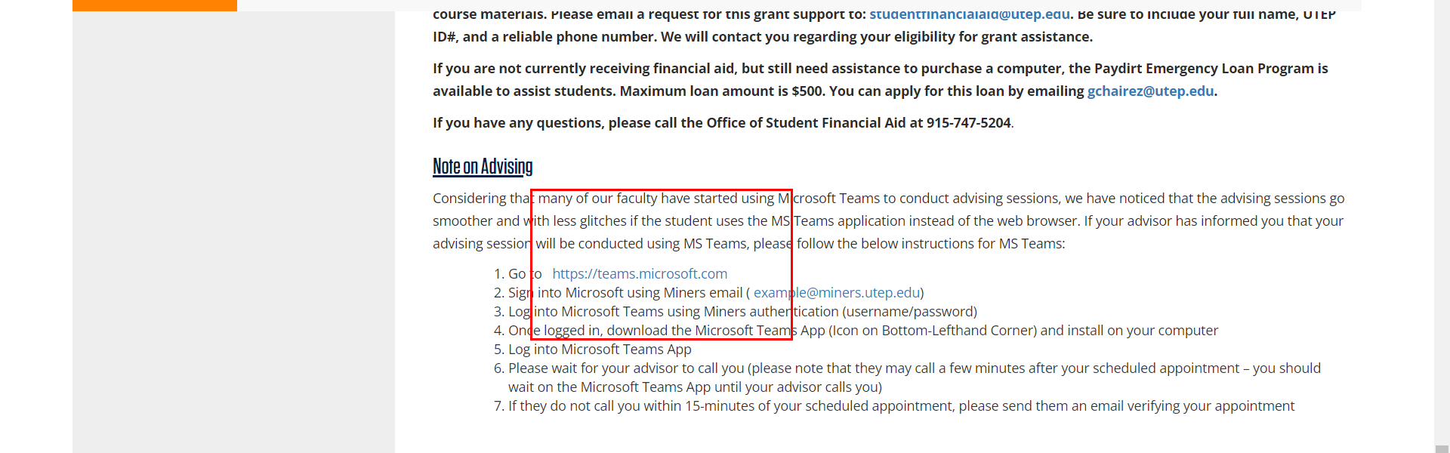

• Broken link on <https://www.utep.edu/cs/news/computer_science_announcements.html> on **Main Content** section, the broken link is displayed as: **https://www.utep.edu/cs/advising/graduate-advising.html** and the link is pointing to : <https://www.utep.edu/cs/advising/graduate-advising.html>

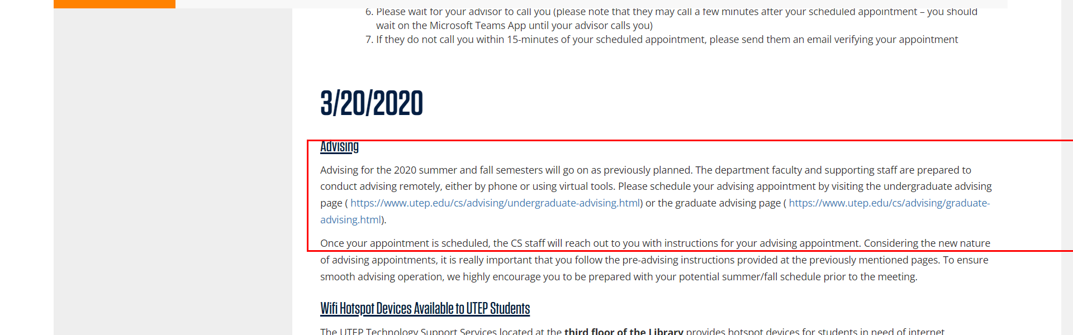

• Broken link on <https://www.utep.edu/cs/news/computer_science_announcements.html> on **Main Content** section, the broken link is displayed as: **https://anitab.org/awards-grants/covid-19-emergency-assistance/** and the link is pointing to : <https://anitab.org/awards-grants/covid-19-emergency-assistance/>

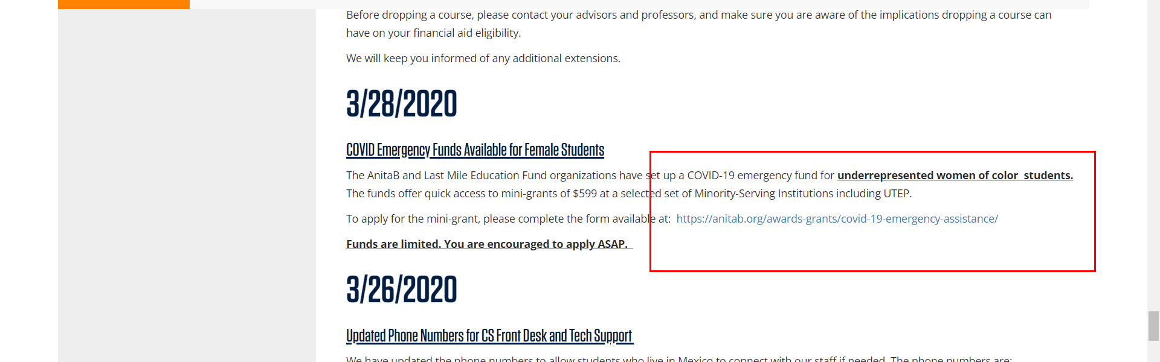

• Broken link on <https://www.utep.edu/cs/news/computer_science_announcements.html> on **Main Content** section, the broken link is displayed as: **https://www.utep.edu/cs/advising/undergraduate-advising.html** and the link is pointing to : <https://www.utep.edu/cs/advising/undergraduate-advising.html>

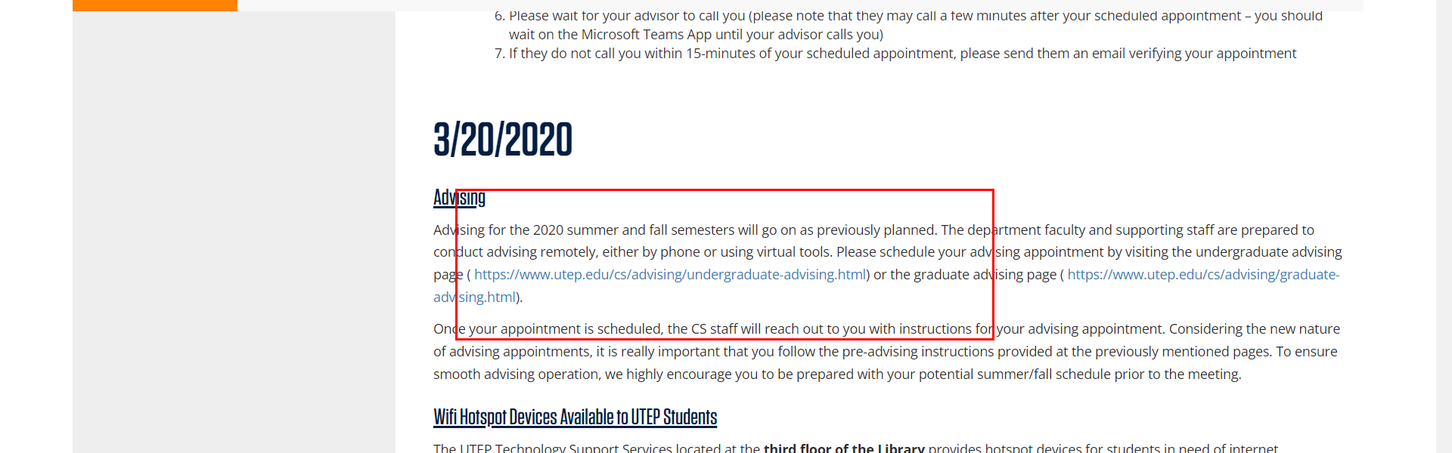

• Broken link on <https://www.utep.edu/cs/news/congratulations-dr-ceberio.html> on **Main Content** section, the broken link is displayed as: and the link is pointing to : <http://www.cs.utep.edu/wp-content/uploads/2014/04/Engineering-Ceberio-M-copy-th.jpg>

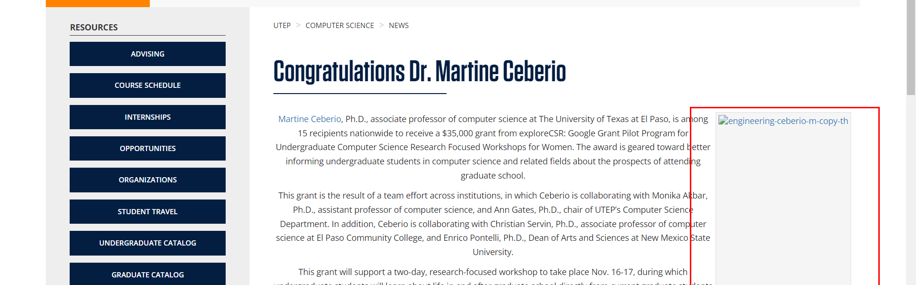

• Broken link on <https://www.utep.edu/cs/news/news_archive.html> on **Main Content** section, the broken link is displayed as: **Read More** and the link is pointing to : <https://www.utep.edu/cs/news/news-2013/congratulations-dr-kreinovich1124>

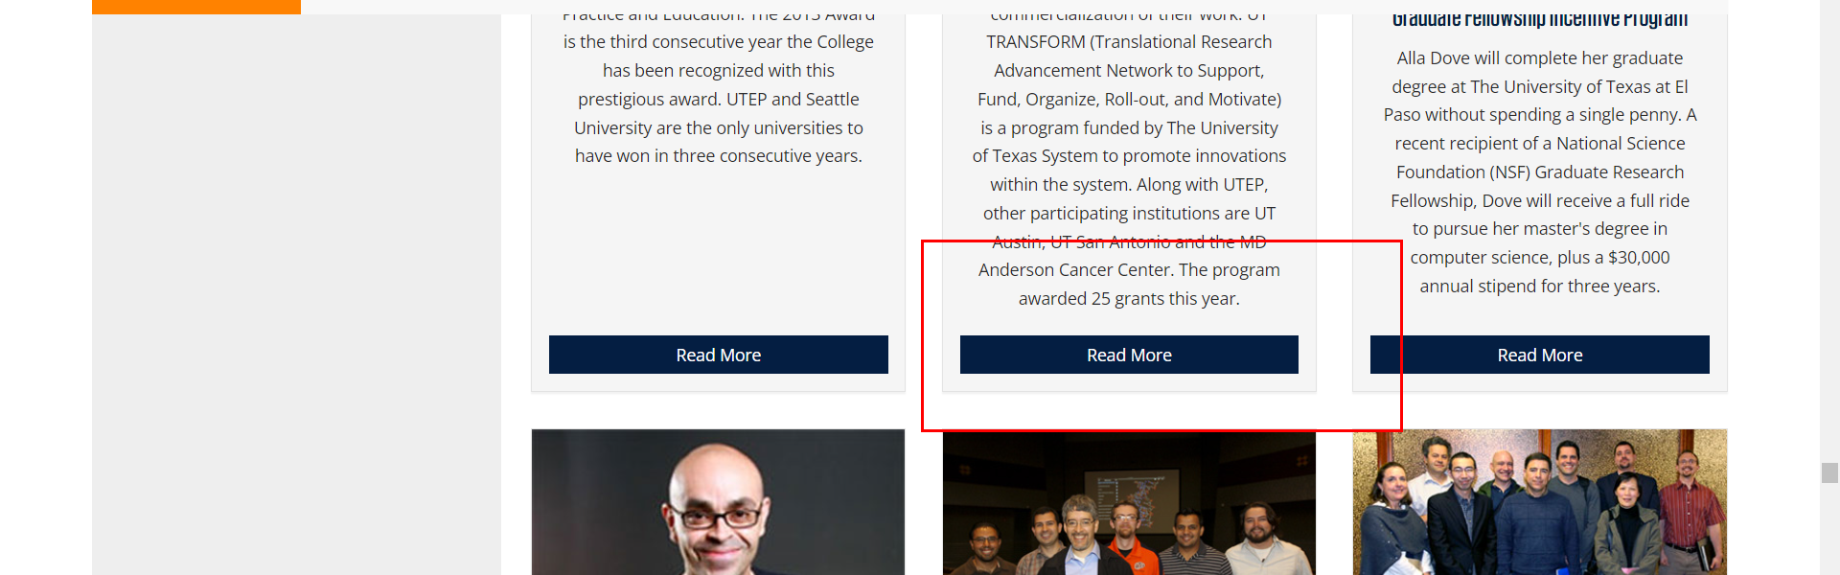

• Broken link on <https://www.utep.edu/cs/news/news_archive.html> on **Main Content** section, the broken link is displayed as: **Read More** and the link is pointing to : <https://www.utep.edu/cs/news/news-2013/congratulations-dr-kreinovich112>

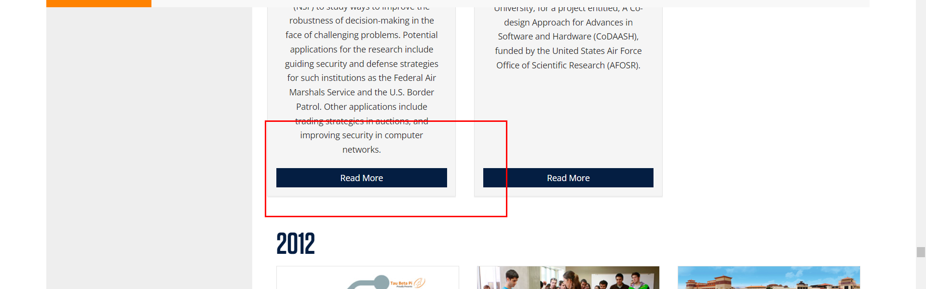

• Broken link on <https://www.utep.edu/cs/news/news_archive.html> on **Main Content** section, the broken link is displayed as: **Read More** and the link is pointing to : <https://www.utep.edu/cs/news/news-2011/congratulations-dr-kreinovich1>

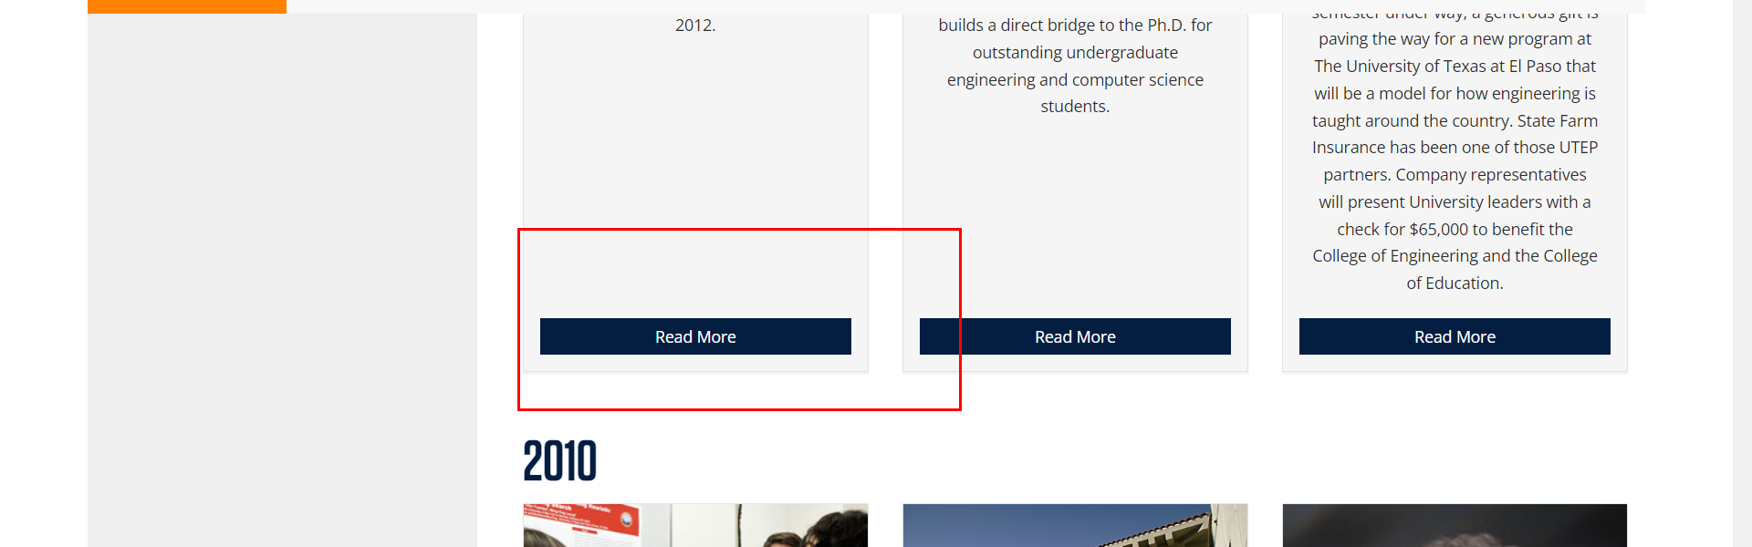

• Broken link on <https://www.utep.edu/cs/news/virtual-cs-graduation-ceremony.html> on **Main Content** section, the broken link is displayed as: and the link is pointing to : <http://www.cs.utep.edu/wp-content/uploads/2014/04/Engineering-Ceberio-M-copy-th.jpg>



• Broken link on <https://www.utep.edu/cs/news/news-2008/congratulations-dr-ceberio2212112.html> on **Main Content (Top small navigation)** section, the broken link is displayed as: **news-2008** and the link is pointing to : <https://www.utep.edu/cs/news/news-2008/>

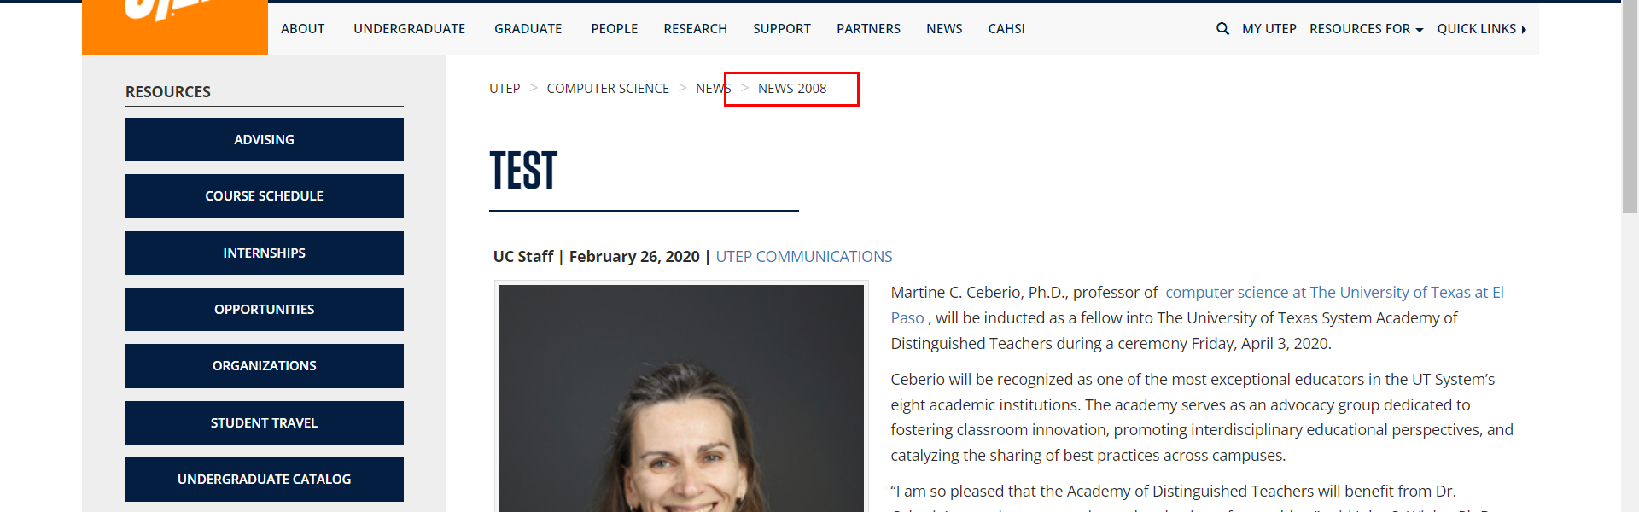

• Broken link on <https://www.utep.edu/cs/news/news-2008/congratulations-dr-ceberio2212112.html> on **Main Content** section, the broken link is displayed as: **UTEP COMMUNICATIONS** and the link is pointing to : <https://www.utep.edu/cs/news/news-2008/%E2%80%9Dhttps:/www.utep.edu/newsfeed/%E2%80%9D>

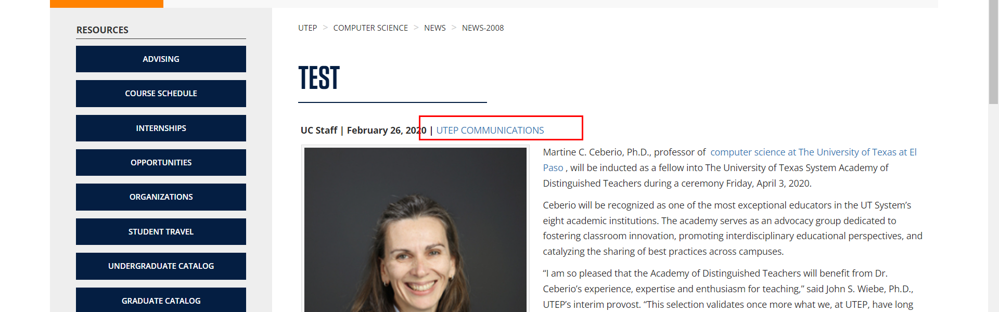

• Broken link on <https://www.utep.edu/cs/news/news-2009/congratulations-dr-ceberio2212112.html> on **Main Content (Top small navigation)** section, the broken link is displayed as: **news-2009** and the link is pointing to : <https://www.utep.edu/cs/news/news-2009/>

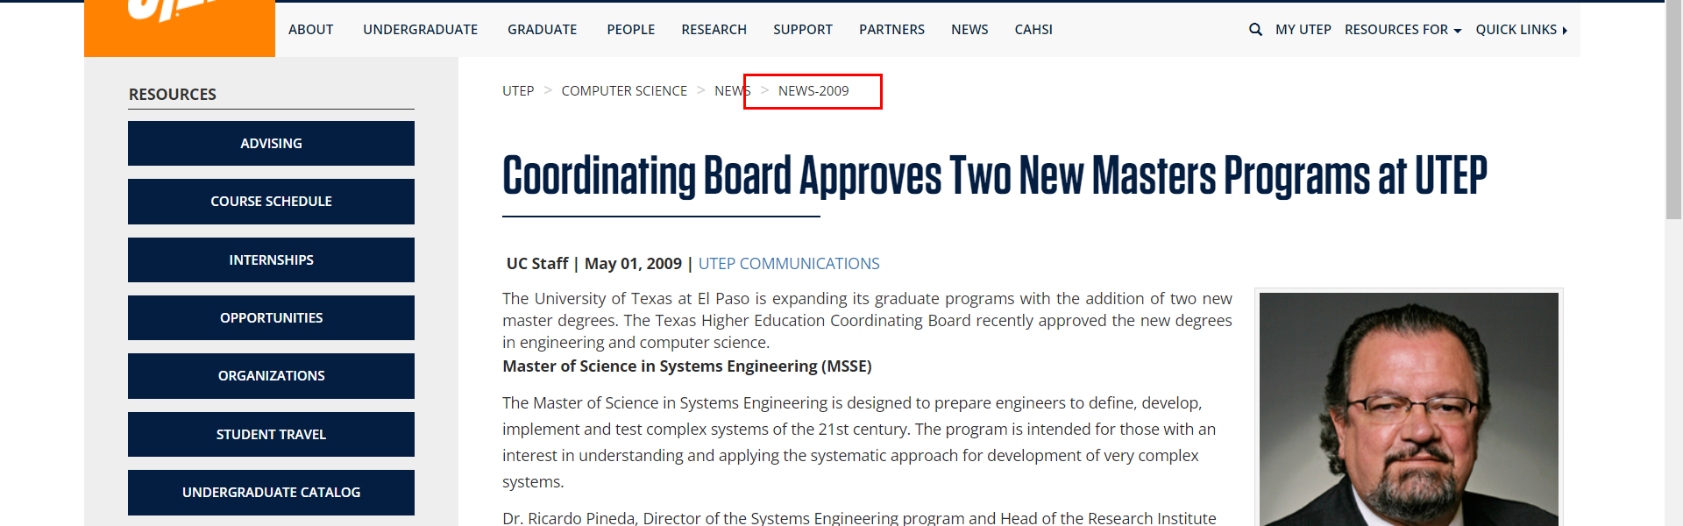

• Broken link on <https://www.utep.edu/cs/news/news-2009/congratulations-dr-ceberio2212112.html> on **Main Content** section, the broken link is displayed as: **UTEP COMMUNICATIONS** and the link is pointing to : <https://www.utep.edu/cs/news/news-2009/%E2%80%9Dhttps:/www.utep.edu/newsfeed/%E2%80%9D>

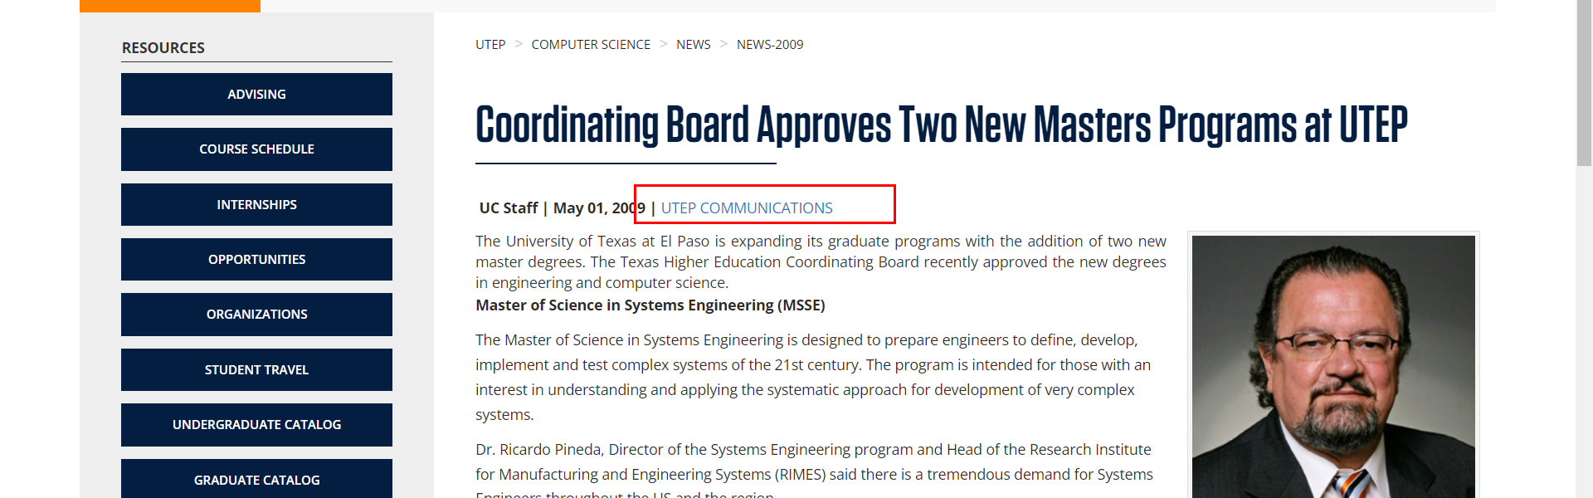

• Broken link on <https://www.utep.edu/cs/news/news-2010/congratulations-dr-ceberio2212112.html> on **Main Content (Top small navigation)** section, the broken link is displayed as: **news-2010** and the link is pointing to : <https://www.utep.edu/cs/news/news-2010/>

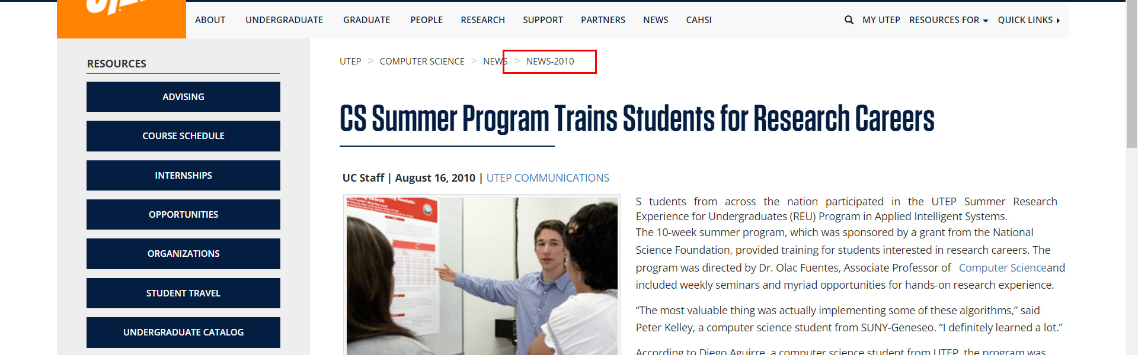

• Broken link on <https://www.utep.edu/cs/news/news-2010/congratulations-dr-ceberio2212112.html> on **Main Content** section, the broken link is displayed as: **UTEP COMMUNICATIONS** and the link is pointing to : <https://www.utep.edu/cs/news/news-2010/%E2%80%9Dhttps:/www.utep.edu/newsfeed/%E2%80%9D>

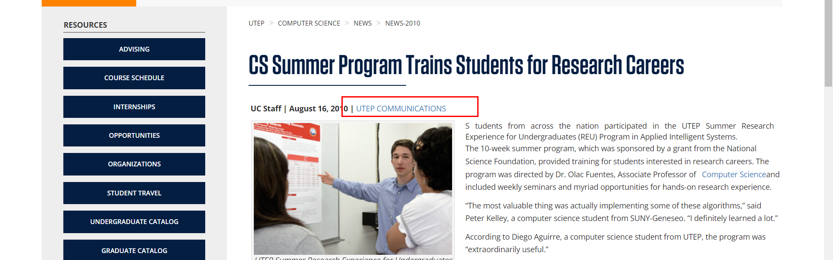

• Broken link on <https://www.utep.edu/cs/news/news-2010/congratulations-dr-ceberio22121121.html> on **Main Content (Top small navigation)** section, the broken link is displayed as: **news-2010** and the link is pointing to : <https://www.utep.edu/cs/news/news-2010/>

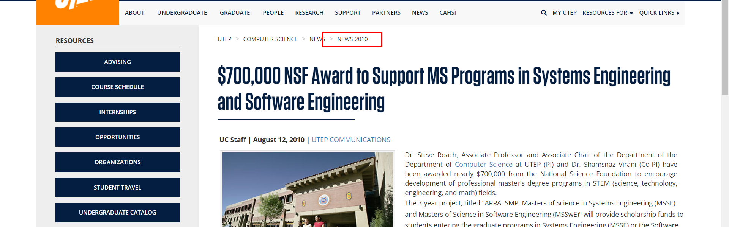

• Broken link on <https://www.utep.edu/cs/news/news-2010/congratulations-dr-ceberio22121121.html> on **Main Content** section, the broken link is displayed as: **UTEP COMMUNICATIONS** and the link is pointing to : <https://www.utep.edu/cs/news/news-2010/%E2%80%9Dhttps:/www.utep.edu/newsfeed/%E2%80%9D>

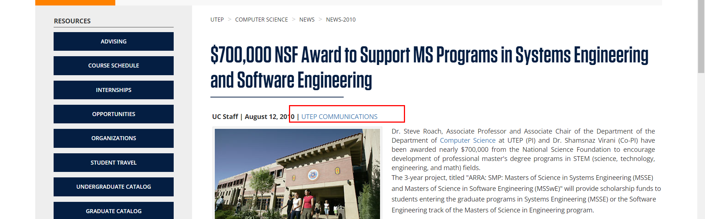

• Broken link on <https://www.utep.edu/cs/news/news-2010/congratulations-dr-ceberio221211211.html> on **Main Content (Top small navigation)** section, the broken link is displayed as: **news-2010** and the link is pointing to : <https://www.utep.edu/cs/news/news-2010/>

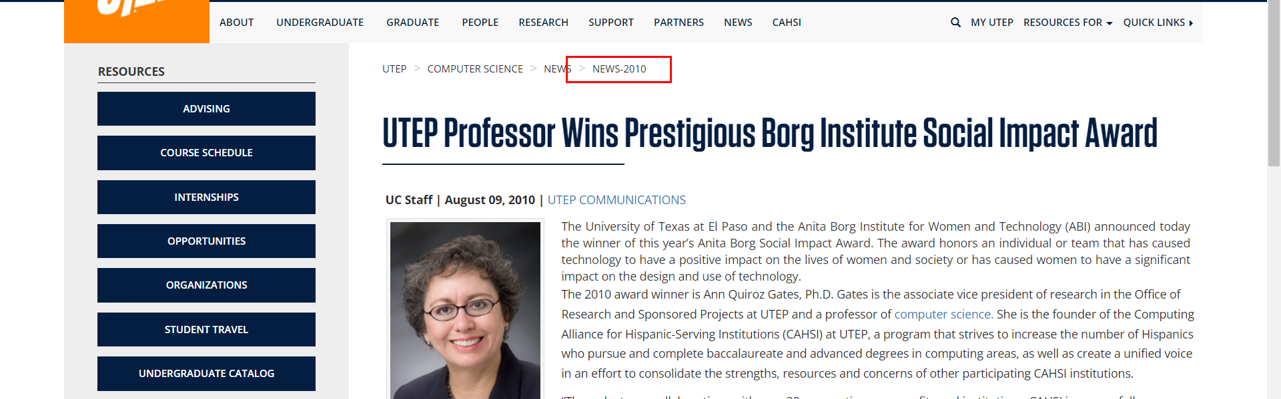

• Broken link on <https://www.utep.edu/cs/news/news-2010/congratulations-dr-ceberio221211211.html> on **Main Content** section, the broken link is displayed as: **UTEP COMMUNICATIONS** and the link is pointing to : <https://www.utep.edu/cs/news/news-2010/%E2%80%9Dhttps:/www.utep.edu/newsfeed/%E2%80%9D>



• Broken link on <https://www.utep.edu/cs/news/news-2010/congratulations-dr-ceberio221211212.html> on **Main Content (Top small navigation)** section, the broken link is displayed as: **news-2010** and the link is pointing to : <https://www.utep.edu/cs/news/news-2010/>



• Broken link on <https://www.utep.edu/cs/news/news-2010/congratulations-dr-ceberio221211212.html> on **Main Content** section, the broken link is displayed as: **UTEP COMMUNICATIONS** and the link is pointing to : <https://www.utep.edu/cs/news/news-2010/%E2%80%9Dhttps:/www.utep.edu/newsfeed/%E2%80%9D>



• Broken link on <https://www.utep.edu/cs/news/news-2010/congratulations-dr-ceberio22121122.html> on **Main Content (Top small navigation)** section, the broken link is displayed as: **news-2010** and the link is pointing to : <https://www.utep.edu/cs/news/news-2010/>

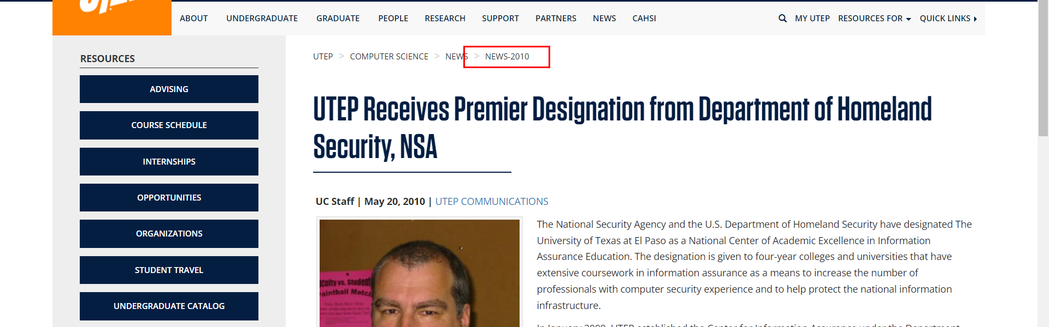

• Broken link on <https://www.utep.edu/cs/news/news-2010/congratulations-dr-ceberio22121122.html> on **Main Content** section, the broken link is displayed as: **UTEP COMMUNICATIONS** and the link is pointing to : <https://www.utep.edu/cs/news/news-2010/%E2%80%9Dhttps:/www.utep.edu/newsfeed/%E2%80%9D>



• Broken link on <https://www.utep.edu/cs/news/news-2010/congratulations-dr-ceberio22121123.html> on **Main Content (Top small navigation)** section, the broken link is displayed as: **news-2010** and the link is pointing to : <https://www.utep.edu/cs/news/news-2010/>

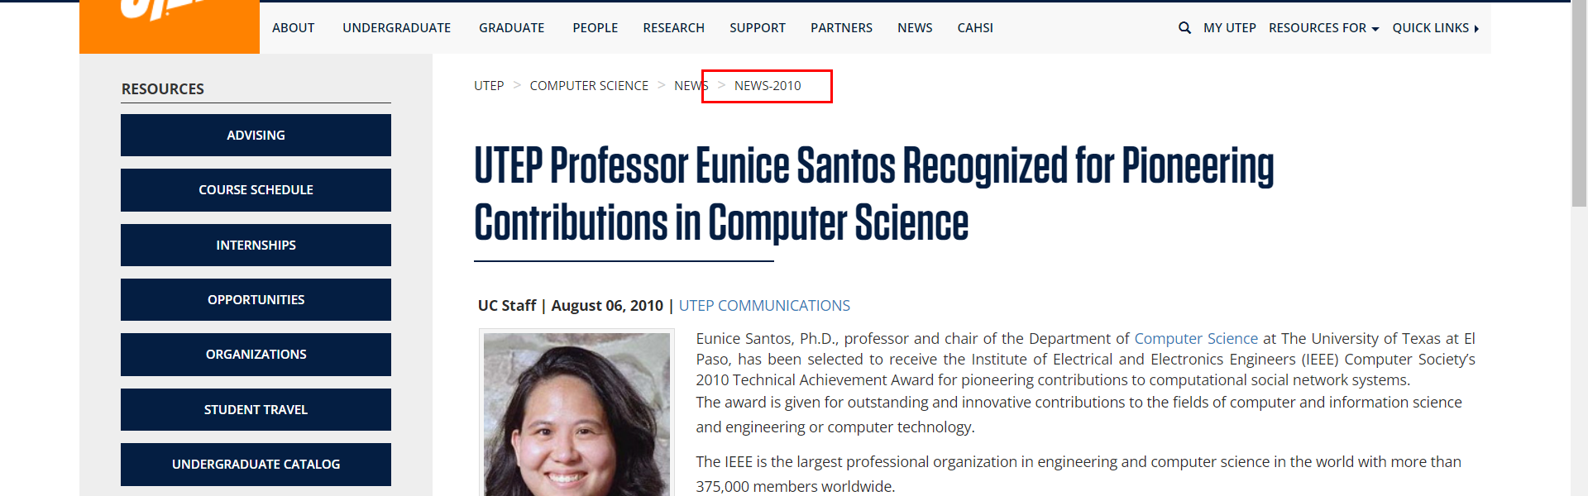

• Broken link on <https://www.utep.edu/cs/news/news-2010/congratulations-dr-ceberio22121123.html> on **Main Content** section, the broken link is displayed as: **UTEP COMMUNICATIONS** and the link is pointing to : <https://www.utep.edu/cs/news/news-2010/%E2%80%9Dhttps:/www.utep.edu/newsfeed/%E2%80%9D>

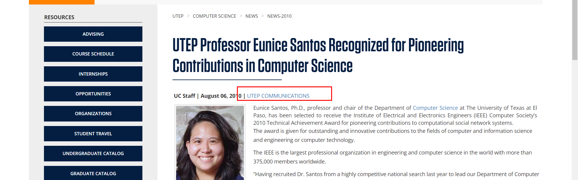

• Broken link on <https://www.utep.edu/cs/news/news-2011/congratulations-dr-ceberio2212112.html> on **Main Content (Top small navigation)** section, the broken link is displayed as: **news-2011** and the link is pointing to : <https://www.utep.edu/cs/news/news-2011/>

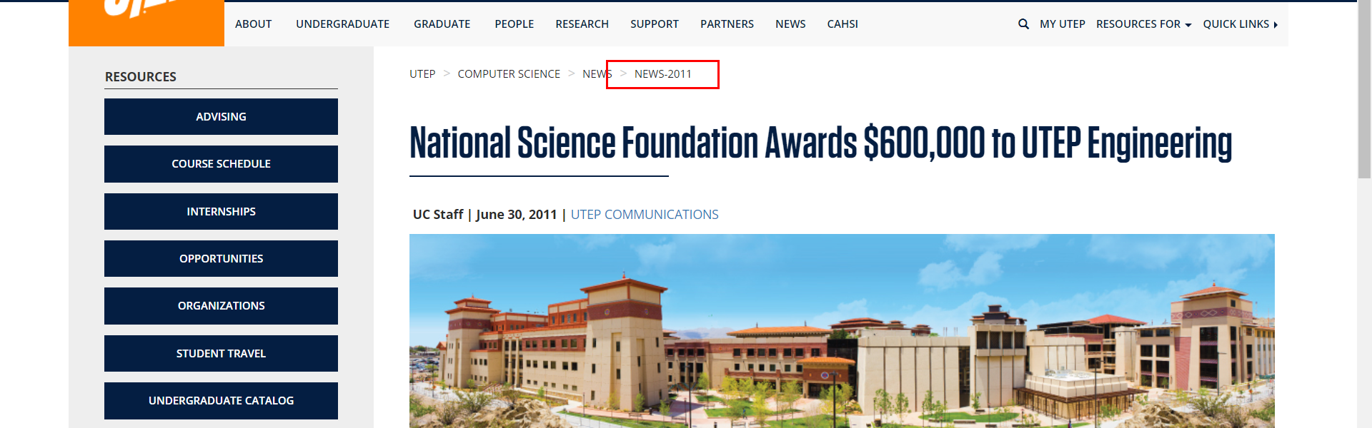

• Broken link on <https://www.utep.edu/cs/news/news-2011/congratulations-dr-ceberio2212112.html> on **Main Content** section, the broken link is displayed as: **UTEP COMMUNICATIONS** and the link is pointing to : <https://www.utep.edu/cs/news/news-2011/%E2%80%9Dhttps:/www.utep.edu/newsfeed/%E2%80%9D>



• Broken link on <https://www.utep.edu/cs/news/news-2011/congratulations-dr-ceberio221211211.html> on **Main Content (Top small navigation)** section, the broken link is displayed as: **news-2011** and the link is pointing to : <https://www.utep.edu/cs/news/news-2011/>

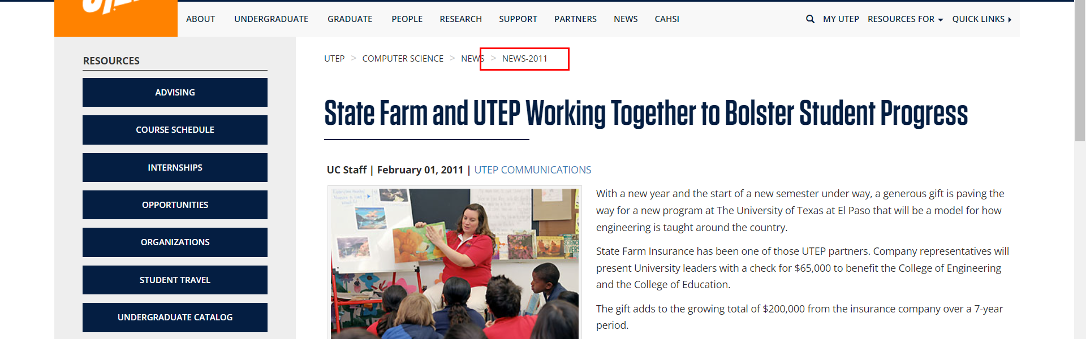

• Broken link on <https://www.utep.edu/cs/news/news-2011/congratulations-dr-ceberio221211211.html> on **Main Content** section, the broken link is displayed as: **UTEP COMMUNICATIONS** and the link is pointing to : <https://www.utep.edu/cs/news/news-2011/%E2%80%9Dhttps:/www.utep.edu/newsfeed/%E2%80%9D>



• Broken link on <https://www.utep.edu/cs/news/news-2011/congratulations-dr-ceberio22121122.html> on **Main Content (Top small navigation)** section, the broken link is displayed as: **news-2011** and the link is pointing to : <https://www.utep.edu/cs/news/news-2011/>

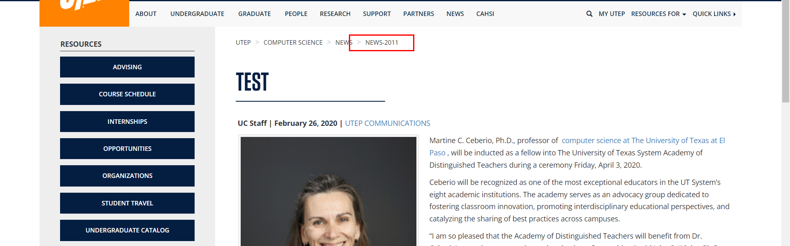

• Broken link on <https://www.utep.edu/cs/news/news-2011/congratulations-dr-ceberio22121122.html> on **Main Content** section, the broken link is displayed as: **UTEP COMMUNICATIONS** and the link is pointing to : <https://www.utep.edu/cs/news/news-2011/%E2%80%9Dhttps:/www.utep.edu/newsfeed/%E2%80%9D>

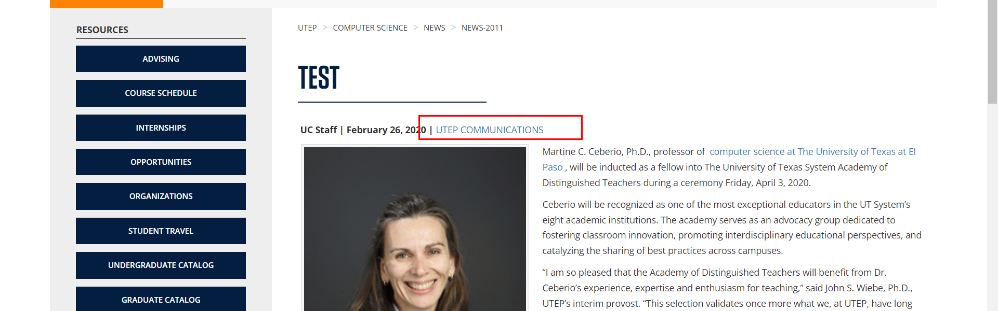

• Broken link on <https://www.utep.edu/cs/news/news-2012/computer-science-students-create-app-for-usa-science-and-engineering-festival.html> on **Main Content (Top small navigation)** section, the broken link is displayed as: **news-2012** and the link is pointing to : <https://www.utep.edu/cs/news/news-2012/>

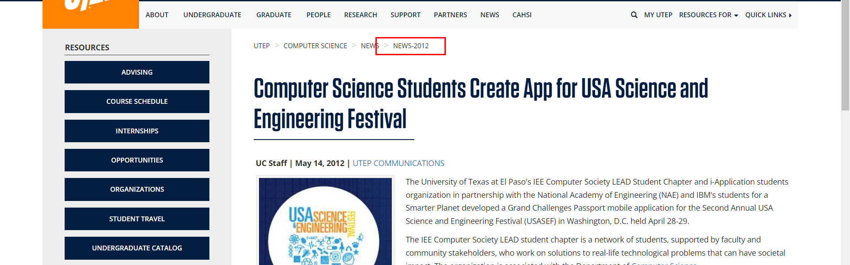

• Broken link on <https://www.utep.edu/cs/news/news-2012/computer-science-students-create-app-for-usa-science-and-engineering-festival.html> on **Main Content** section, the broken link is displayed as: **UTEP COMMUNICATIONS** and the link is pointing to : <https://www.utep.edu/cs/news/news-2012/%E2%80%9Dhttps:/www.utep.edu/newsfeed/%E2%80%9D>

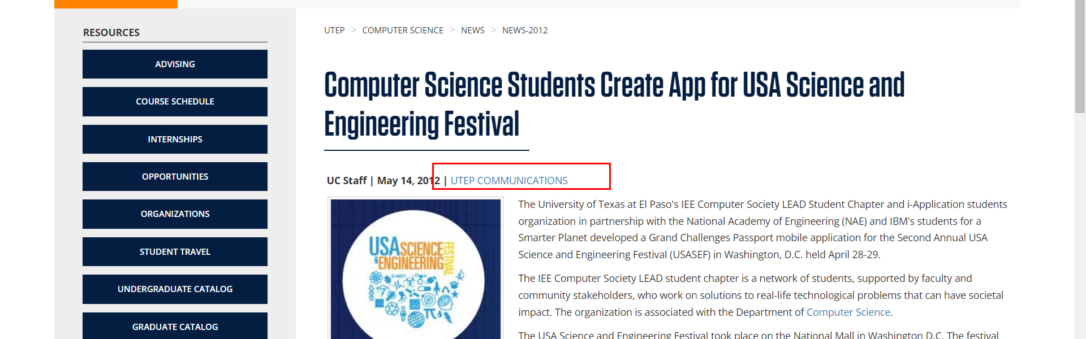

• Broken link on <https://www.utep.edu/cs/news/news-2012/congratulations-dr-ceberio2212112.html> on **Main Content (Top small navigation)** section, the broken link is displayed as: **news-2012** and the link is pointing to : <https://www.utep.edu/cs/news/news-2012/>

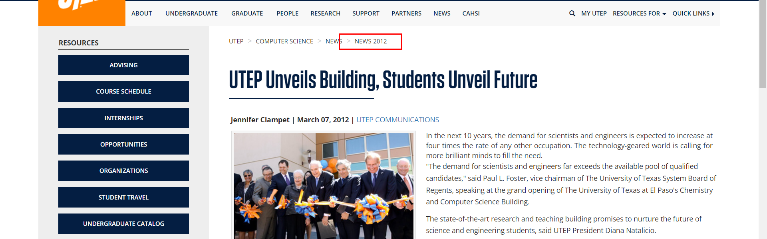

• Broken link on <https://www.utep.edu/cs/news/news-2012/congratulations-dr-ceberio2212112.html> on **Main Content** section, the broken link is displayed as: **UTEP COMMUNICATIONS** and the link is pointing to : <https://www.utep.edu/cs/news/news-2012/%E2%80%9Dhttps:/www.utep.edu/newsfeed/%E2%80%9D>

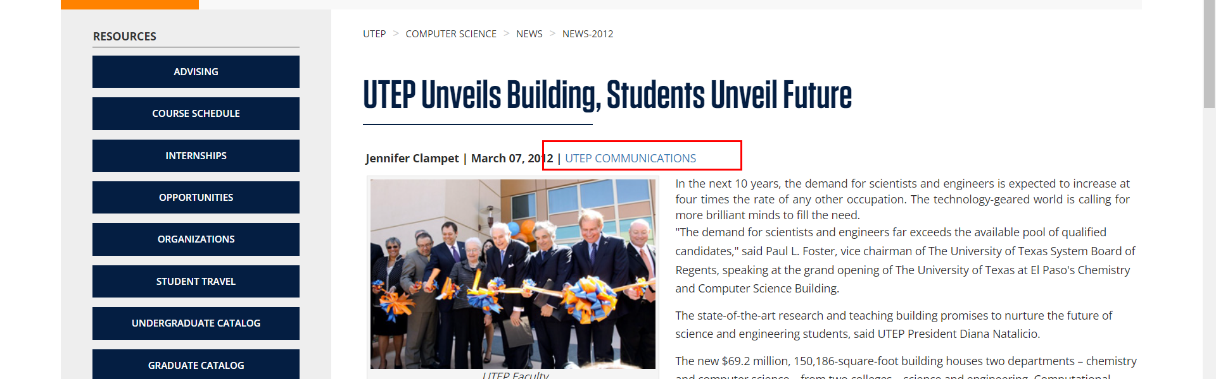

• Broken link on <https://www.utep.edu/cs/news/news-2012/congratulations-dr-ceberio22121122.html> on **Main Content (Top small navigation)** section, the broken link is displayed as: **news-2012** and the link is pointing to : <https://www.utep.edu/cs/news/news-2012/>

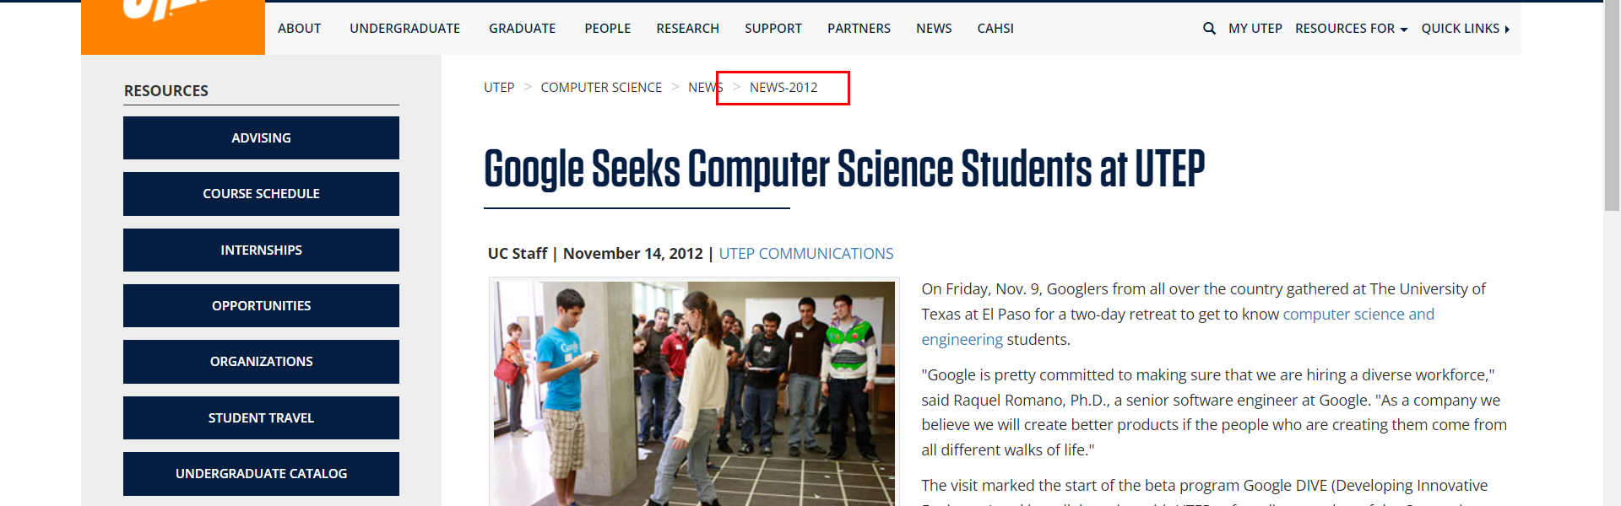

• Broken link on <https://www.utep.edu/cs/news/news-2012/congratulations-dr-ceberio22121122.html> on **Main Content** section, the broken link is displayed as: **UTEP COMMUNICATIONS** and the link is pointing to : <https://www.utep.edu/cs/news/news-2012/%E2%80%9Dhttps:/www.utep.edu/newsfeed/%E2%80%9D>



• Broken link on <https://www.utep.edu/cs/news/news-2012/congratulations-dr-ceberio22121123.html> on **Main Content (Top small navigation)** section, the broken link is displayed as: **news-2012** and the link is pointing to : <https://www.utep.edu/cs/news/news-2012/>

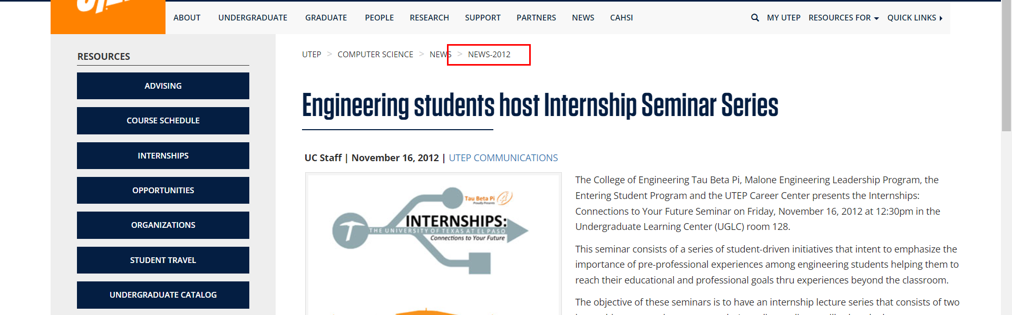

• Broken link on <https://www.utep.edu/cs/news/news-2012/congratulations-dr-ceberio22121123.html> on **Main Content** section, the broken link is displayed as: **UTEP COMMUNICATIONS** and the link is pointing to : <https://www.utep.edu/cs/news/news-2012/%E2%80%9Dhttps:/www.utep.edu/newsfeed/%E2%80%9D>

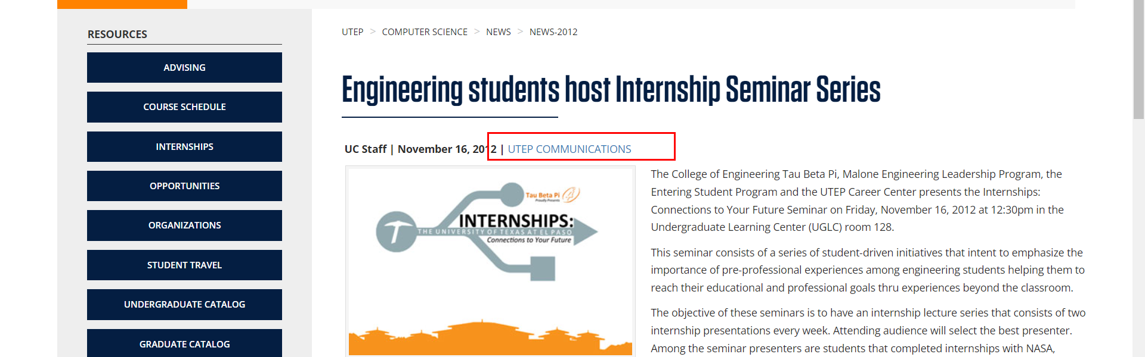

• Broken link on <https://www.utep.edu/cs/news/news-2012/congratulations-dr-kreinovich1110.html> on **Main Content (Top small navigation)** section, the broken link is displayed as: **news-2012** and the link is pointing to : <https://www.utep.edu/cs/news/news-2012/>

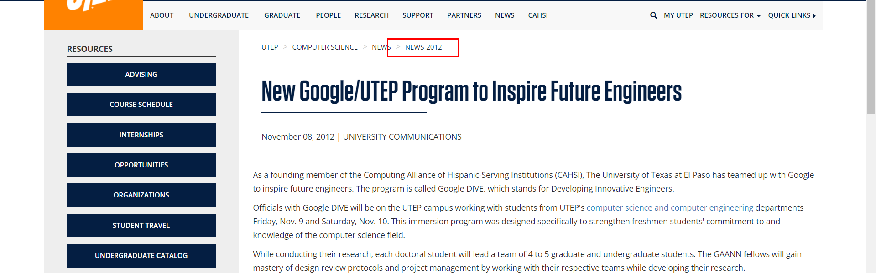

• Broken link on <https://www.utep.edu/cs/news/news-2012/congratulations-dr-kreinovich1111.html> on **Main Content (Top small navigation)** section, the broken link is displayed as: **news-2012** and the link is pointing to : <https://www.utep.edu/cs/news/news-2012/>

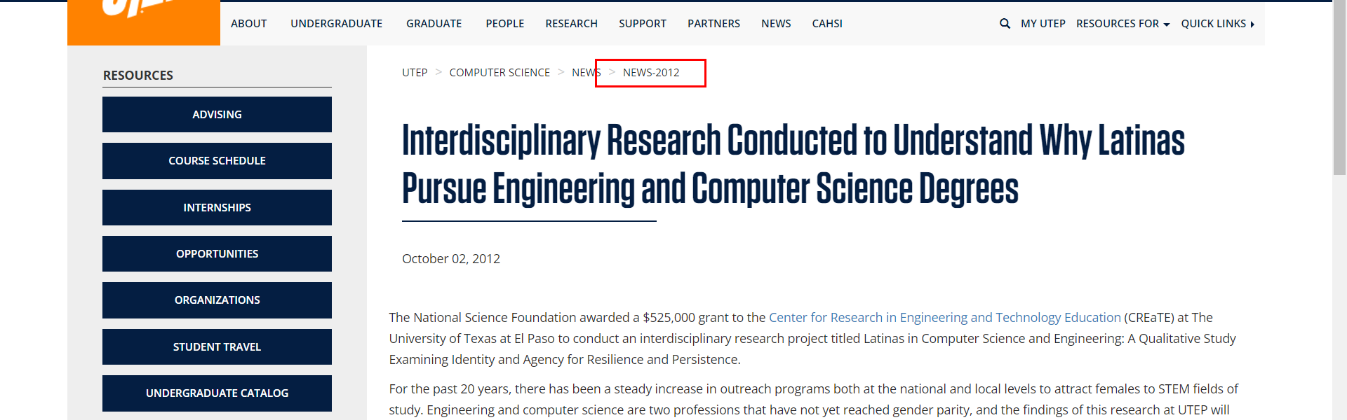

• Broken link on <https://www.utep.edu/cs/news/news-2012/congratulations-dr-kreinovich112.html> on **Main Content (Top small navigation)** section, the broken link is displayed as: **news-2012** and the link is pointing to : <https://www.utep.edu/cs/news/news-2012/>

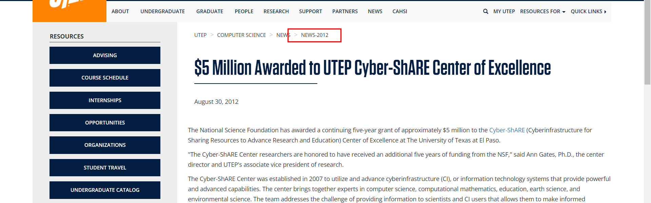

• Broken link on <https://www.utep.edu/cs/news/news-2012/congratulations-dr-kreinovich113.html> on **Main Content (Top small navigation)** section, the broken link is displayed as: **news-2012** and the link is pointing to : <https://www.utep.edu/cs/news/news-2012/>

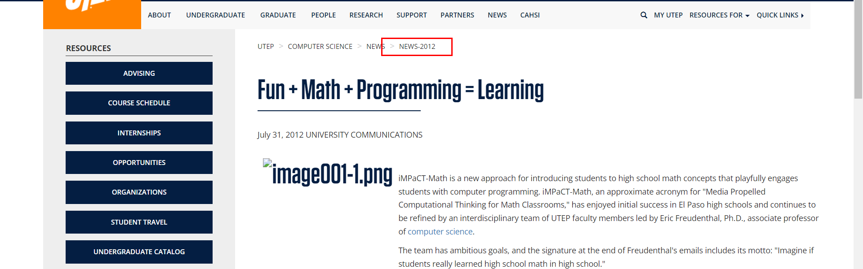

• Broken link on <https://www.utep.edu/cs/news/news-2012/congratulations-dr-kreinovich114.html> on **Main Content (Top small navigation)** section, the broken link is displayed as: **news-2012** and the link is pointing to : <https://www.utep.edu/cs/news/news-2012/>

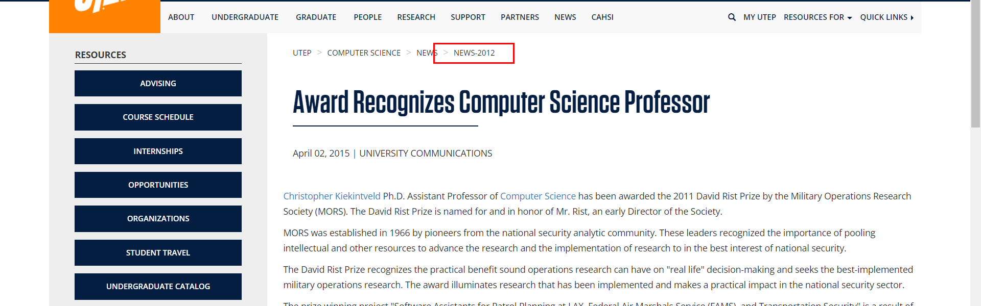

• Broken link on <https://www.utep.edu/cs/news/news-2012/congratulations-dr-kreinovich117.html> on **Main Content (Top small navigation)** section, the broken link is displayed as: **news-2012** and the link is pointing to : <https://www.utep.edu/cs/news/news-2012/>

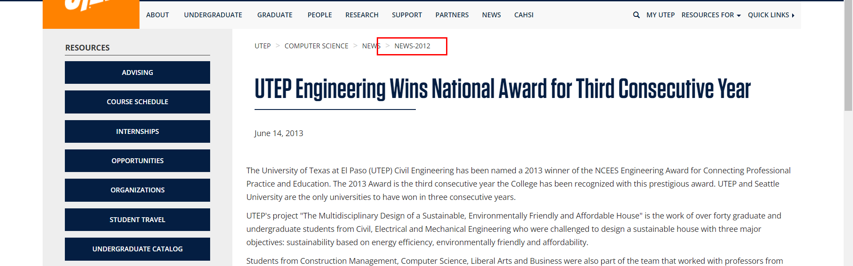

• Broken link on <https://www.utep.edu/cs/news/news-2012/congratulations-dr-kreinovich118.html> on **Main Content (Top small navigation)** section, the broken link is displayed as: **news-2012** and the link is pointing to : <https://www.utep.edu/cs/news/news-2012/>

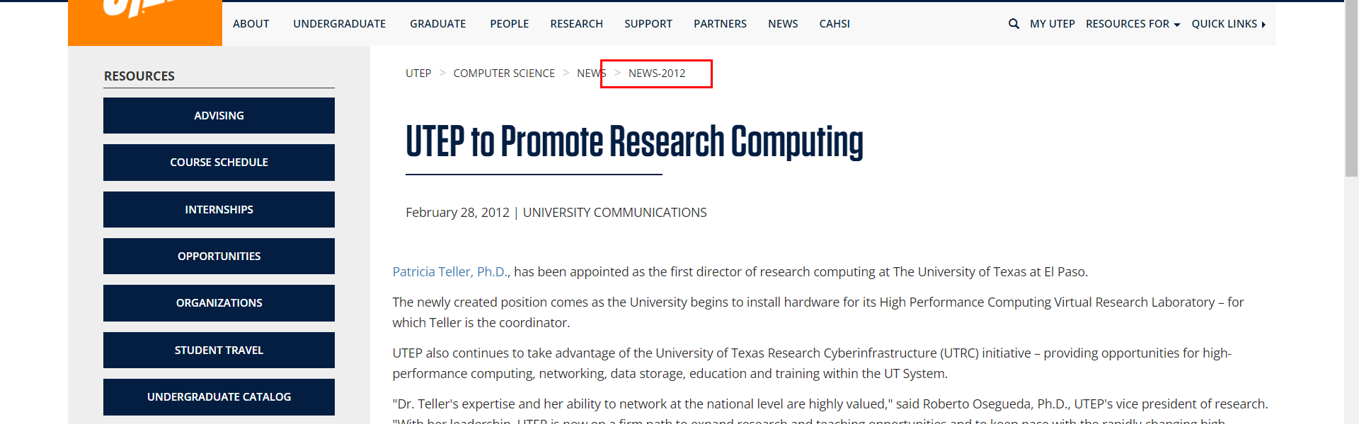

• Broken link on <https://www.utep.edu/cs/news/news-2012/congratulations-dr-kreinovich119.html> on **Main Content (Top small navigation)** section, the broken link is displayed as: **news-2012** and the link is pointing to : <https://www.utep.edu/cs/news/news-2012/>

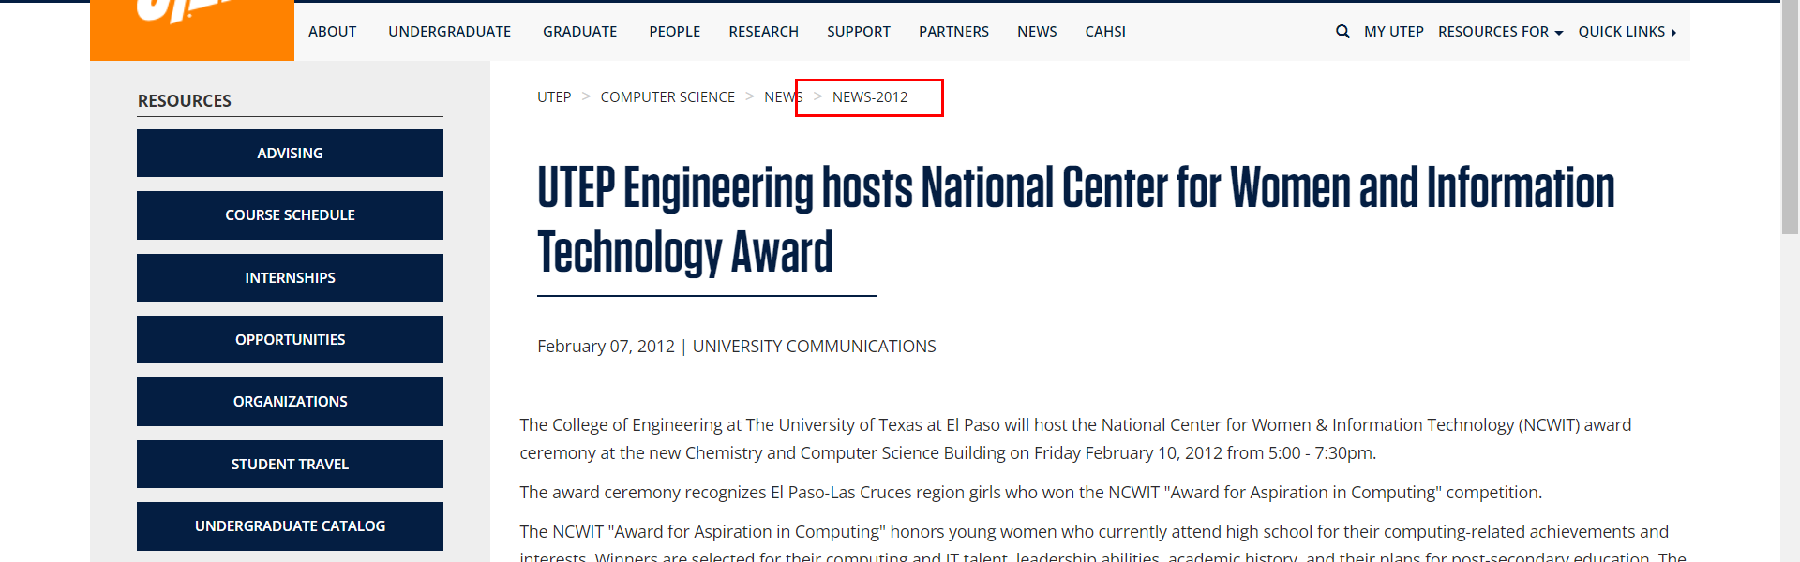

• Broken link on <https://www.utep.edu/cs/news/news-2012/director-of-research-computing-named.html> on **Main Content (Top small navigation)** section, the broken link is displayed as: **news-2012** and the link is pointing to : <https://www.utep.edu/cs/news/news-2012/>

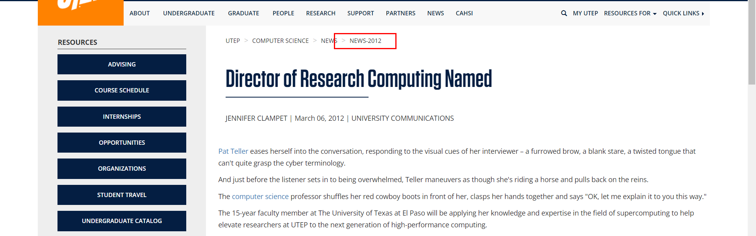

• Broken link on <https://www.utep.edu/cs/news/news-2012/gabriel.html> on **Main Content (Top small navigation)** section, the broken link is displayed as: **news-2012** and the link is pointing to : <https://www.utep.edu/cs/news/news-2012/>

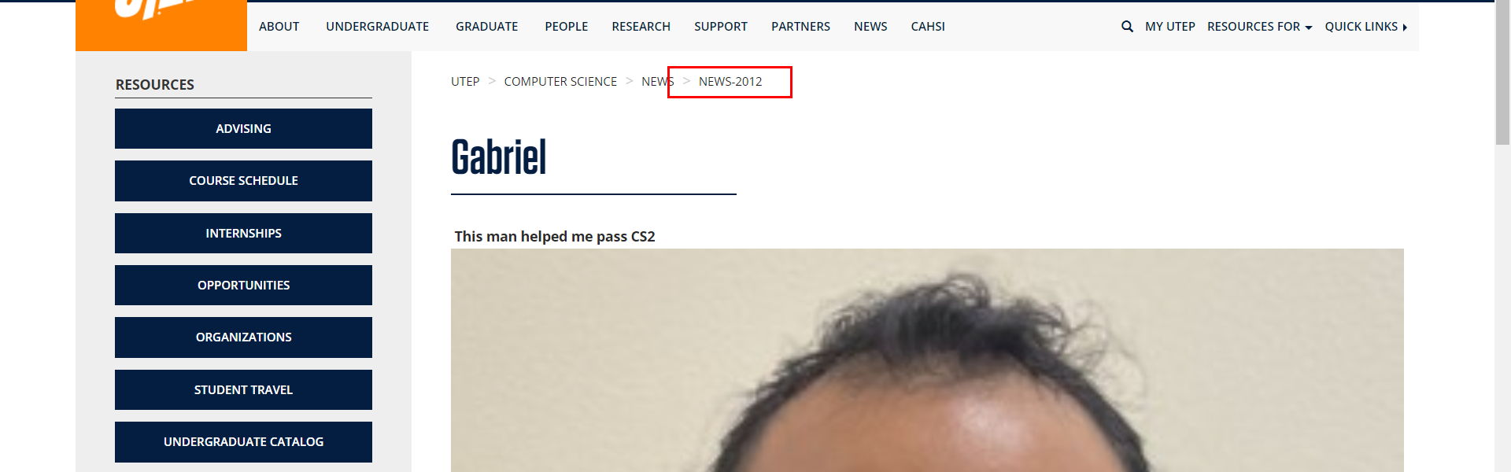

• Broken link on <https://www.utep.edu/cs/news/news-2013/congratulations-dr-ceberio2212112.html> on **Main Content (Top small navigation)** section, the broken link is displayed as: **news-2013** and the link is pointing to : <https://www.utep.edu/cs/news/news-2013/>

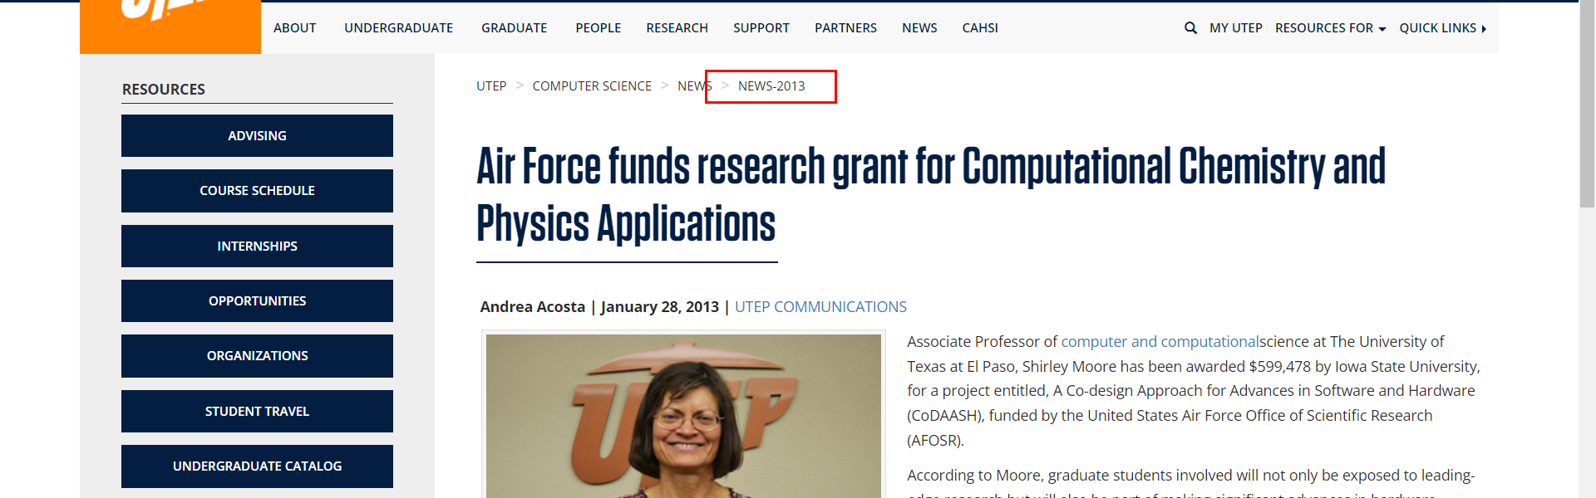

• Broken link on <https://www.utep.edu/cs/news/news-2013/congratulations-dr-ceberio2212112.html> on **Main Content** section, the broken link is displayed as: **UTEP COMMUNICATIONS** and the link is pointing to : <https://www.utep.edu/cs/news/news-2013/%E2%80%9Dhttps:/www.utep.edu/newsfeed/%E2%80%9D>

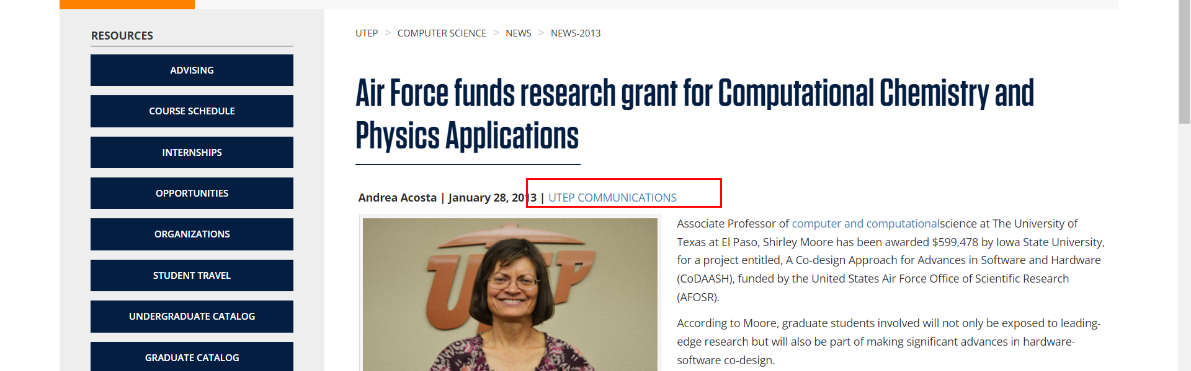

• Broken link on <https://www.utep.edu/cs/news/news-2013/congratulations-dr-ceberio22121121.html> on **Main Content (Top small navigation)** section, the broken link is displayed as: **news-2013** and the link is pointing to : <https://www.utep.edu/cs/news/news-2013/>

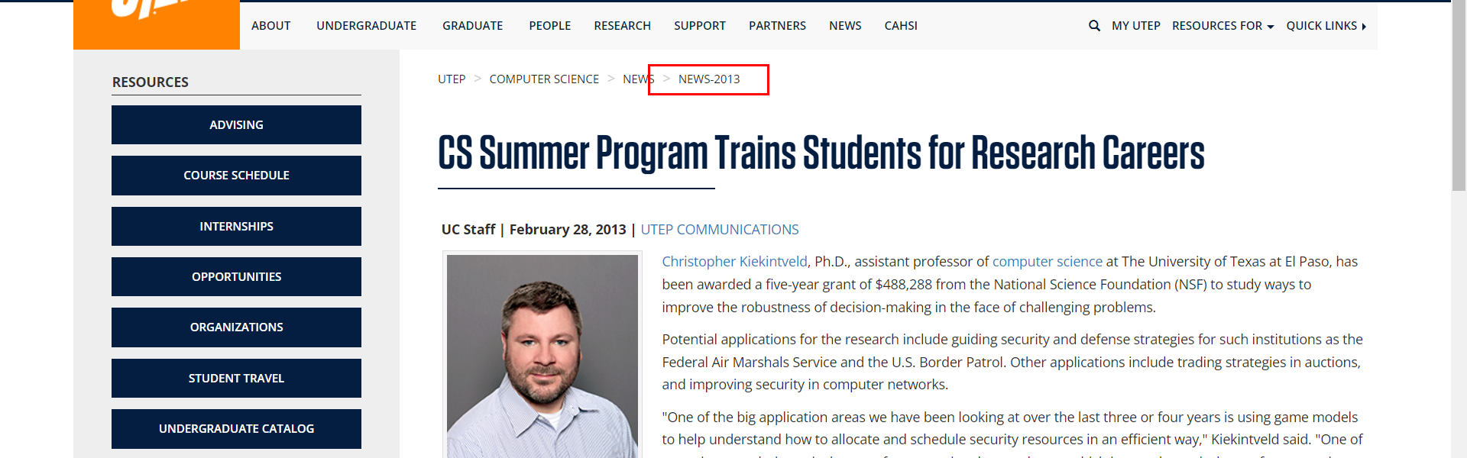

• Broken link on <https://www.utep.edu/cs/news/news-2013/congratulations-dr-ceberio22121121.html> on **Main Content** section, the broken link is displayed as: **UTEP COMMUNICATIONS** and the link is pointing to : <https://www.utep.edu/cs/news/news-2013/%E2%80%9Dhttps:/www.utep.edu/newsfeed/%E2%80%9D>



• Broken link on <https://www.utep.edu/cs/news/news-2013/congratulations-dr-ceberio221211211.html> on **Main Content (Top small navigation)** section, the broken link is displayed as: **news-2013** and the link is pointing to : <https://www.utep.edu/cs/news/news-2013/>



• Broken link on <https://www.utep.edu/cs/news/news-2013/congratulations-dr-ceberio221211211.html> on **Main Content** section, the broken link is displayed as: **UTEP COMMUNICATIONS** and the link is pointing to : <https://www.utep.edu/cs/news/news-2013/%E2%80%9Dhttps:/www.utep.edu/newsfeed/%E2%80%9D>



• Broken link on <https://www.utep.edu/cs/news/news-2013/congratulations-dr-ceberio2212112111.html> on **Main Content (Top small navigation)** section, the broken link is displayed as: **news-2013** and the link is pointing to : <https://www.utep.edu/cs/news/news-2013/>

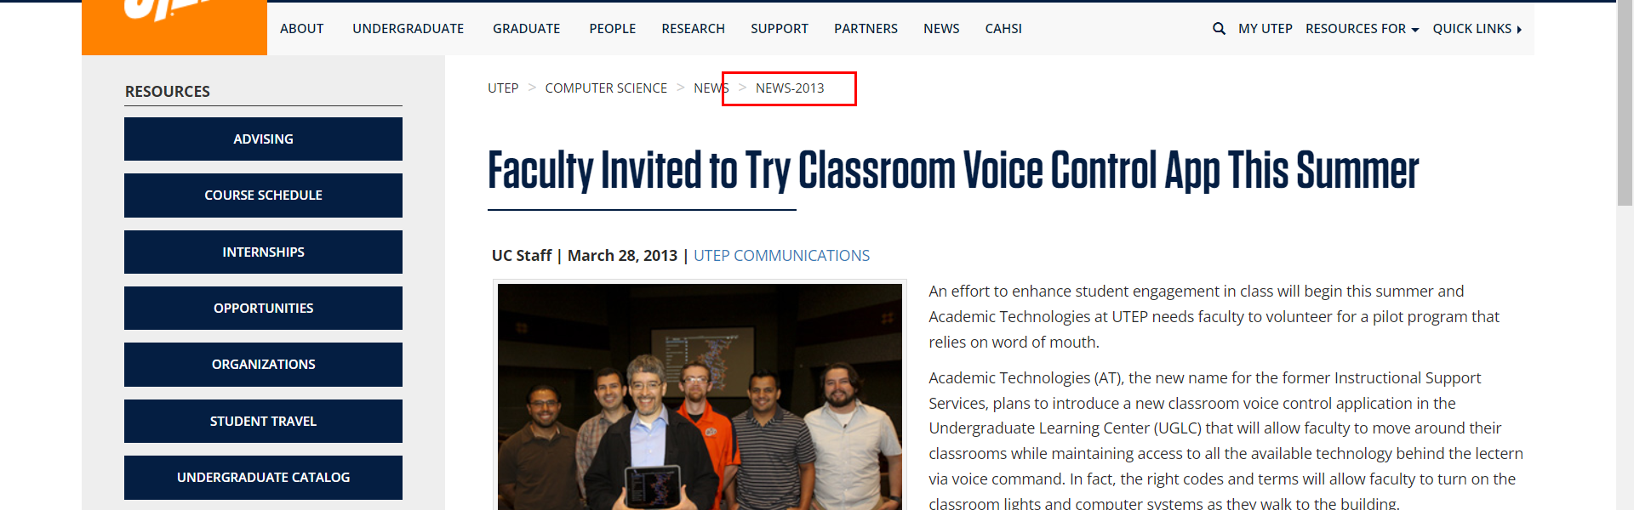

• Broken link on <https://www.utep.edu/cs/news/news-2013/congratulations-dr-ceberio2212112111.html> on **Main Content** section, the broken link is displayed as: **UTEP COMMUNICATIONS** and the link is pointing to : <https://www.utep.edu/cs/news/news-2013/%E2%80%9Dhttps:/www.utep.edu/newsfeed/%E2%80%9D>

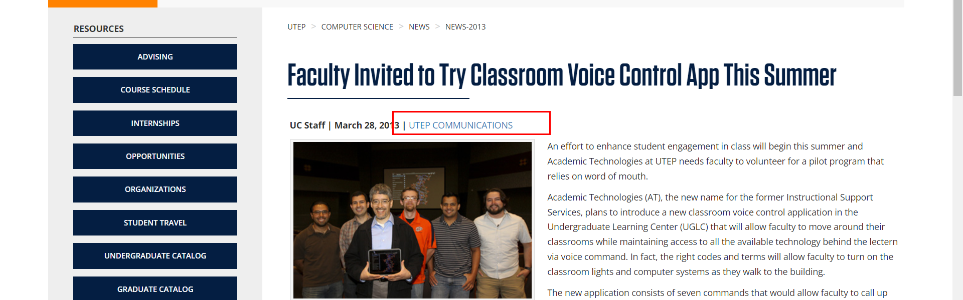

• Broken link on <https://www.utep.edu/cs/news/news-2013/congratulations-dr-ceberio221211212.html> on **Main Content (Top small navigation)** section, the broken link is displayed as: **news-2013** and the link is pointing to : <https://www.utep.edu/cs/news/news-2013/>

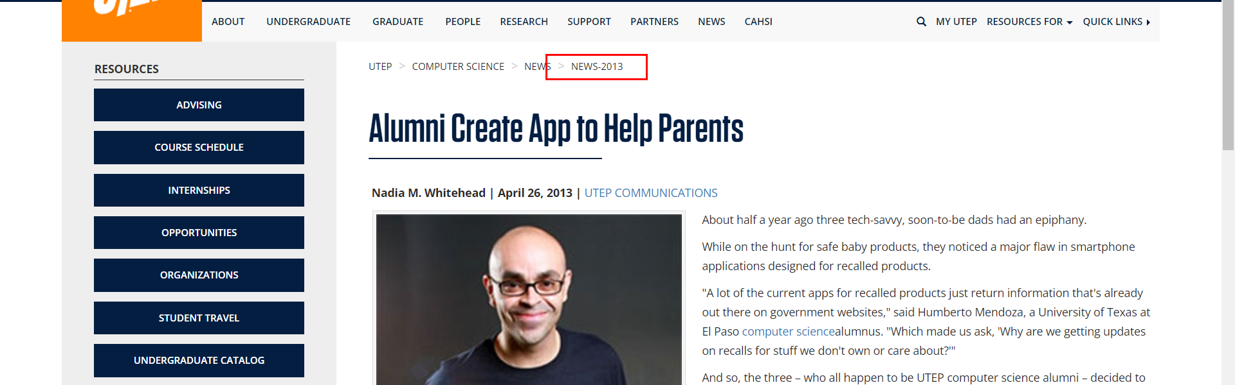

• Broken link on <https://www.utep.edu/cs/news/news-2013/congratulations-dr-ceberio221211212.html> on **Main Content** section, the broken link is displayed as: **UTEP COMMUNICATIONS** and the link is pointing to : <https://www.utep.edu/cs/news/news-2013/%E2%80%9Dhttps:/www.utep.edu/newsfeed/%E2%80%9D>

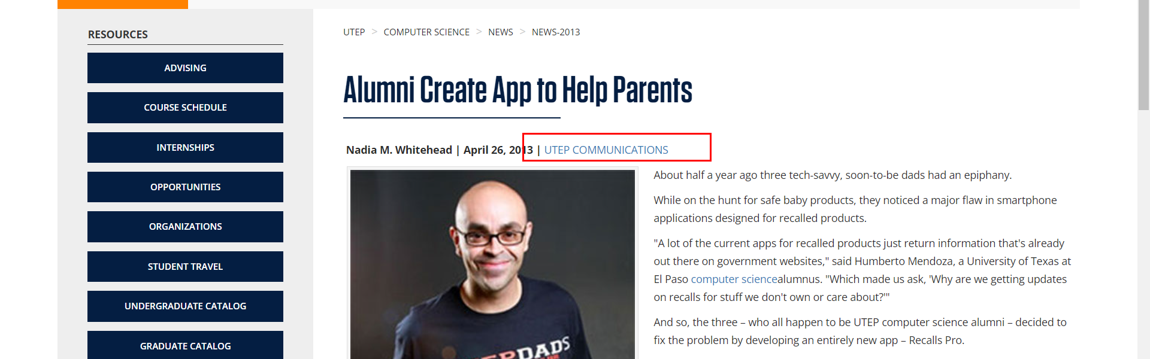

• Broken link on <https://www.utep.edu/cs/news/news-2013/congratulations-dr-ceberio22121122.html> on **Main Content (Top small navigation)** section, the broken link is displayed as: **news-2013** and the link is pointing to : <https://www.utep.edu/cs/news/news-2013/>

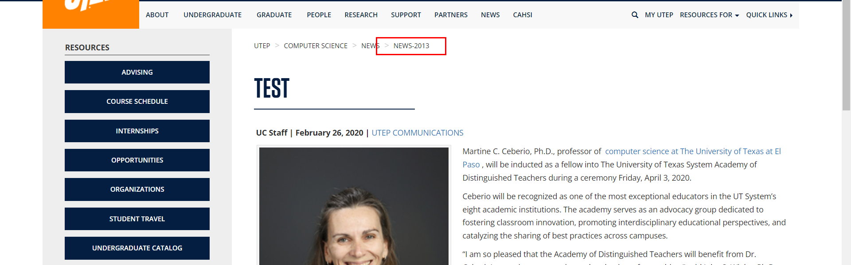

• Broken link on <https://www.utep.edu/cs/news/news-2013/congratulations-dr-ceberio22121122.html> on **Main Content** section, the broken link is displayed as: **UTEP COMMUNICATIONS** and the link is pointing to : <https://www.utep.edu/cs/news/news-2013/%E2%80%9Dhttps:/www.utep.edu/newsfeed/%E2%80%9D>

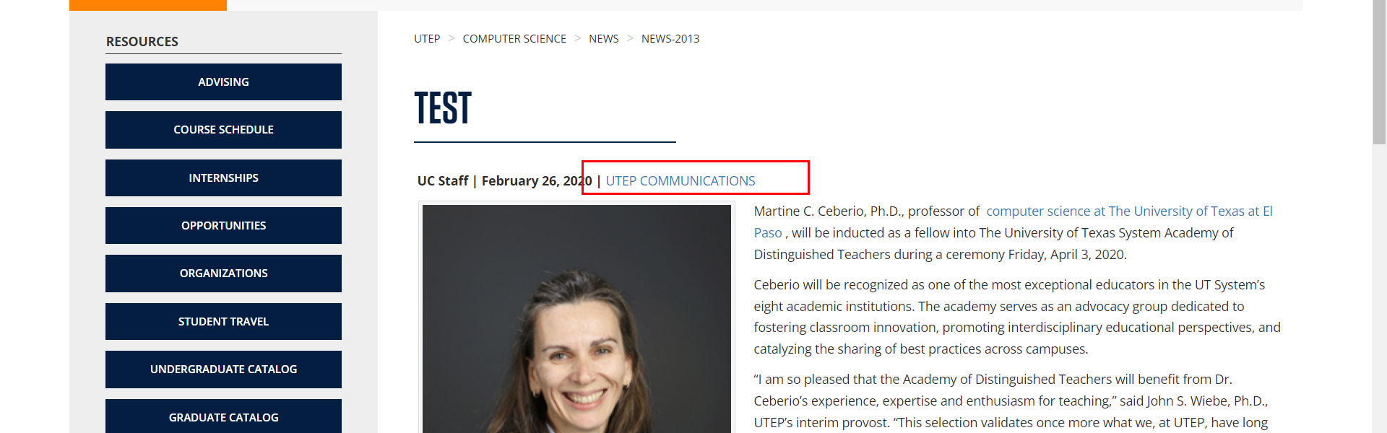

• Broken link on <https://www.utep.edu/cs/news/news-2013/congratulations-dr-ceberio221211221.html> on **Main Content (Top small navigation)** section, the broken link is displayed as: **news-2013** and the link is pointing to : <https://www.utep.edu/cs/news/news-2013/>



• Broken link on <https://www.utep.edu/cs/news/news-2013/congratulations-dr-ceberio221211221.html> on **Main Content** section, the broken link is displayed as: **UTEP COMMUNICATIONS** and the link is pointing to : <https://www.utep.edu/cs/news/news-2013/%E2%80%9Dhttps:/www.utep.edu/newsfeed/%E2%80%9D>

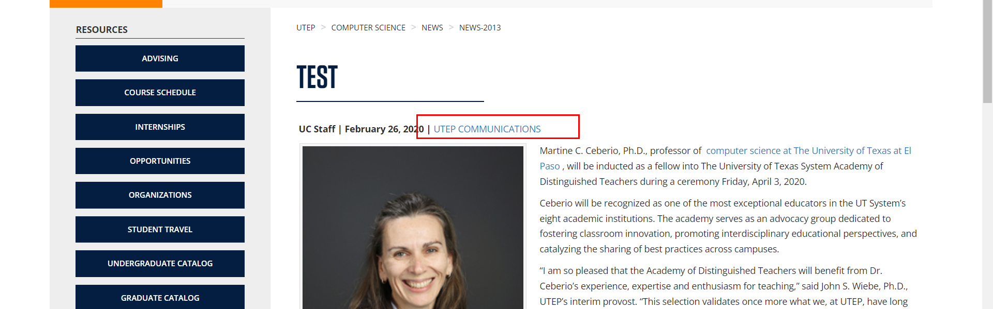

• Broken link on <https://www.utep.edu/cs/news/news-2013/congratulations-dr-ceberio22121123.html> on **Main Content (Top small navigation)** section, the broken link is displayed as: **news-2013** and the link is pointing to : <https://www.utep.edu/cs/news/news-2013/>

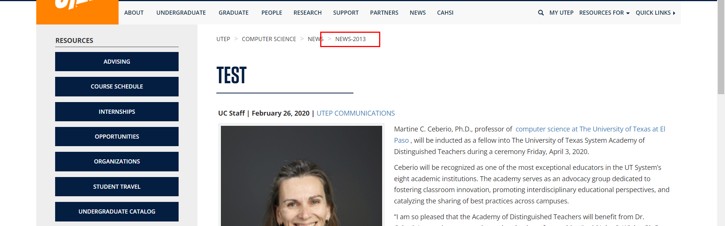

• Broken link on <https://www.utep.edu/cs/news/news-2013/congratulations-dr-ceberio22121123.html> on **Main Content** section, the broken link is displayed as: **UTEP COMMUNICATIONS** and the link is pointing to : <https://www.utep.edu/cs/news/news-2013/%E2%80%9Dhttps:/www.utep.edu/newsfeed/%E2%80%9D>



• Broken link on <https://www.utep.edu/cs/news/news-2013/congratulations-dr-kreinovich1121.html> on **Main Content (Top small navigation)** section, the broken link is displayed as: **news-2013** and the link is pointing to : <https://www.utep.edu/cs/news/news-2013/>

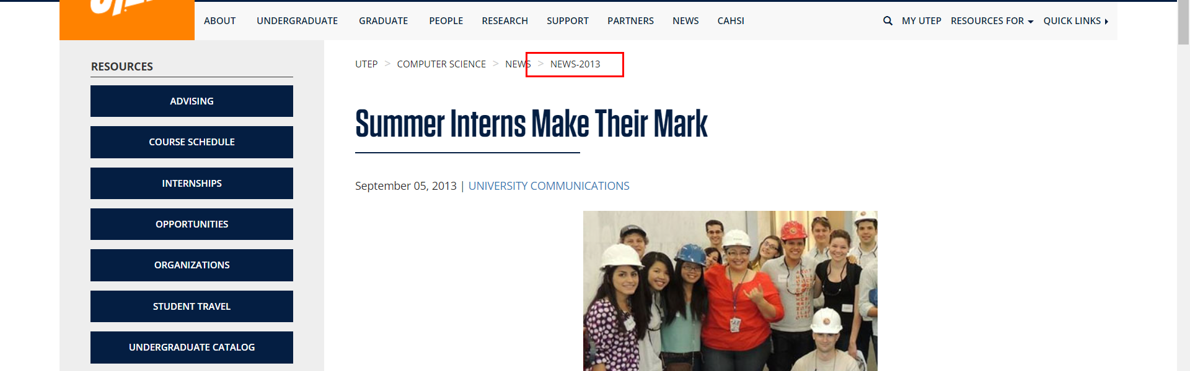

• Broken link on <https://www.utep.edu/cs/news/news-2013/congratulations-dr-kreinovich11210.html> on **Main Content (Top small navigation)** section, the broken link is displayed as: **news-2013** and the link is pointing to : <https://www.utep.edu/cs/news/news-2013/>

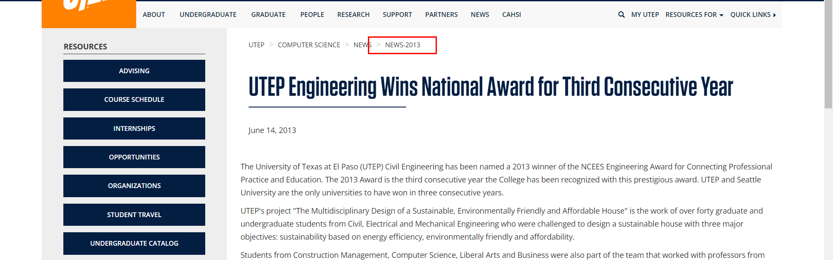

• Broken link on <https://www.utep.edu/cs/news/news-2013/congratulations-dr-kreinovich11212.html> on **Main Content (Top small navigation)** section, the broken link is displayed as: **news-2013** and the link is pointing to : <https://www.utep.edu/cs/news/news-2013/>

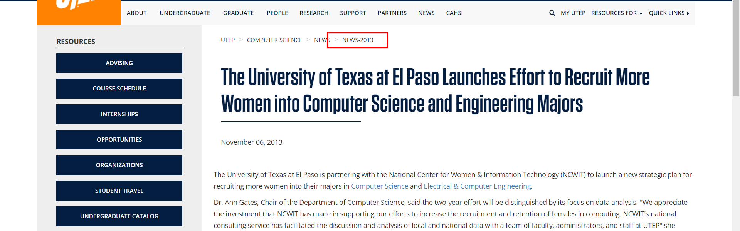

• Broken link on <https://www.utep.edu/cs/news/news-2013/congratulations-dr-kreinovich11213.html> on **Main Content (Top small navigation)** section, the broken link is displayed as: **news-2013** and the link is pointing to : <https://www.utep.edu/cs/news/news-2013/>

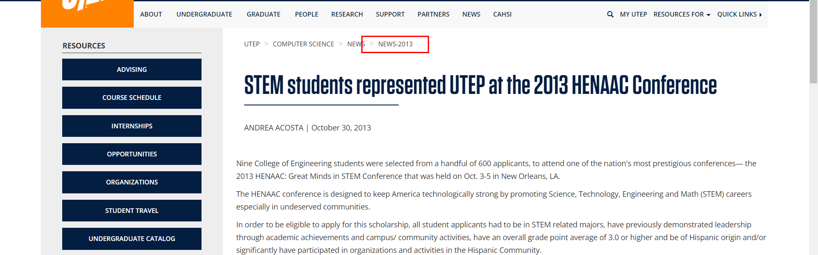

• Broken link on <https://www.utep.edu/cs/news/news-2013/congratulations-dr-kreinovich11214.html> on **Main Content (Top small navigation)** section, the broken link is displayed as: **news-2013** and the link is pointing to : <https://www.utep.edu/cs/news/news-2013/>

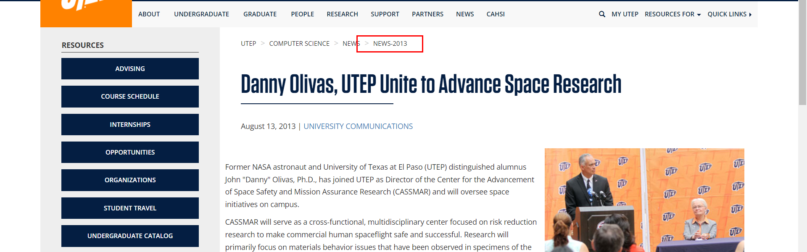

• Broken link on <https://www.utep.edu/cs/news/news-2013/congratulations-dr-kreinovich11214.html> on **Main Content** section, the broken link is displayed as: **Ann Gates** and the link is pointing to : [http://faculty.utep.edu/agates](https://www.utep.edu/agates)

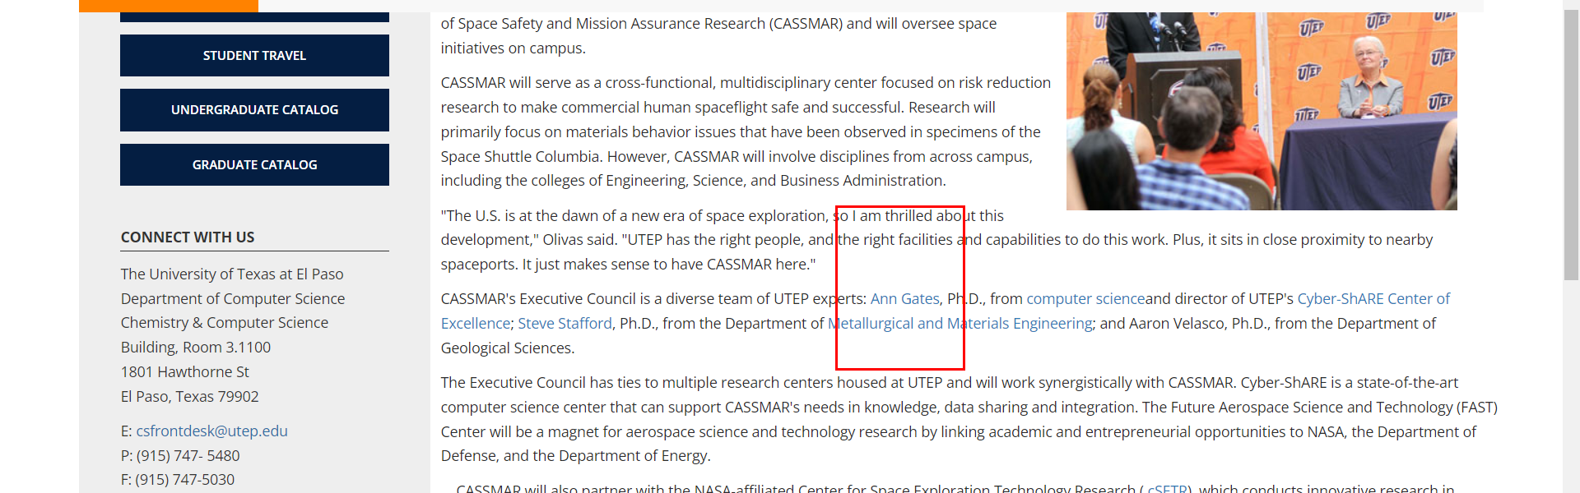

• Broken link on <https://www.utep.edu/cs/news/news-2013/congratulations-dr-kreinovich11215.html> on **Main Content (Top small navigation)** section, the broken link is displayed as: **news-2013** and the link is pointing to : <https://www.utep.edu/cs/news/news-2013/>

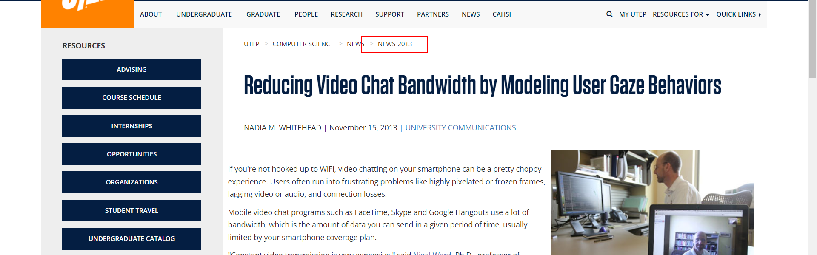

• Broken link on <https://www.utep.edu/cs/news/news-2013/congratulations-dr-kreinovich11216.html> on **Main Content (Top small navigation)** section, the broken link is displayed as: **news-2013** and the link is pointing to : <https://www.utep.edu/cs/news/news-2013/>

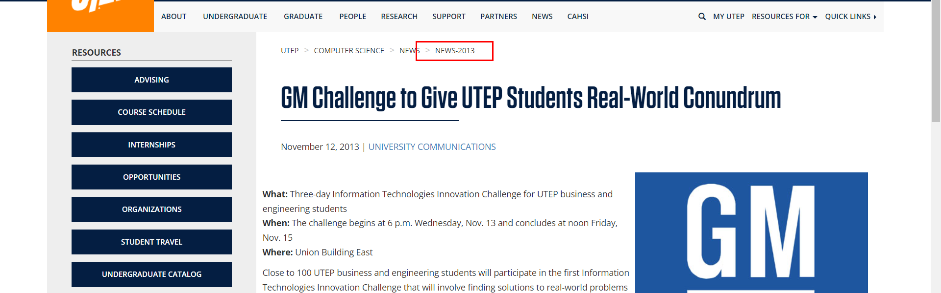

• Broken link on <https://www.utep.edu/cs/news/news-2013/congratulations-dr-kreinovich11217.html> on **Main Content (Top small navigation)** section, the broken link is displayed as: **news-2013** and the link is pointing to : <https://www.utep.edu/cs/news/news-2013/>

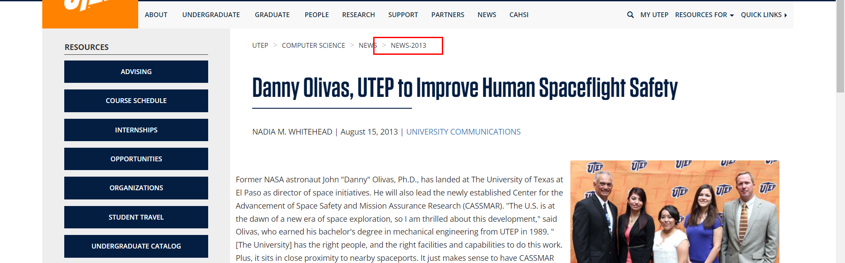

• Broken link on <https://www.utep.edu/cs/news/news-2013/congratulations-dr-kreinovich1122.html> on **Main Content (Top small navigation)** section, the broken link is displayed as: **news-2013** and the link is pointing to : <https://www.utep.edu/cs/news/news-2013/>

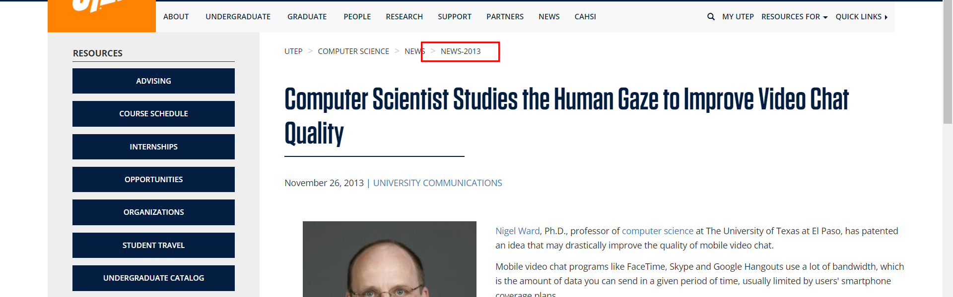

• Broken link on <https://www.utep.edu/cs/news/news-2013/congratulations-dr-kreinovich1123.html> on **Main Content (Top small navigation)** section, the broken link is displayed as: **news-2013** and the link is pointing to : <https://www.utep.edu/cs/news/news-2013/>



• Broken link on <https://www.utep.edu/cs/news/news-2013/congratulations-dr-kreinovich1125.html> on **Main Content (Top small navigation)** section, the broken link is displayed as: **news-2013** and the link is pointing to : <https://www.utep.edu/cs/news/news-2013/>

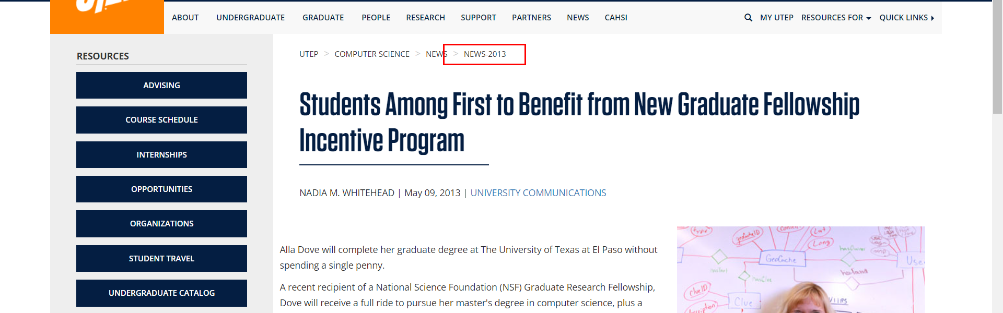

• Broken link on <https://www.utep.edu/cs/news/news-2014/congratulations-dr-ceberio2212112.html> on **Main Content (Top small navigation)** section, the broken link is displayed as: **news-2014** and the link is pointing to : <https://www.utep.edu/cs/news/news-2014/>

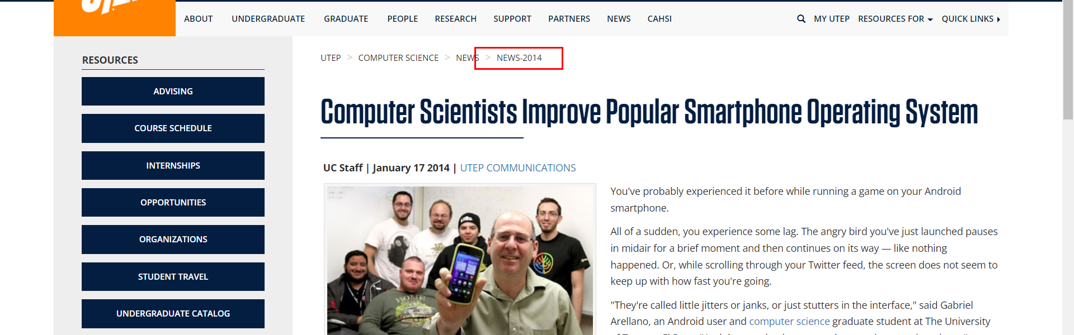

• Broken link on <https://www.utep.edu/cs/news/news-2014/congratulations-dr-ceberio2212112.html> on **Main Content** section, the broken link is displayed as: **UTEP COMMUNICATIONS** and the link is pointing to : <https://www.utep.edu/cs/news/news-2014/%E2%80%9Dhttps:/www.utep.edu/newsfeed/%E2%80%9D>

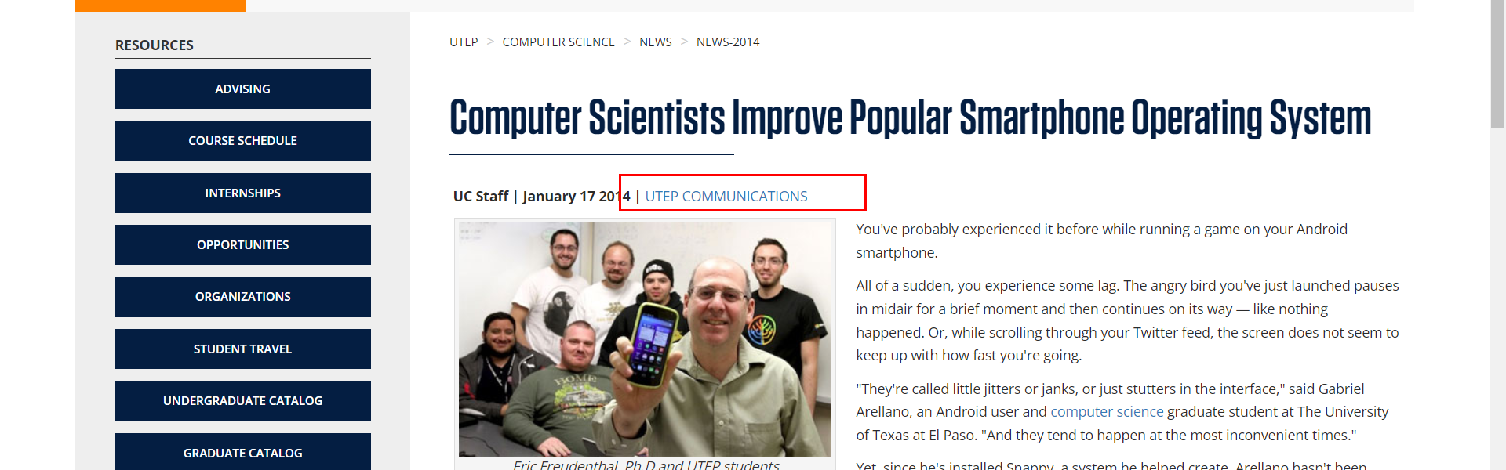

• Broken link on <https://www.utep.edu/cs/news/news-2014/congratulations-dr-ceberio22121121.html> on **Main Content (Top small navigation)** section, the broken link is displayed as: **news-2014** and the link is pointing to : <https://www.utep.edu/cs/news/news-2014/>

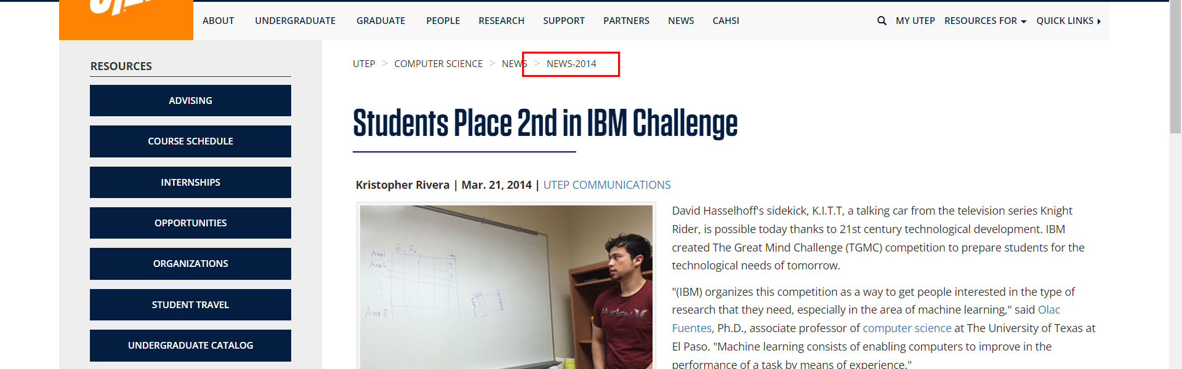

• Broken link on <https://www.utep.edu/cs/news/news-2014/congratulations-dr-ceberio22121121.html> on **Main Content** section, the broken link is displayed as: **UTEP COMMUNICATIONS** and the link is pointing to : <https://www.utep.edu/cs/news/news-2014/%E2%80%9Dhttps:/www.utep.edu/newsfeed/%E2%80%9D>



• Broken link on <https://www.utep.edu/cs/news/news-2014/congratulations-dr-ceberio221211211.html> on **Main Content (Top small navigation)** section, the broken link is displayed as: **news-2014** and the link is pointing to : <https://www.utep.edu/cs/news/news-2014/>

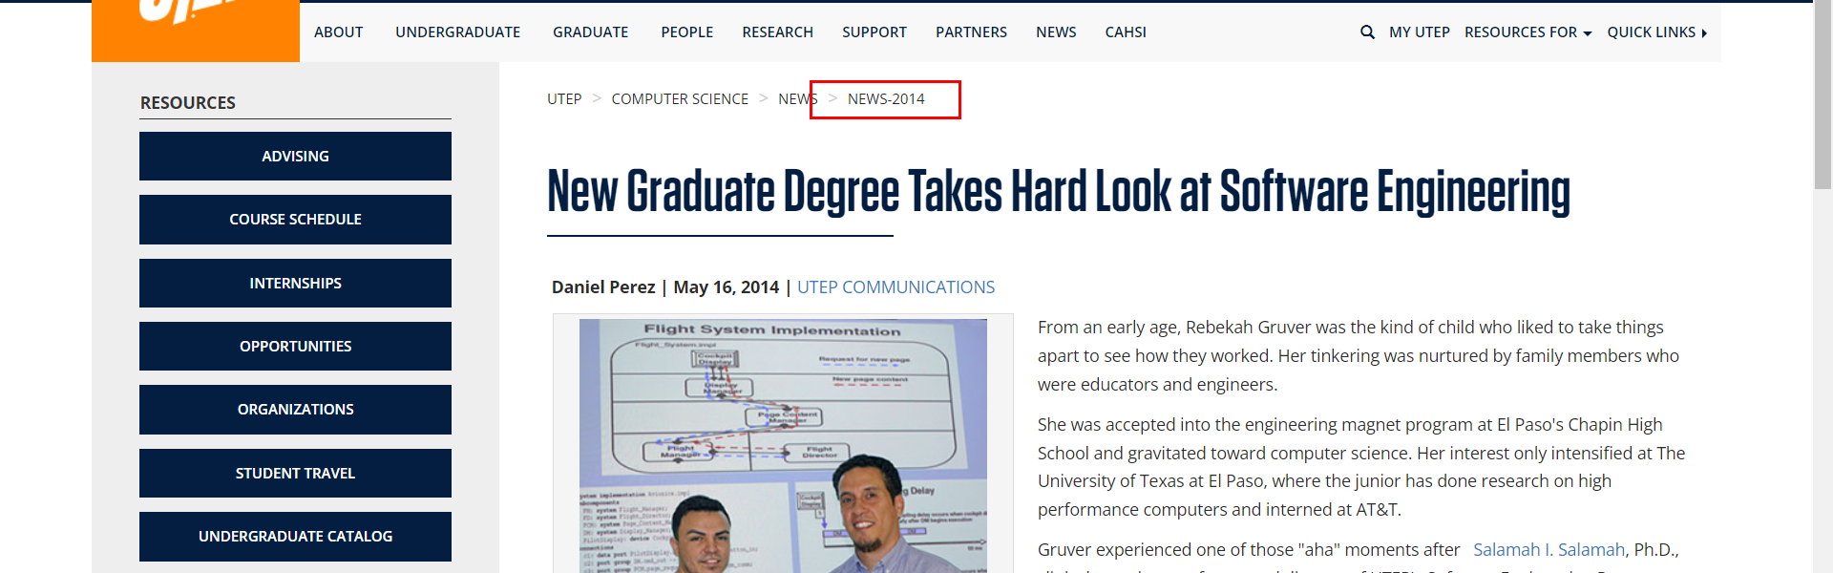

• Broken link on <https://www.utep.edu/cs/news/news-2014/congratulations-dr-ceberio221211211.html> on **Main Content** section, the broken link is displayed as: **UTEP COMMUNICATIONS** and the link is pointing to : <https://www.utep.edu/cs/news/news-2014/%E2%80%9Dhttps:/www.utep.edu/newsfeed/%E2%80%9D>

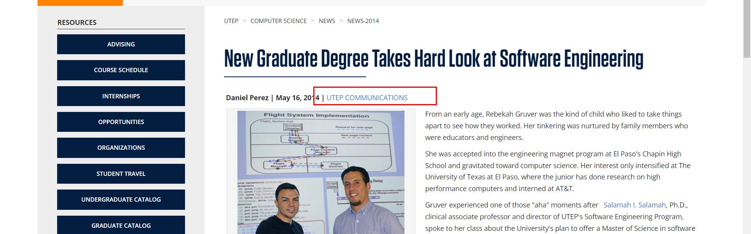

• Broken link on <https://www.utep.edu/cs/news/news-2014/congratulations-dr-ceberio2212112111.html> on **Main Content (Top small navigation)** section, the broken link is displayed as: **news-2014** and the link is pointing to : <https://www.utep.edu/cs/news/news-2014/>

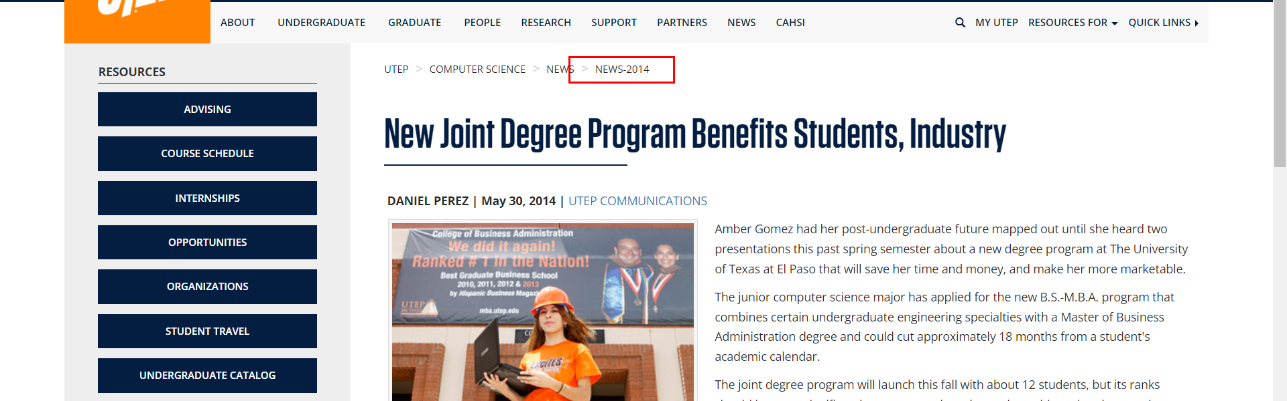

• Broken link on <https://www.utep.edu/cs/news/news-2014/congratulations-dr-ceberio2212112111.html> on **Main Content** section, the broken link is displayed as: **UTEP COMMUNICATIONS** and the link is pointing to : <https://www.utep.edu/cs/news/news-2014/%E2%80%9Dhttps:/www.utep.edu/newsfeed/%E2%80%9D>



• Broken link on <https://www.utep.edu/cs/news/news-2014/congratulations-dr-ceberio22121121111.html> on **Main Content (Top small navigation)** section, the broken link is displayed as: **news-2014** and the link is pointing to : <https://www.utep.edu/cs/news/news-2014/>



• Broken link on <https://www.utep.edu/cs/news/news-2014/congratulations-dr-ceberio22121121111.html> on **Main Content** section, the broken link is displayed as: **UTEP COMMUNICATIONS** and the link is pointing to : <https://www.utep.edu/cs/news/news-2014/%E2%80%9Dhttps:/www.utep.edu/newsfeed/%E2%80%9D>



• Broken link on <https://www.utep.edu/cs/news/news-2014/congratulations-dr-ceberio22121121111.html> on **Main Content** section, the broken link is displayed as: **Salamah I. Salamah** and the link is pointing to : <http://www.cs.utep.edu/DeptCS/people/facultyList.html>

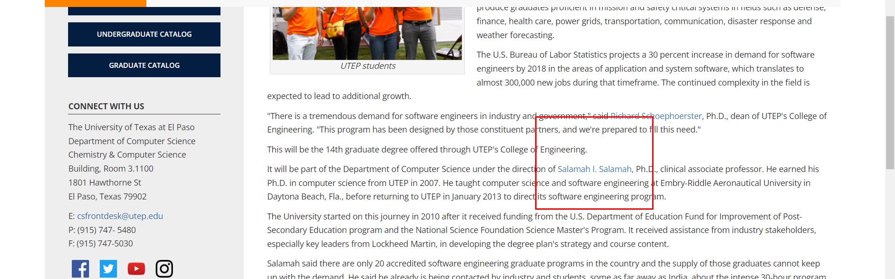

• Broken link on <https://www.utep.edu/cs/news/news-2014/congratulations-dr-ceberio221211212.html> on **Main Content (Top small navigation)** section, the broken link is displayed as: **news-2014** and the link is pointing to : <https://www.utep.edu/cs/news/news-2014/>

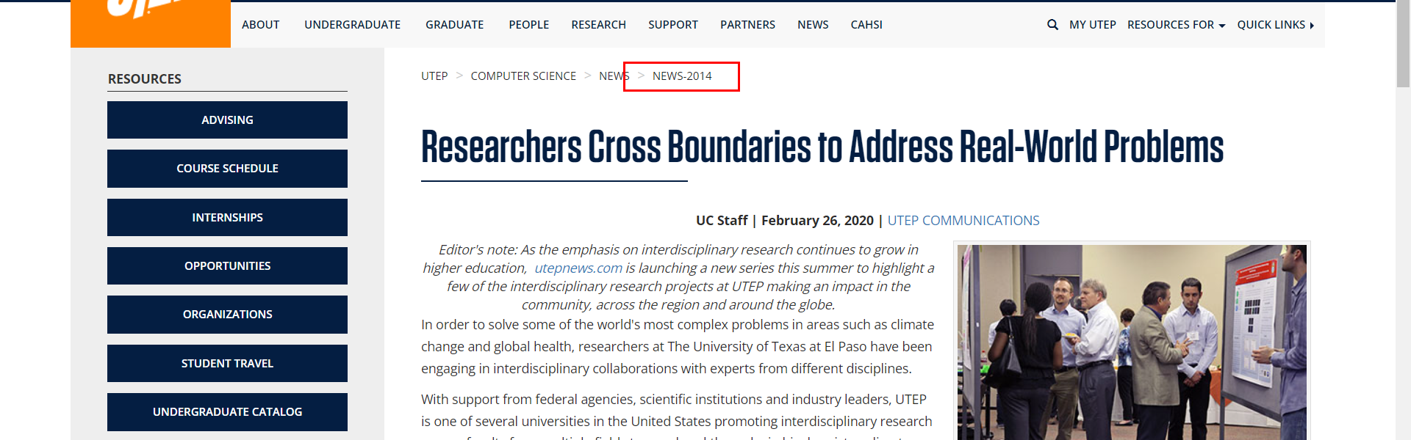

• Broken link on <https://www.utep.edu/cs/news/news-2014/congratulations-dr-ceberio221211212.html> on **Main Content** section, the broken link is displayed as: **UTEP COMMUNICATIONS** and the link is pointing to : <https://www.utep.edu/cs/news/news-2014/%E2%80%9Dhttps:/www.utep.edu/newsfeed/%E2%80%9D>

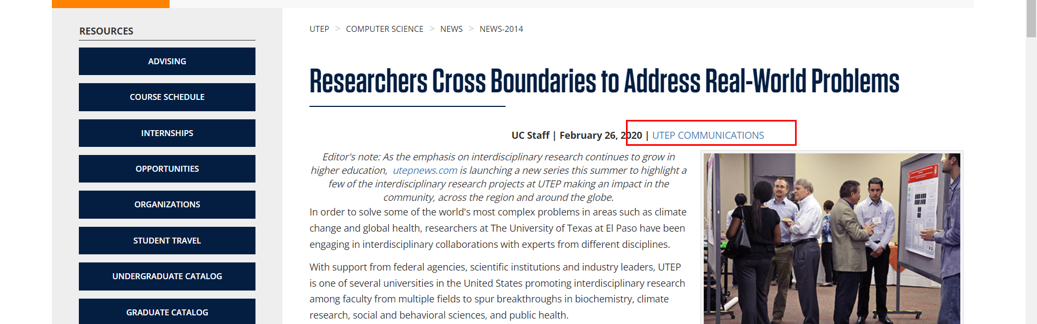

• Broken link on <https://www.utep.edu/cs/news/news-2014/congratulations-dr-ceberio2212112121.html> on **Main Content (Top small navigation)** section, the broken link is displayed as: **news-2014** and the link is pointing to : <https://www.utep.edu/cs/news/news-2014/>

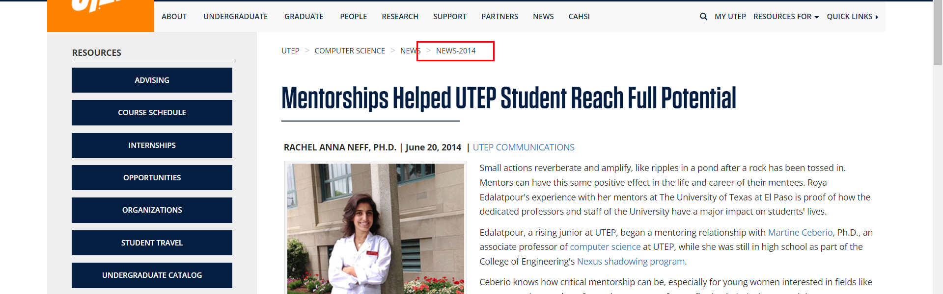

• Broken link on <https://www.utep.edu/cs/news/news-2014/congratulations-dr-ceberio2212112121.html> on **Main Content** section, the broken link is displayed as: **UTEP COMMUNICATIONS** and the link is pointing to : <https://www.utep.edu/cs/news/news-2014/%E2%80%9Dhttps:/www.utep.edu/newsfeed/%E2%80%9D>

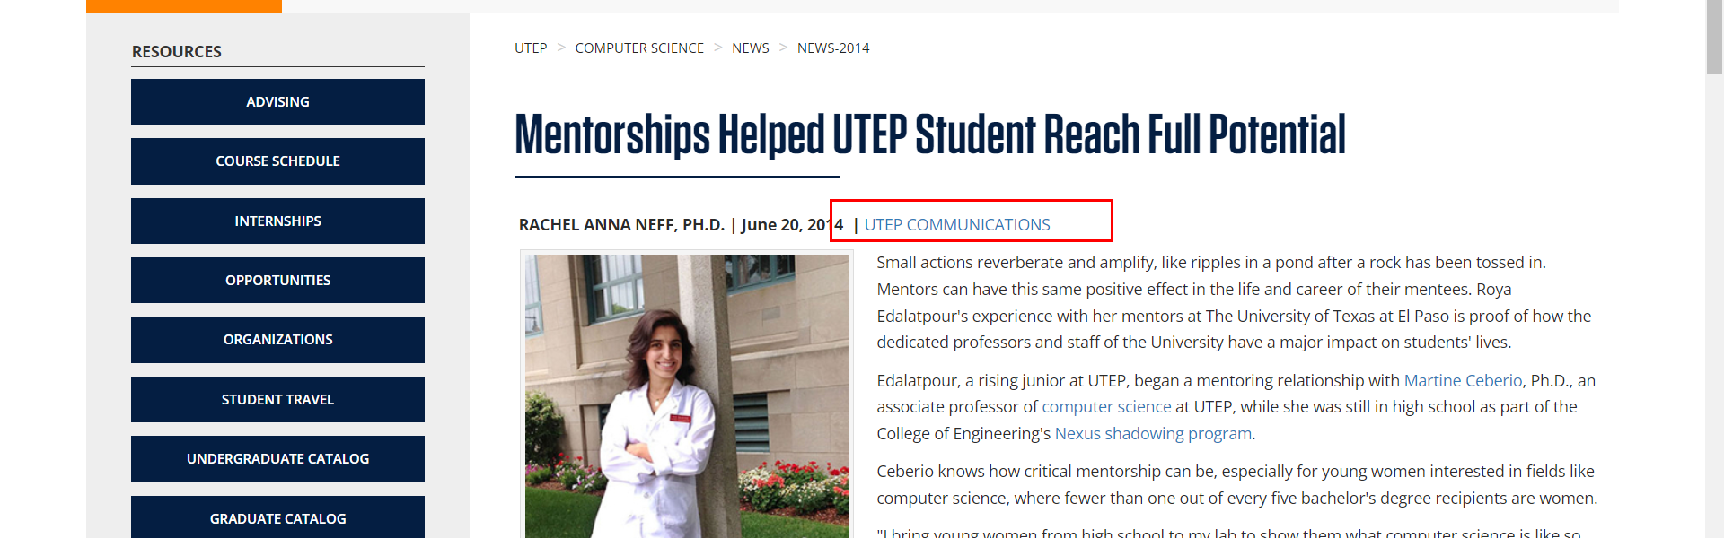

• Broken link on <https://www.utep.edu/cs/news/news-2014/congratulations-dr-ceberio22121122.html> on **Main Content (Top small navigation)** section, the broken link is displayed as: **news-2014** and the link is pointing to : <https://www.utep.edu/cs/news/news-2014/>

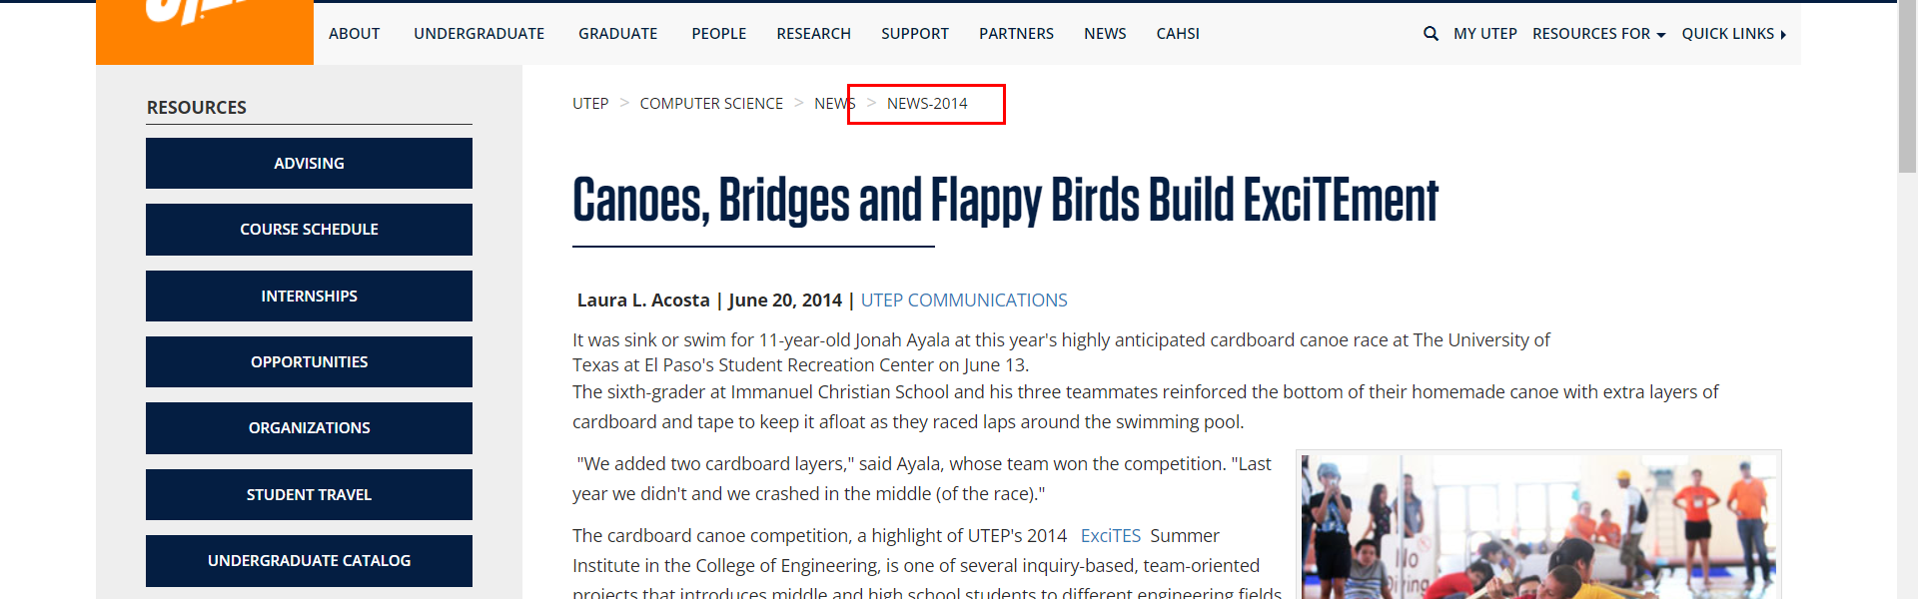

• Broken link on <https://www.utep.edu/cs/news/news-2014/congratulations-dr-ceberio22121122.html> on **Main Content** section, the broken link is displayed as: **UTEP COMMUNICATIONS** and the link is pointing to : <https://www.utep.edu/cs/news/news-2014/%E2%80%9Dhttps:/www.utep.edu/newsfeed/%E2%80%9D>

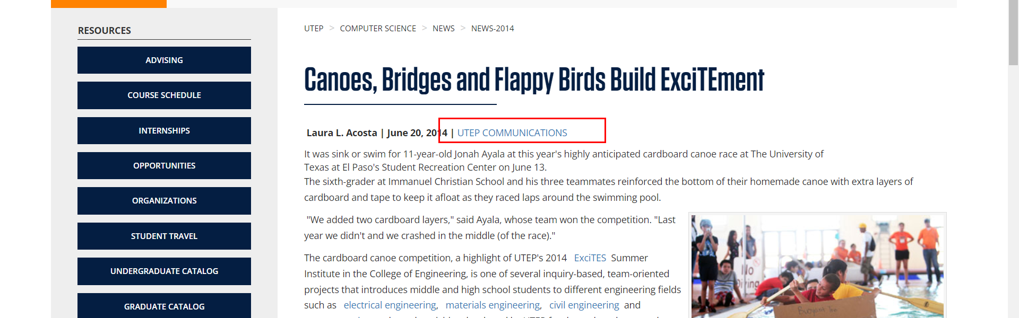

• Broken link on <https://www.utep.edu/cs/news/news-2014/congratulations-dr-ceberio221211221.html> on **Main Content (Top small navigation)** section, the broken link is displayed as: **news-2014** and the link is pointing to : <https://www.utep.edu/cs/news/news-2014/>

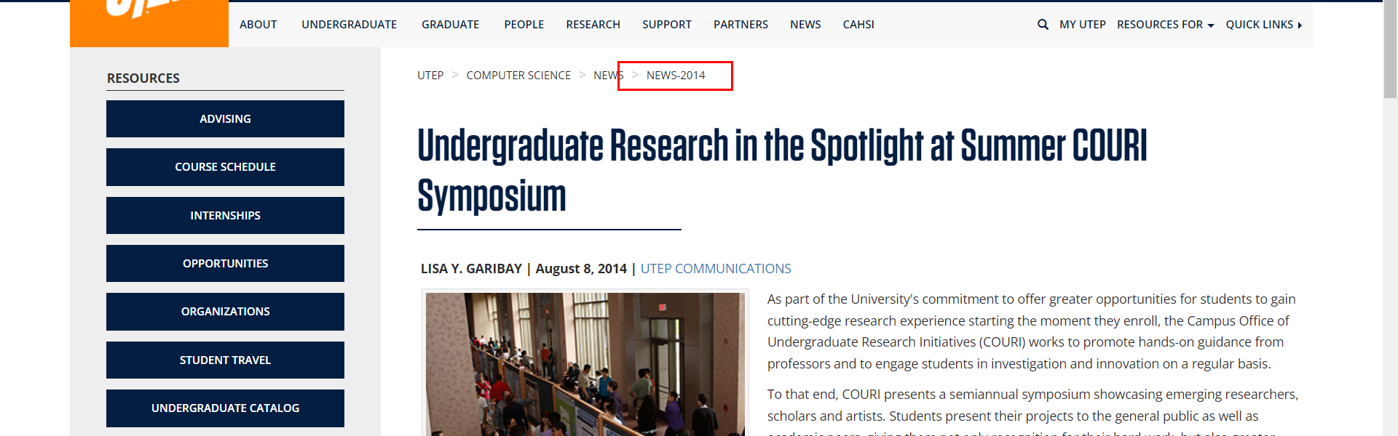

• Broken link on <https://www.utep.edu/cs/news/news-2014/congratulations-dr-ceberio221211221.html> on **Main Content** section, the broken link is displayed as: **UTEP COMMUNICATIONS** and the link is pointing to : <https://www.utep.edu/cs/news/news-2014/%E2%80%9Dhttps:/www.utep.edu/newsfeed/%E2%80%9D>



• Broken link on <https://www.utep.edu/cs/news/news-2014/congratulations-dr-ceberio2212112211.html> on **Main Content (Top small navigation)** section, the broken link is displayed as: **news-2014** and the link is pointing to : <https://www.utep.edu/cs/news/news-2014/>

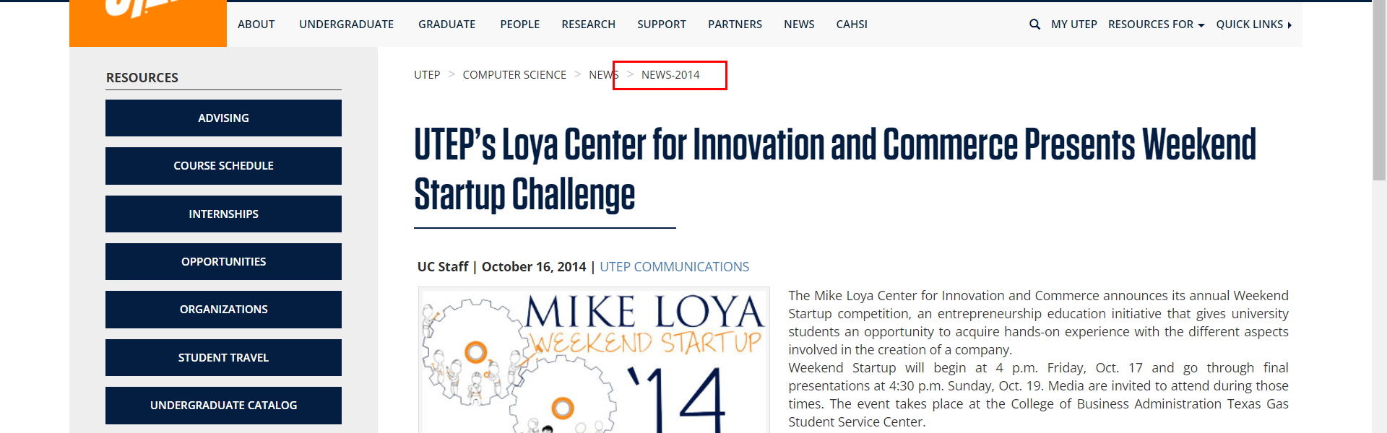

• Broken link on <https://www.utep.edu/cs/news/news-2014/congratulations-dr-ceberio2212112211.html> on **Main Content** section, the broken link is displayed as: **UTEP COMMUNICATIONS** and the link is pointing to : <https://www.utep.edu/cs/news/news-2014/%E2%80%9Dhttps:/www.utep.edu/newsfeed/%E2%80%9D>

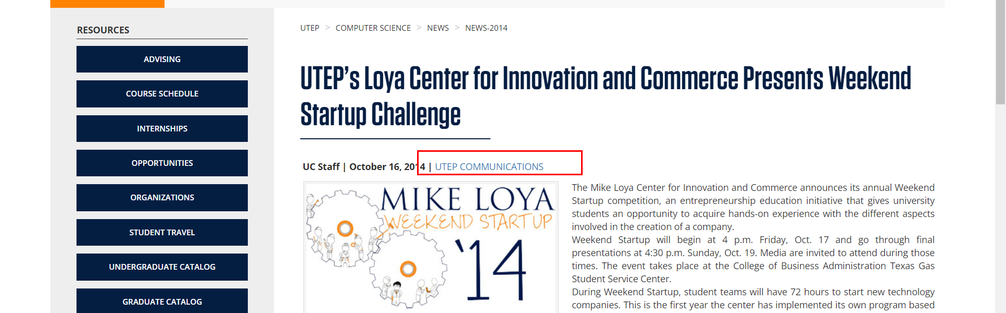

• Broken link on <https://www.utep.edu/cs/news/news-2014/congratulations-dr-ceberio22121123.html> on **Main Content (Top small navigation)** section, the broken link is displayed as: **news-2014** and the link is pointing to : <https://www.utep.edu/cs/news/news-2014/>

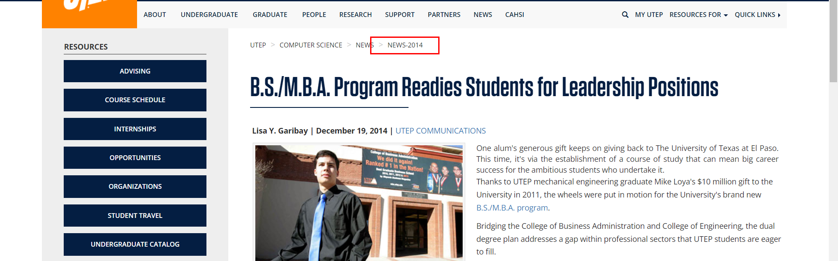

• Broken link on <https://www.utep.edu/cs/news/news-2014/congratulations-dr-ceberio22121123.html> on **Main Content** section, the broken link is displayed as: **UTEP COMMUNICATIONS** and the link is pointing to : <https://www.utep.edu/cs/news/news-2014/%E2%80%9Dhttps:/www.utep.edu/newsfeed/%E2%80%9D>



• Broken link on <https://www.utep.edu/cs/news/news-2014/congratulations-dr-ceberio221211231.html> on **Main Content (Top small navigation)** section, the broken link is displayed as: **news-2014** and the link is pointing to : <https://www.utep.edu/cs/news/news-2014/>

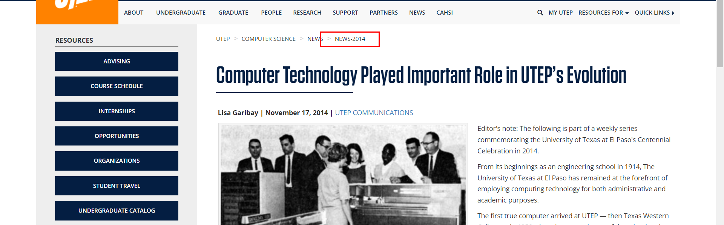

• Broken link on <https://www.utep.edu/cs/news/news-2014/congratulations-dr-ceberio221211231.html> on **Main Content** section, the broken link is displayed as: **UTEP COMMUNICATIONS** and the link is pointing to : <https://www.utep.edu/cs/news/news-2014/%E2%80%9Dhttps:/www.utep.edu/newsfeed/%E2%80%9D>

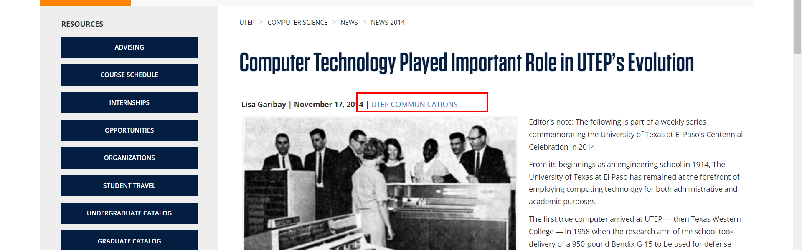

• Broken link on <https://www.utep.edu/cs/news/news-2015/computer-scientists-improve-popular-smartphone-operating-system1431.html> on **Main Content (Top small navigation)** section, the broken link is displayed as: **news-2015** and the link is pointing to : <https://www.utep.edu/cs/news/news-2015/>



• Broken link on <https://www.utep.edu/cs/news/news-2015/computer-scientists-improve-popular-smartphone-operating-system1431.html> on **Main Content** section, the broken link is displayed as: **UTEP COMMUNICATIONS** and the link is pointing to : <https://www.utep.edu/cs/news/news-2015/%E2%80%9Dhttps:/www.utep.edu/newsfeed/%E2%80%9D>



• Broken link on <https://www.utep.edu/cs/news/news-2015/computer-scientists-improve-popular-smartphone-operating-system1432.html> on **Main Content (Top small navigation)** section, the broken link is displayed as: **news-2015** and the link is pointing to : <https://www.utep.edu/cs/news/news-2015/>

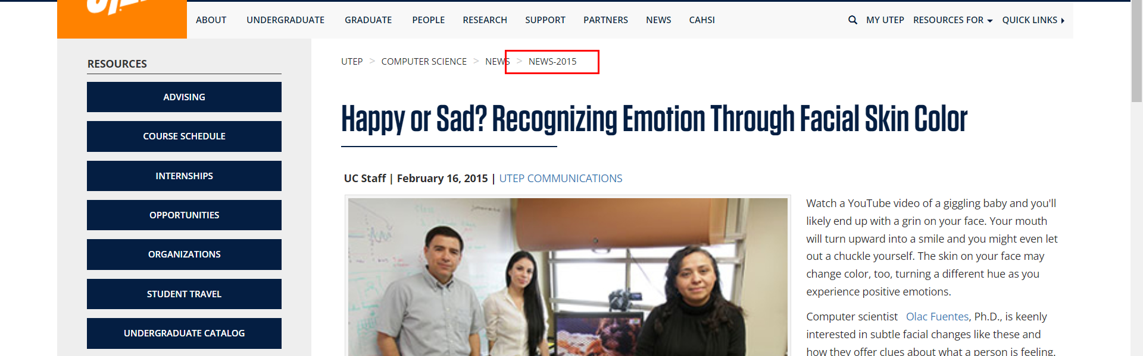

• Broken link on <https://www.utep.edu/cs/news/news-2015/computer-scientists-improve-popular-smartphone-operating-system1432.html> on **Main Content** section, the broken link is displayed as: **UTEP COMMUNICATIONS** and the link is pointing to : <https://www.utep.edu/cs/news/news-2015/%E2%80%9Dhttps:/www.utep.edu/newsfeed/%E2%80%9D>

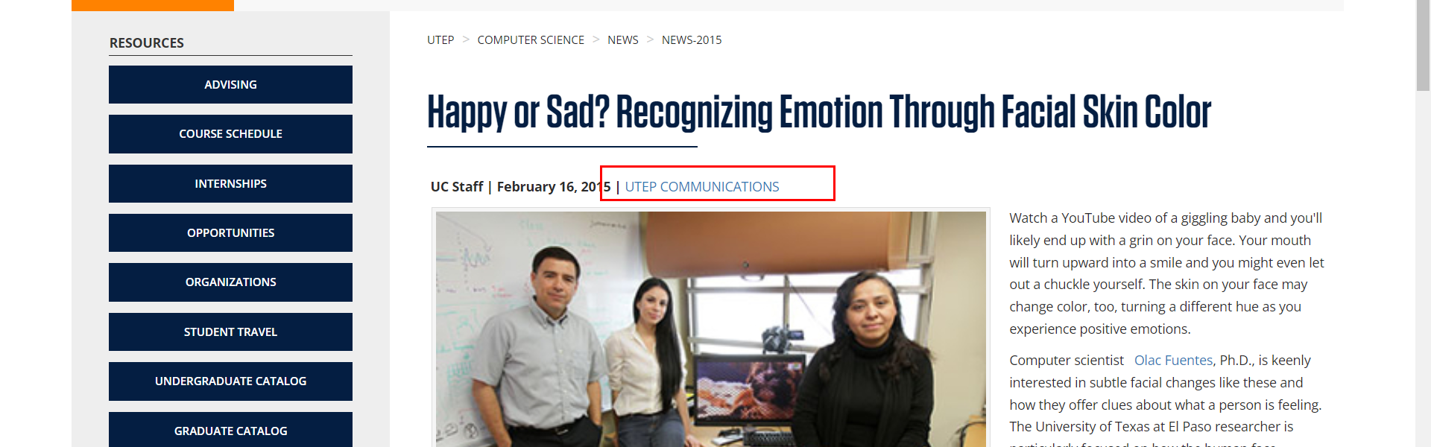

• Broken link on <https://www.utep.edu/cs/news/news-2015/congratulations-dr-ceberio2212112.html> on **Main Content (Top small navigation)** section, the broken link is displayed as: **news-2015** and the link is pointing to : <https://www.utep.edu/cs/news/news-2015/>

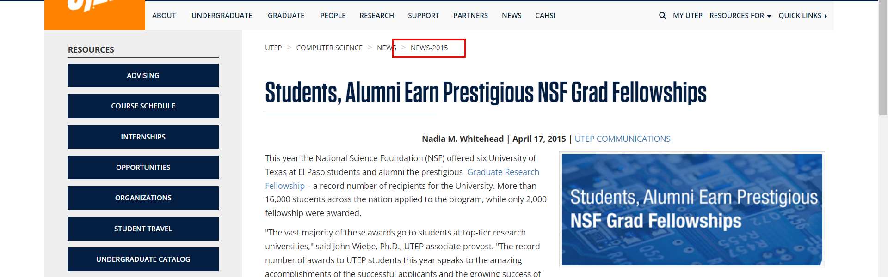

• Broken link on <https://www.utep.edu/cs/news/news-2015/congratulations-dr-ceberio2212112.html> on **Main Content** section, the broken link is displayed as: **UTEP COMMUNICATIONS** and the link is pointing to : <https://www.utep.edu/cs/news/news-2015/%E2%80%9Dhttps:/www.utep.edu/newsfeed/%E2%80%9D>



• Broken link on <https://www.utep.edu/cs/news/news-2015/congratulations-dr-ceberio22121121.html> on **Main Content (Top small navigation)** section, the broken link is displayed as: **news-2015** and the link is pointing to : <https://www.utep.edu/cs/news/news-2015/>

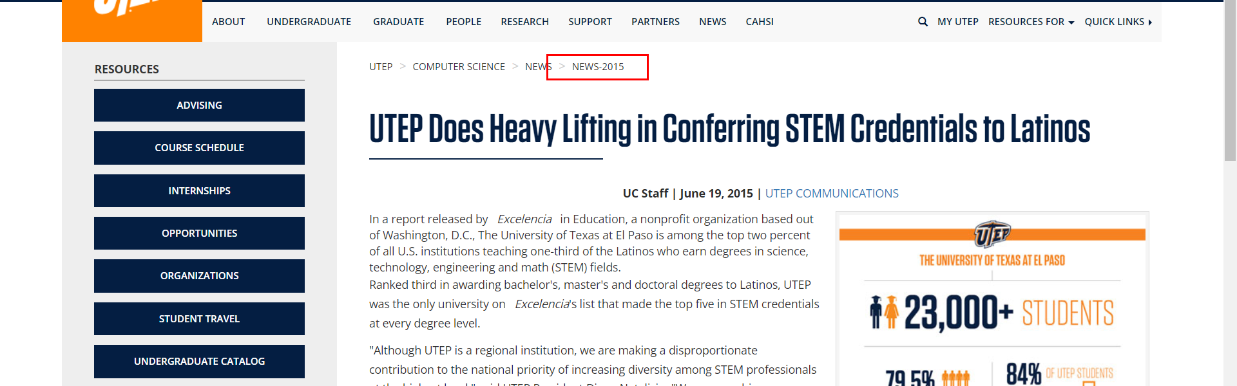

• Broken link on <https://www.utep.edu/cs/news/news-2015/congratulations-dr-ceberio22121121.html> on **Main Content** section, the broken link is displayed as: **UTEP COMMUNICATIONS** and the link is pointing to : <https://www.utep.edu/cs/news/news-2015/%E2%80%9Dhttps:/www.utep.edu/newsfeed/%E2%80%9D>

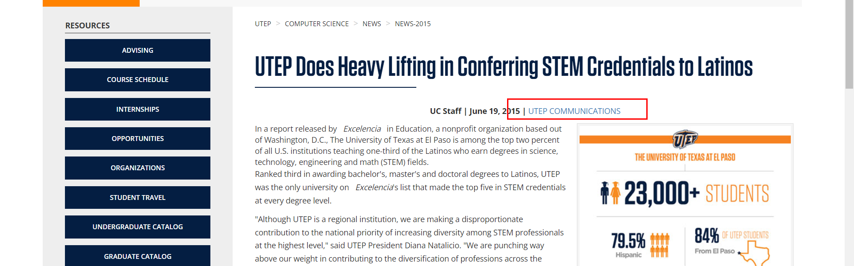

• Broken link on <https://www.utep.edu/cs/news/news-2015/congratulations-dr-ceberio221211211.html> on **Main Content (Top small navigation)** section, the broken link is displayed as: **news-2015** and the link is pointing to : <https://www.utep.edu/cs/news/news-2015/>

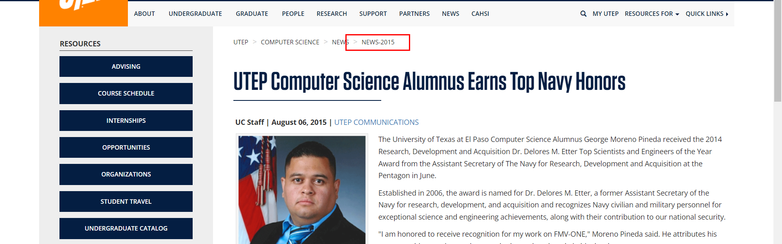

• Broken link on <https://www.utep.edu/cs/news/news-2015/congratulations-dr-ceberio221211211.html> on **Main Content** section, the broken link is displayed as: **UTEP COMMUNICATIONS** and the link is pointing to : <https://www.utep.edu/cs/news/news-2015/%E2%80%9Dhttps:/www.utep.edu/newsfeed/%E2%80%9D>



• Broken link on <https://www.utep.edu/cs/news/news-2015/congratulations-dr-ceberio2212112111.html> on **Main Content (Top small navigation)** section, the broken link is displayed as: **news-2015** and the link is pointing to : <https://www.utep.edu/cs/news/news-2015/>



• Broken link on <https://www.utep.edu/cs/news/news-2015/congratulations-dr-ceberio2212112111.html> on **Main Content** section, the broken link is displayed as: **UTEP COMMUNICATIONS** and the link is pointing to : <https://www.utep.edu/cs/news/news-2015/%E2%80%9Dhttps:/www.utep.edu/newsfeed/%E2%80%9D>



• Broken link on <https://www.utep.edu/cs/news/news-2015/congratulations-dr-ceberio22121121111.html> on **Main Content (Top small navigation)** section, the broken link is displayed as: **news-2015** and the link is pointing to : <https://www.utep.edu/cs/news/news-2015/>

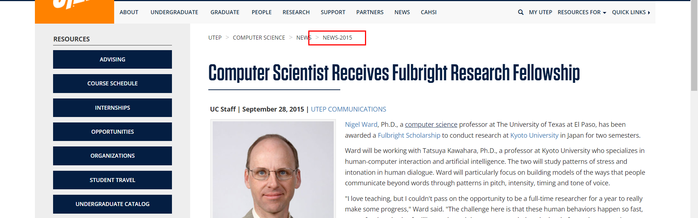

• Broken link on <https://www.utep.edu/cs/news/news-2015/congratulations-dr-ceberio22121121111.html> on **Main Content** section, the broken link is displayed as: **UTEP COMMUNICATIONS** and the link is pointing to : <https://www.utep.edu/cs/news/news-2015/%E2%80%9Dhttps:/www.utep.edu/newsfeed/%E2%80%9D>



• Broken link on <https://www.utep.edu/cs/news/news-2015/congratulations-dr-ceberio2212112112.html> on **Main Content (Top small navigation)** section, the broken link is displayed as: **news-2015** and the link is pointing to : <https://www.utep.edu/cs/news/news-2015/>

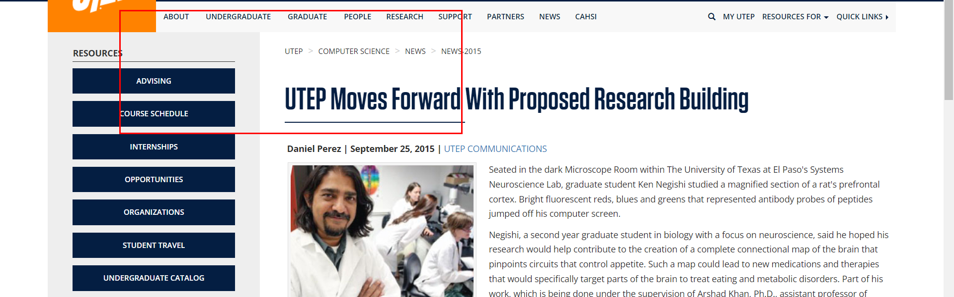

• Broken link on <https://www.utep.edu/cs/news/news-2015/congratulations-dr-ceberio2212112112.html> on **Main Content** section, the broken link is displayed as: **UTEP COMMUNICATIONS** and the link is pointing to : <https://www.utep.edu/cs/news/news-2015/%E2%80%9Dhttps:/www.utep.edu/newsfeed/%E2%80%9D>

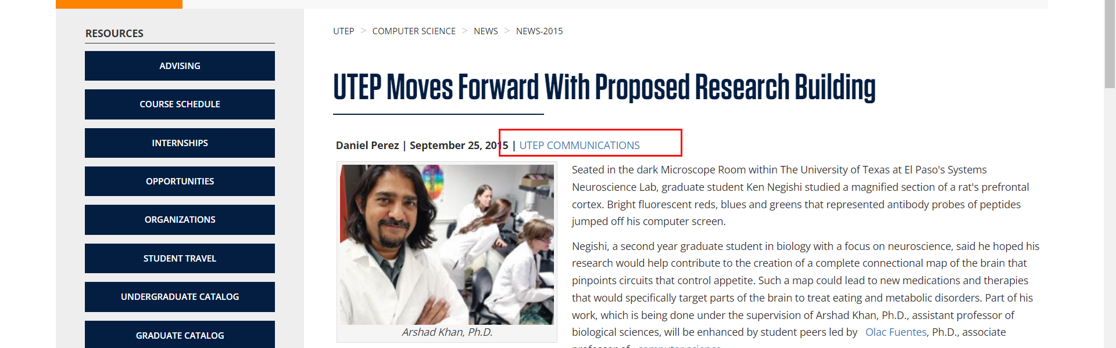

• Broken link on <https://www.utep.edu/cs/news/news-2015/congratulations-dr-ceberio2212112113.html> on **Main Content (Top small navigation)** section, the broken link is displayed as: **news-2015** and the link is pointing to : <https://www.utep.edu/cs/news/news-2015/>

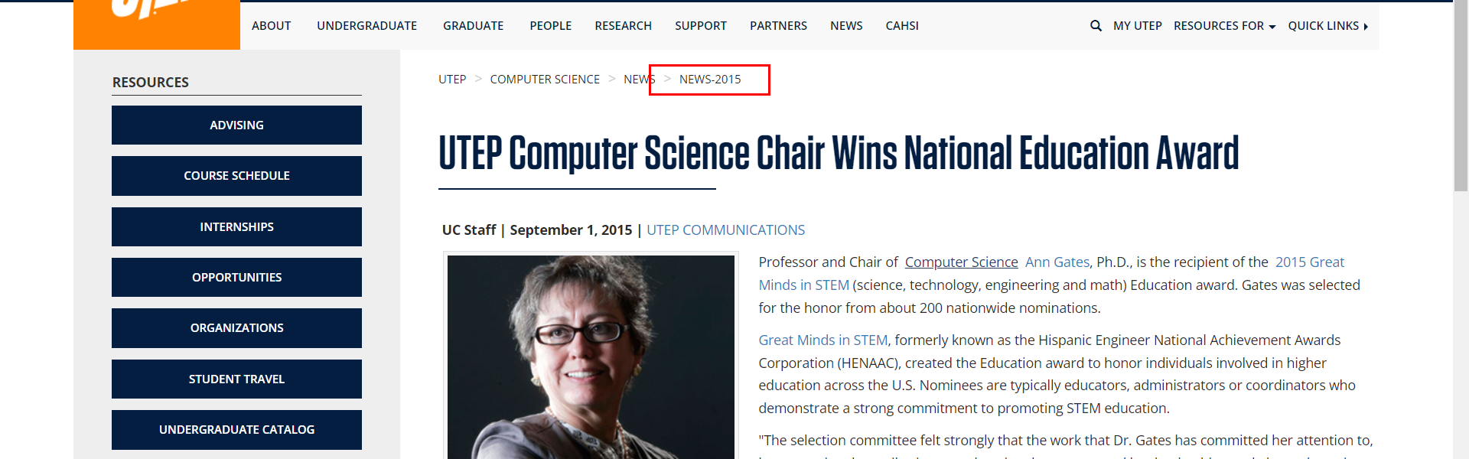

• Broken link on <https://www.utep.edu/cs/news/news-2015/congratulations-dr-ceberio2212112113.html> on **Main Content** section, the broken link is displayed as: **UTEP COMMUNICATIONS** and the link is pointing to : <https://www.utep.edu/cs/news/news-2015/%E2%80%9Dhttps:/www.utep.edu/newsfeed/%E2%80%9D>



• Broken link on <https://www.utep.edu/cs/news/news-2015/congratulations-dr-ceberio2212112113.html> on **Main Content** section, the broken link is displayed as: **27th Annual HENAAC Conference** and the link is pointing to : [http://www.greatmindsinstem.org/conference/conference-home](https://greatmindsinstem.org/conference/conference-home)

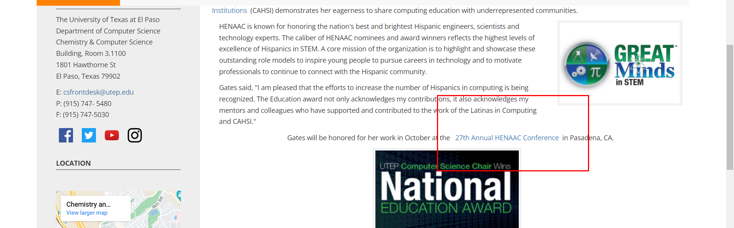

• Broken link on <https://www.utep.edu/cs/news/news-2015/congratulations-dr-ceberio2212112113.html> on **Main Content** section, the broken link is displayed as: **Great Minds in STEM** and the link is pointing to : [http://www.greatmindsinstem.org/index.htm](https://greatmindsinstem.org/index.htm)



• Broken link on <https://www.utep.edu/cs/news/news-2015/congratulations-dr-ceberio2212112113.html> on **Main Content** section, the broken link is displayed as: **2015 Great Minds in STEM** and the link is pointing to : [http://www.greatmindsinstem.org/professionals/award-winners-2015.html](https://greatmindsinstem.org/professionals/award-winners-2015.html)

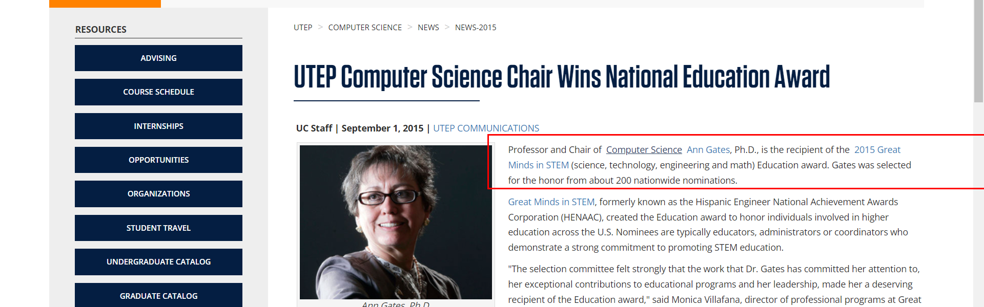

• Broken link on <https://www.utep.edu/cs/news/news-2016/congratulations-dr-ceberio2212112111.html> on **Main Content (Top small navigation)** section, the broken link is displayed as: **news-2016** and the link is pointing to : <https://www.utep.edu/cs/news/news-2016/>

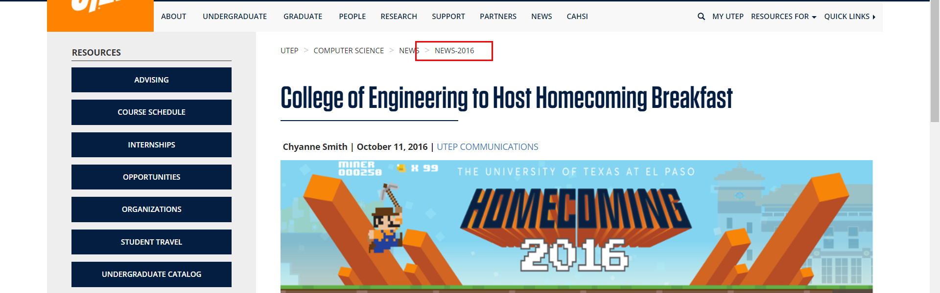

• Broken link on <https://www.utep.edu/cs/news/news-2016/congratulations-dr-ceberio2212112111.html> on **Main Content** section, the broken link is displayed as: **UTEP COMMUNICATIONS** and the link is pointing to : <https://www.utep.edu/cs/news/news-2016/%E2%80%9Dhttps:/www.utep.edu/newsfeed/%E2%80%9D>



• Broken link on <https://www.utep.edu/cs/news/news-2016/congratulations-dr-ceberio2212112112.html> on **Main Content (Top small navigation)** section, the broken link is displayed as: **news-2016** and the link is pointing to : <https://www.utep.edu/cs/news/news-2016/>



• Broken link on <https://www.utep.edu/cs/news/news-2016/congratulations-dr-ceberio2212112112.html> on **Main Content** section, the broken link is displayed as: **UTEP COMMUNICATIONS** and the link is pointing to : <https://www.utep.edu/cs/news/news-2016/%E2%80%9Dhttps:/www.utep.edu/newsfeed/%E2%80%9D>



• Broken link on <https://www.utep.edu/cs/news/news-2016/congratulations-dr-ceberio22121122.html> on **Main Content (Top small navigation)** section, the broken link is displayed as: **news-2016** and the link is pointing to : <https://www.utep.edu/cs/news/news-2016/>

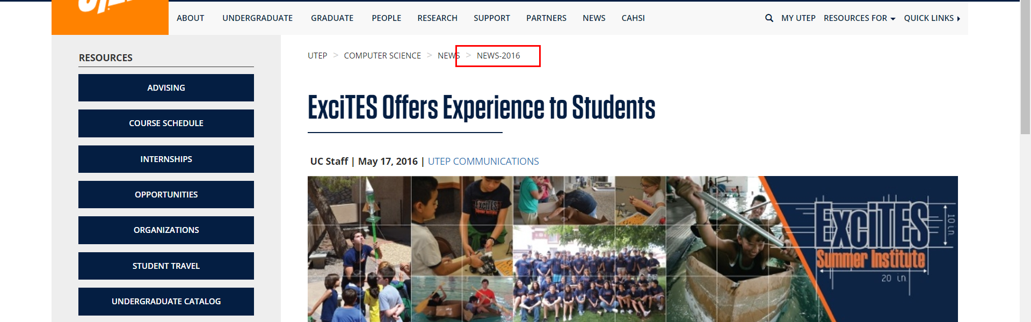

• Broken link on <https://www.utep.edu/cs/news/news-2016/congratulations-dr-ceberio22121122.html> on **Main Content** section, the broken link is displayed as: **UTEP COMMUNICATIONS** and the link is pointing to : <https://www.utep.edu/cs/news/news-2016/%E2%80%9Dhttps:/www.utep.edu/newsfeed/%E2%80%9D>



• Broken link on <https://www.utep.edu/cs/news/news-2016/congratulations-dr-ceberio22121123.html> on **Main Content (Top small navigation)** section, the broken link is displayed as: **news-2016** and the link is pointing to : <https://www.utep.edu/cs/news/news-2016/>

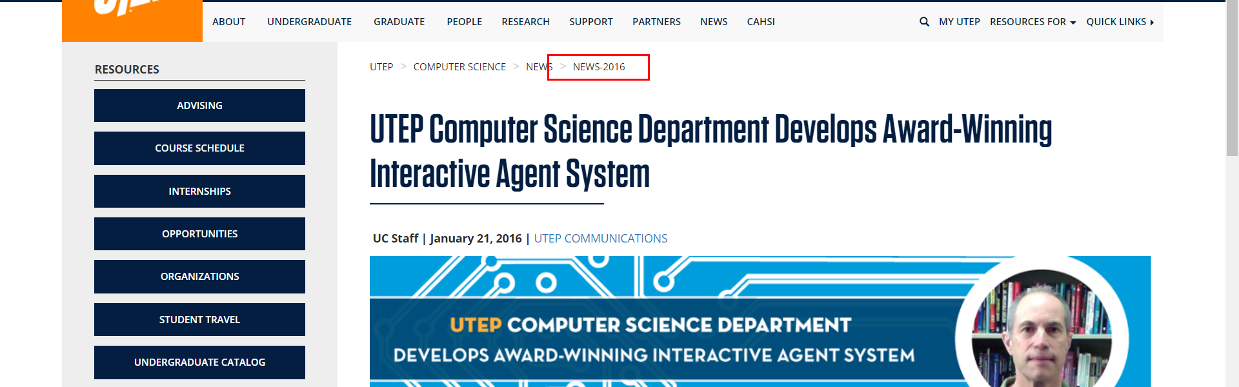

• Broken link on <https://www.utep.edu/cs/news/news-2016/congratulations-dr-ceberio22121123.html> on **Main Content** section, the broken link is displayed as: **UTEP COMMUNICATIONS** and the link is pointing to : <https://www.utep.edu/cs/news/news-2016/%E2%80%9Dhttps:/www.utep.edu/newsfeed/%E2%80%9D>

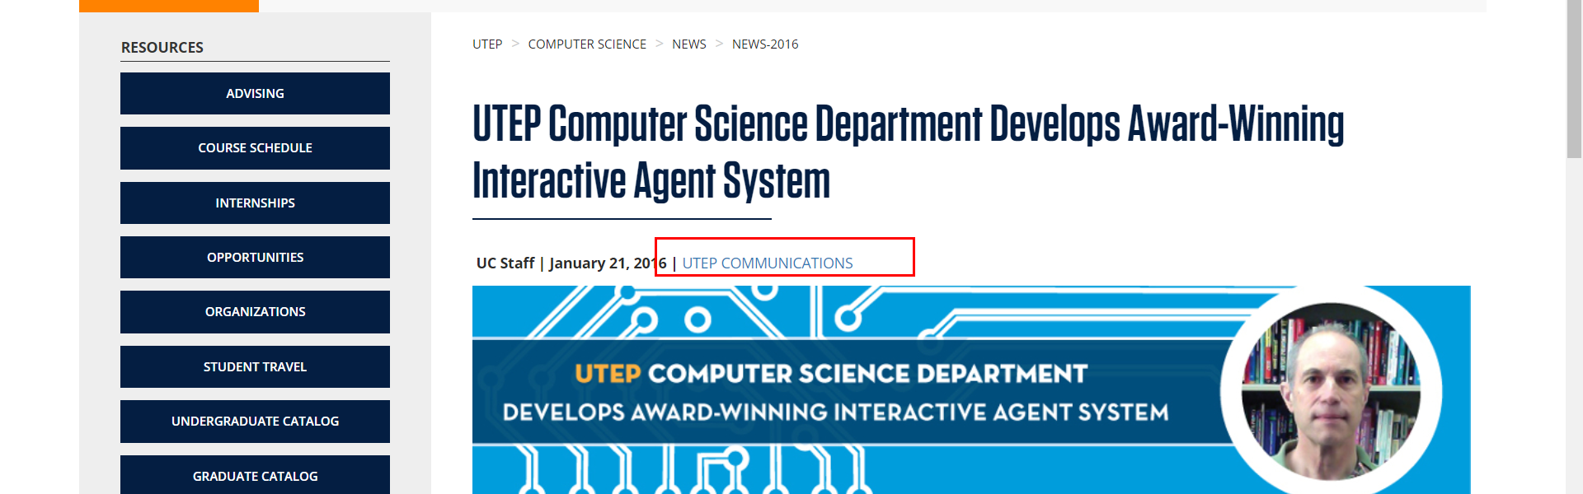

• Broken link on <https://www.utep.edu/cs/news/news-2017/congratulations-dr-ceberio2212112.html> on **Main Content (Top small navigation)** section, the broken link is displayed as: **news-2017** and the link is pointing to : <https://www.utep.edu/cs/news/news-2017/>

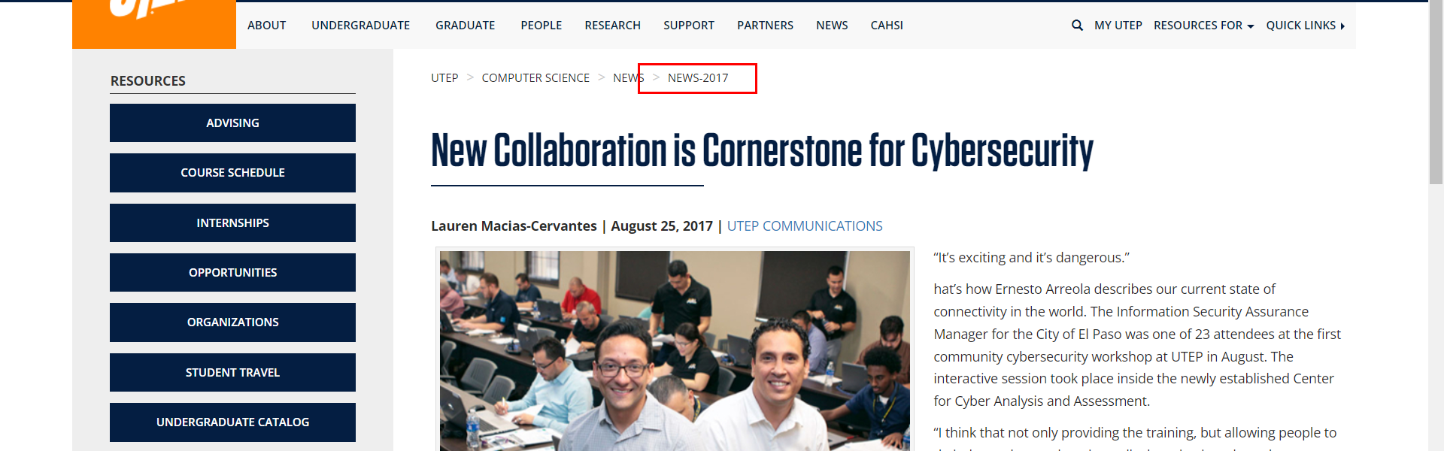

• Broken link on <https://www.utep.edu/cs/news/news-2017/congratulations-dr-ceberio2212112.html> on **Main Content** section, the broken link is displayed as: **UTEP COMMUNICATIONS** and the link is pointing to : <https://www.utep.edu/cs/news/news-2017/%E2%80%9Dhttps:/www.utep.edu/newsfeed/%E2%80%9D>

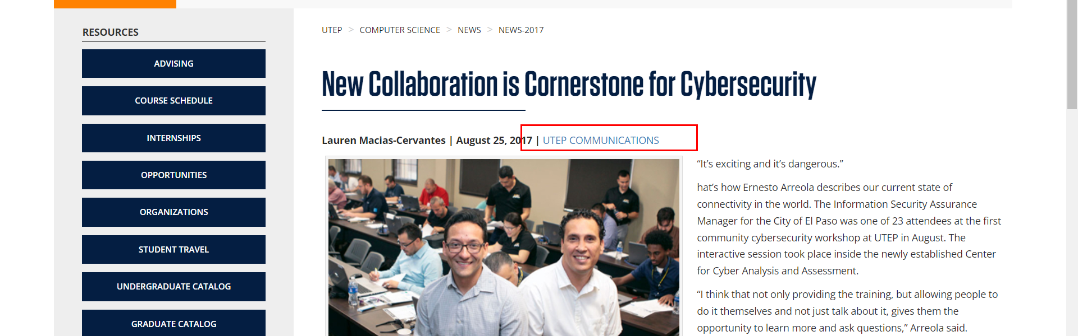

• Broken link on <https://www.utep.edu/cs/news/news-2017/congratulations-dr-ceberio22121121.html> on **Main Content (Top small navigation)** section, the broken link is displayed as: **news-2017** and the link is pointing to : <https://www.utep.edu/cs/news/news-2017/>

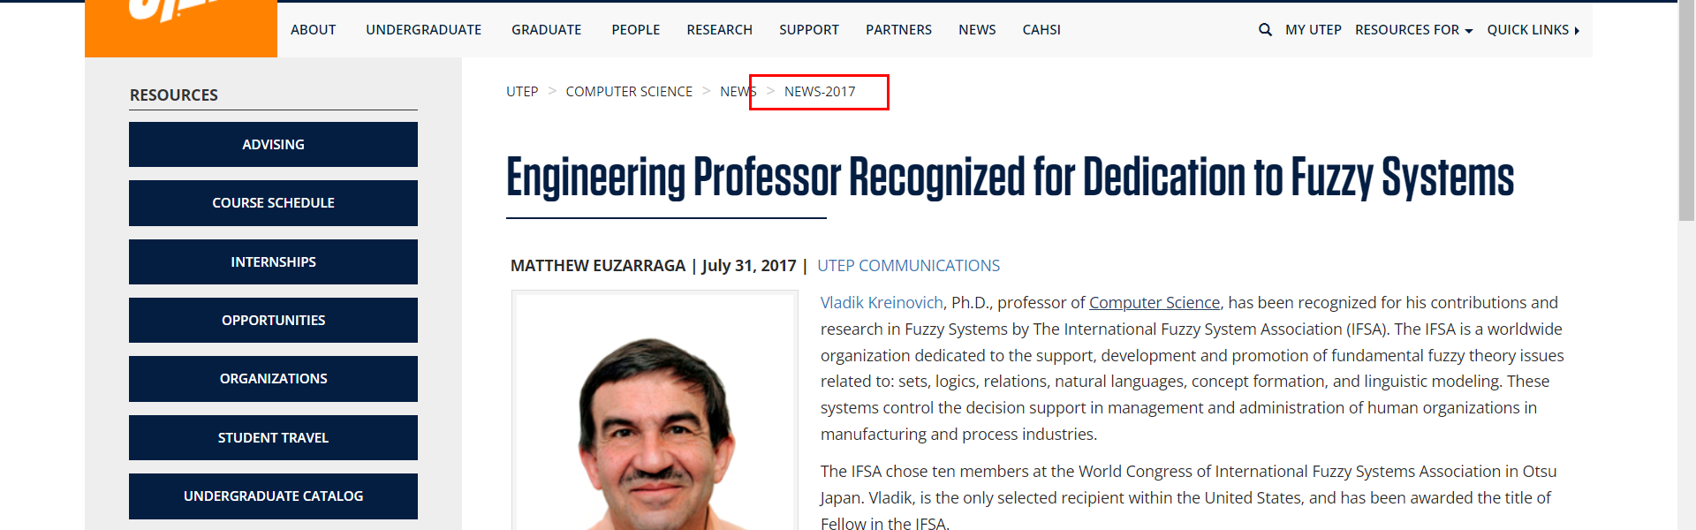

• Broken link on <https://www.utep.edu/cs/news/news-2017/congratulations-dr-ceberio22121121.html> on **Main Content** section, the broken link is displayed as: **UTEP COMMUNICATIONS** and the link is pointing to : <https://www.utep.edu/cs/news/news-2017/%E2%80%9Dhttps:/www.utep.edu/newsfeed/%E2%80%9D>

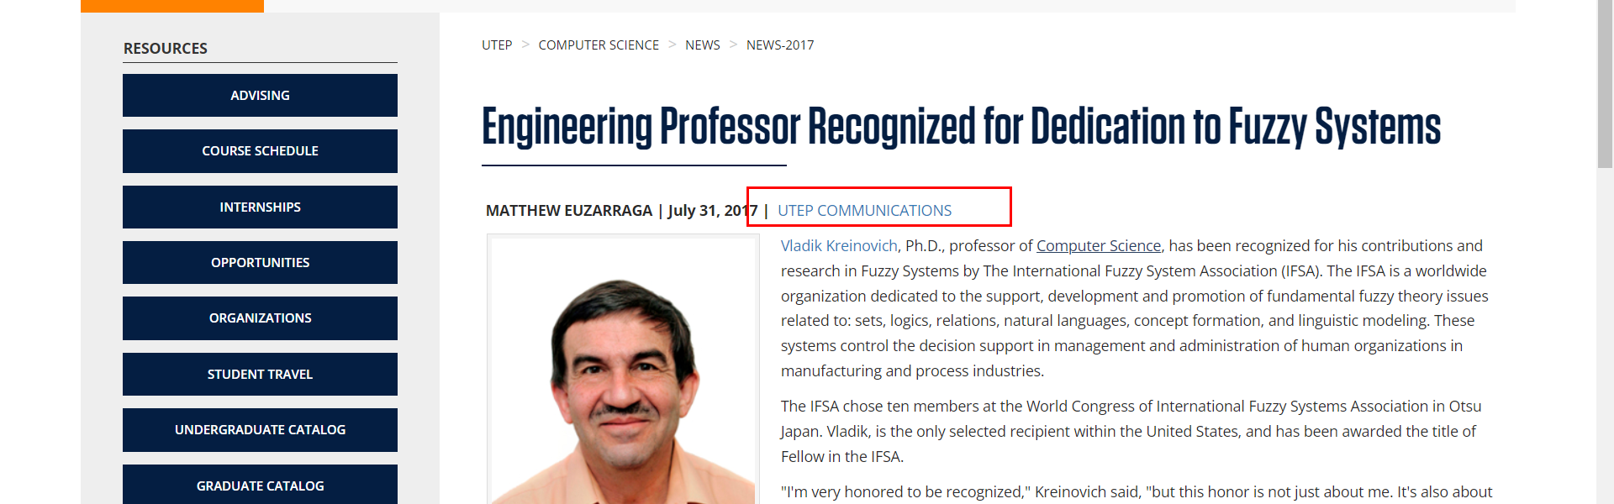

• Broken link on <https://www.utep.edu/cs/news/news-2017/congratulations-dr-ceberio221211211.html> on **Main Content (Top small navigation)** section, the broken link is displayed as: **news-2017** and the link is pointing to : <https://www.utep.edu/cs/news/news-2017/>

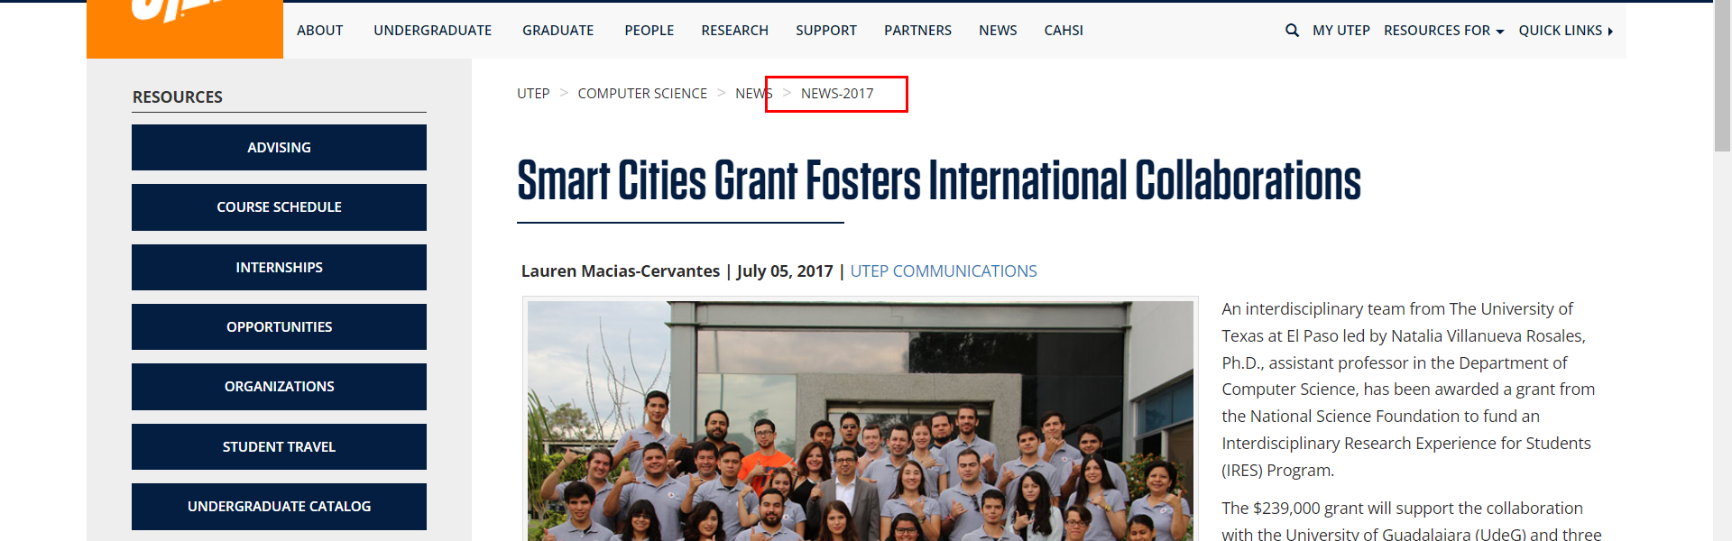

• Broken link on <https://www.utep.edu/cs/news/news-2017/congratulations-dr-ceberio221211211.html> on **Main Content** section, the broken link is displayed as: **UTEP COMMUNICATIONS** and the link is pointing to : <https://www.utep.edu/cs/news/news-2017/%E2%80%9Dhttps:/www.utep.edu/newsfeed/%E2%80%9D>

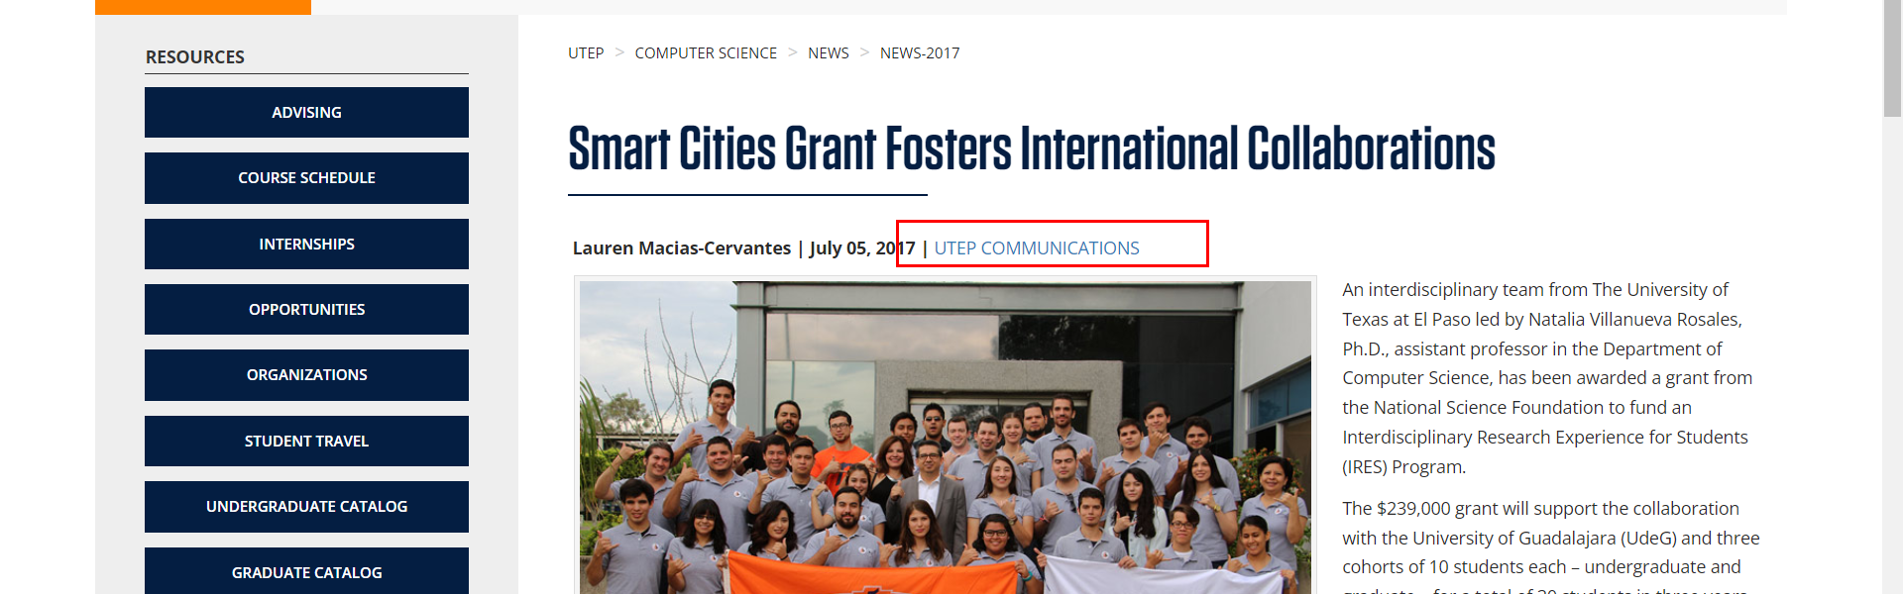

• Broken link on <https://www.utep.edu/cs/news/news-2017/congratulations-dr-ceberio2212112111.html> on **Main Content (Top small navigation)** section, the broken link is displayed as: **news-2017** and the link is pointing to : <https://www.utep.edu/cs/news/news-2017/>

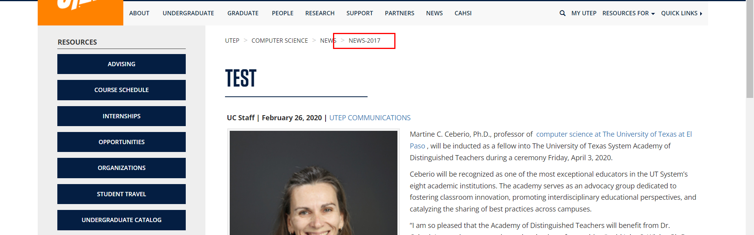

• Broken link on <https://www.utep.edu/cs/news/news-2017/congratulations-dr-ceberio2212112111.html> on **Main Content** section, the broken link is displayed as: **UTEP COMMUNICATIONS** and the link is pointing to : <https://www.utep.edu/cs/news/news-2017/%E2%80%9Dhttps:/www.utep.edu/newsfeed/%E2%80%9D>

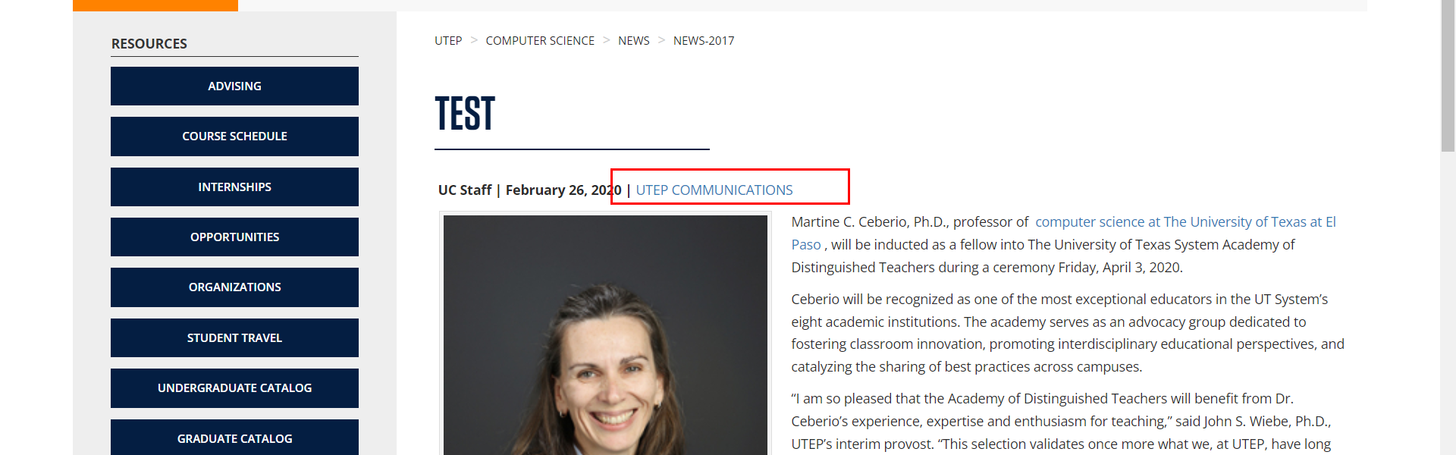

• Broken link on <https://www.utep.edu/cs/news/news-2017/congratulations-dr-ceberio221211212.html> on **Main Content (Top small navigation)** section, the broken link is displayed as: **news-2017** and the link is pointing to : <https://www.utep.edu/cs/news/news-2017/>

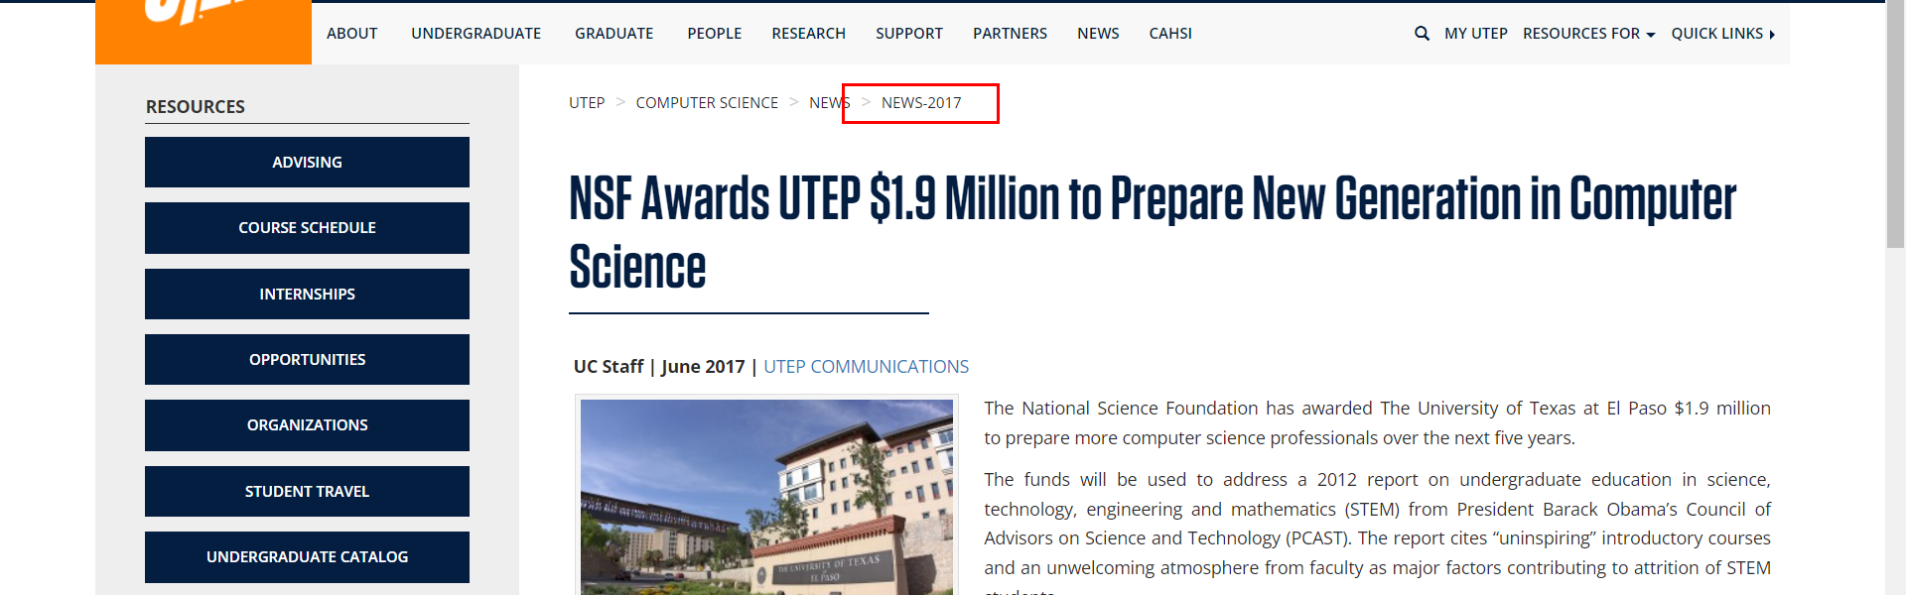

• Broken link on <https://www.utep.edu/cs/news/news-2017/congratulations-dr-ceberio221211212.html> on **Main Content** section, the broken link is displayed as: **UTEP COMMUNICATIONS** and the link is pointing to : <https://www.utep.edu/cs/news/news-2017/%E2%80%9Dhttps:/www.utep.edu/newsfeed/%E2%80%9D>

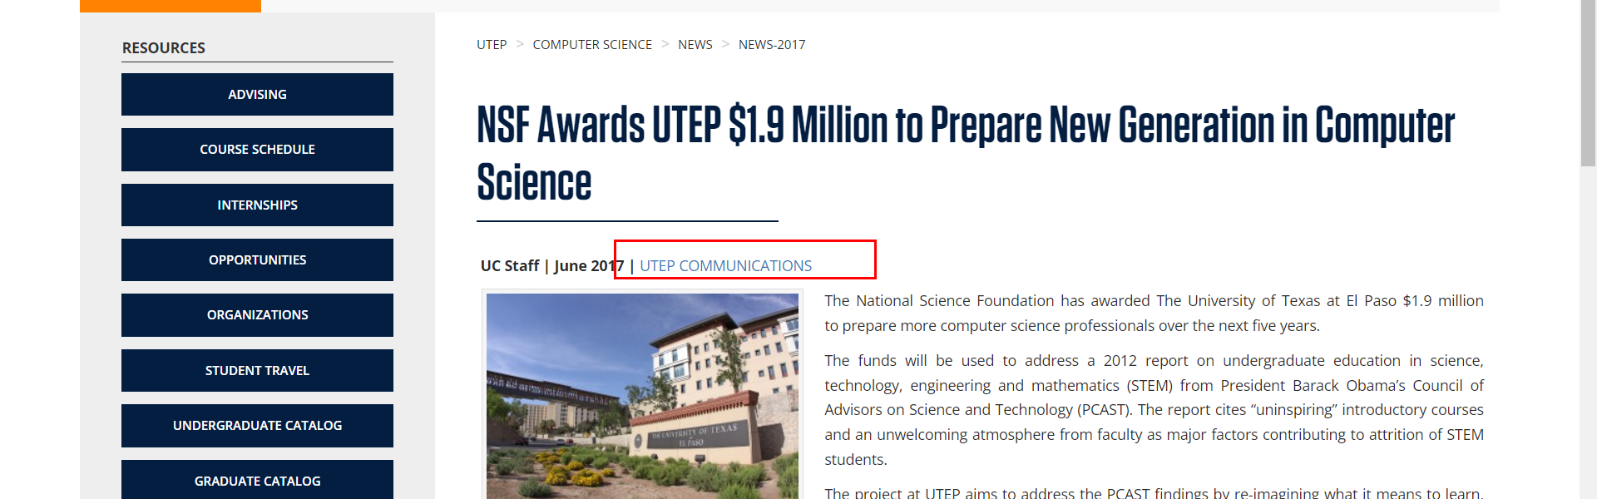

• Broken link on <https://www.utep.edu/cs/news/news-2017/congratulations-dr-ceberio22121122.html> on **Main Content (Top small navigation)** section, the broken link is displayed as: **news-2017** and the link is pointing to : <https://www.utep.edu/cs/news/news-2017/>

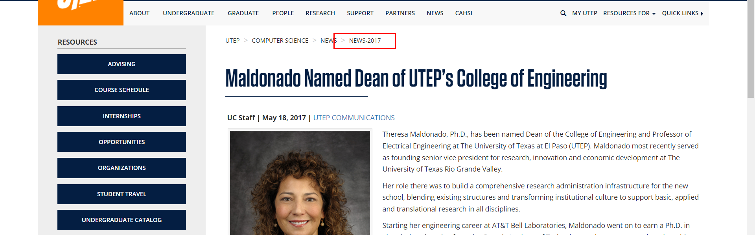

• Broken link on <https://www.utep.edu/cs/news/news-2017/congratulations-dr-ceberio22121122.html> on **Main Content** section, the broken link is displayed as: **UTEP COMMUNICATIONS** and the link is pointing to : <https://www.utep.edu/cs/news/news-2017/%E2%80%9Dhttps:/www.utep.edu/newsfeed/%E2%80%9D>



• Broken link on <https://www.utep.edu/cs/news/news-2017/congratulations-dr-ceberio221211221.html> on **Main Content (Top small navigation)** section, the broken link is displayed as: **news-2017** and the link is pointing to : <https://www.utep.edu/cs/news/news-2017/>

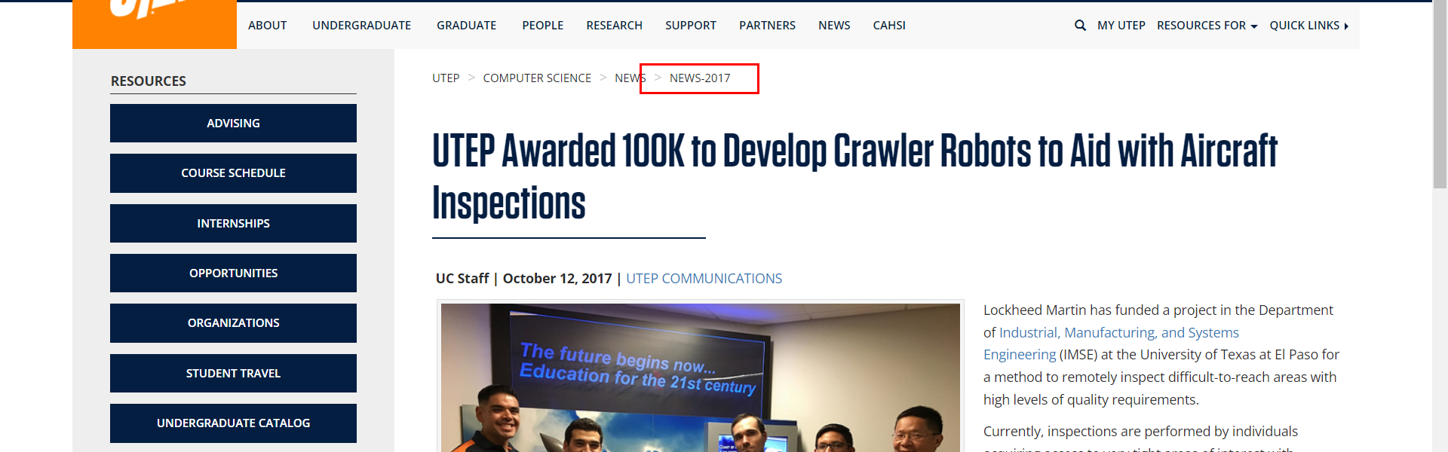

• Broken link on <https://www.utep.edu/cs/news/news-2017/congratulations-dr-ceberio221211221.html> on **Main Content** section, the broken link is displayed as: **UTEP COMMUNICATIONS** and the link is pointing to : <https://www.utep.edu/cs/news/news-2017/%E2%80%9Dhttps:/www.utep.edu/newsfeed/%E2%80%9D>



• Broken link on <https://www.utep.edu/cs/news/news-2017/congratulations-dr-ceberio22121123.html> on **Main Content (Top small navigation)** section, the broken link is displayed as: **news-2017** and the link is pointing to : <https://www.utep.edu/cs/news/news-2017/>

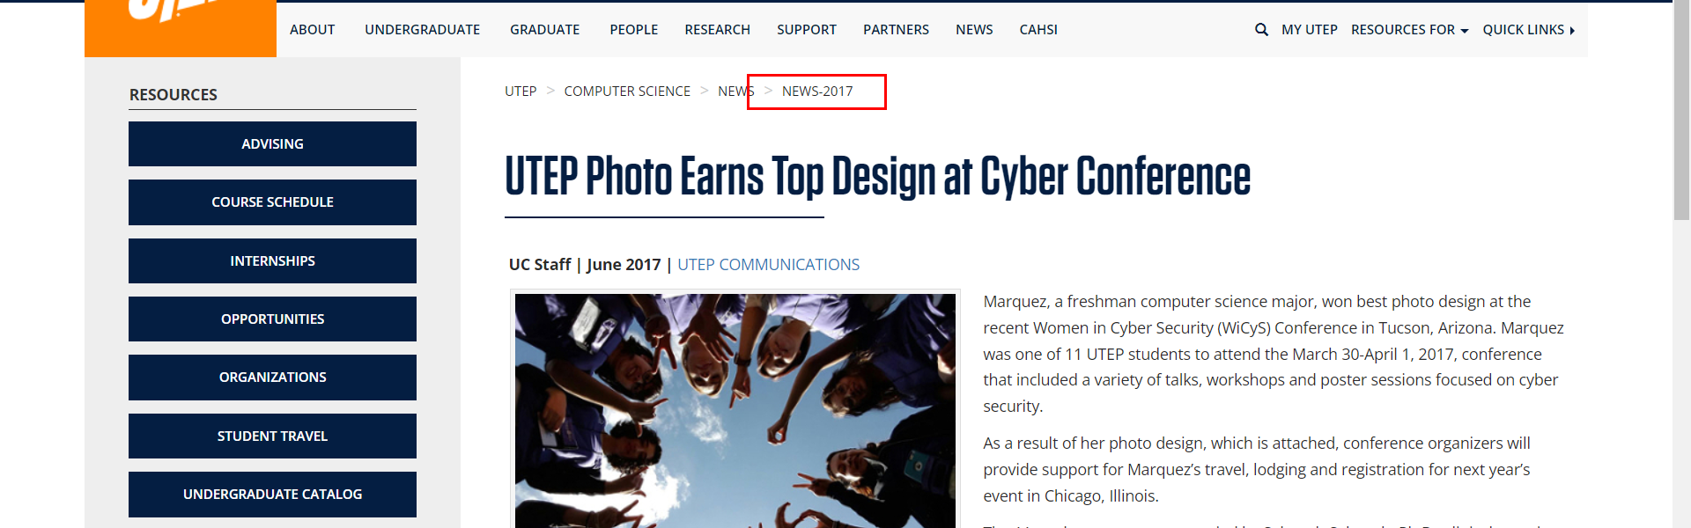

• Broken link on <https://www.utep.edu/cs/news/news-2017/congratulations-dr-ceberio22121123.html> on **Main Content** section, the broken link is displayed as: **UTEP COMMUNICATIONS** and the link is pointing to : <https://www.utep.edu/cs/news/news-2017/%E2%80%9Dhttps:/www.utep.edu/newsfeed/%E2%80%9D>



• Broken link on <https://www.utep.edu/cs/news/news-2017/congratulations-dr-ceberio221211231.html> on **Main Content (Top small navigation)** section, the broken link is displayed as: **news-2017** and the link is pointing to : <https://www.utep.edu/cs/news/news-2017/>

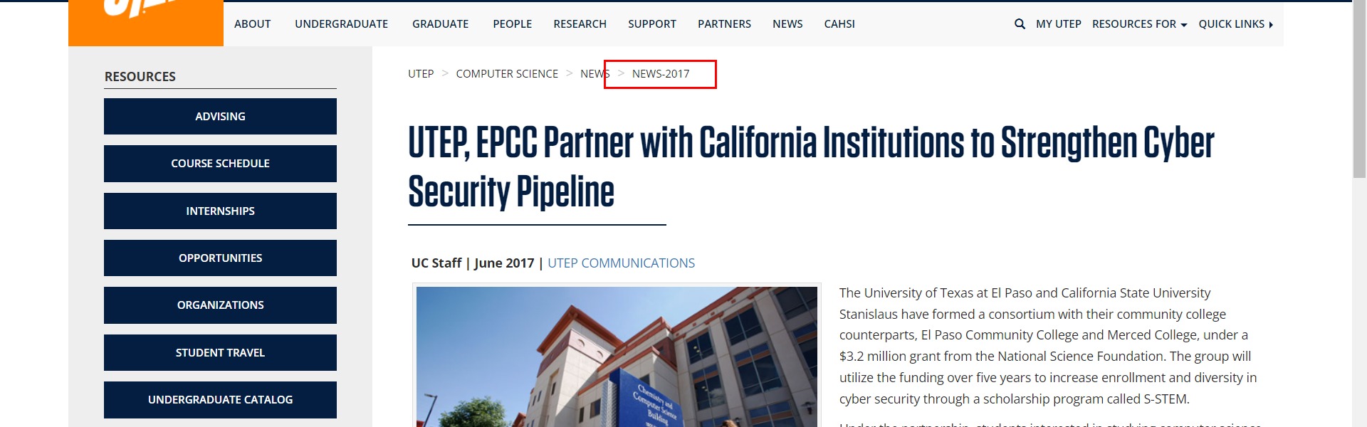

• Broken link on <https://www.utep.edu/cs/news/news-2017/congratulations-dr-ceberio221211231.html> on **Main Content** section, the broken link is displayed as: **UTEP COMMUNICATIONS** and the link is pointing to : <https://www.utep.edu/cs/news/news-2017/%E2%80%9Dhttps:/www.utep.edu/newsfeed/%E2%80%9D>



• Broken link on <https://www.utep.edu/cs/news/news-2018/congratulations-dr-ceberio2212112.html> on **Main Content (Top small navigation)** section, the broken link is displayed as: **news-2018** and the link is pointing to : <https://www.utep.edu/cs/news/news-2018/>

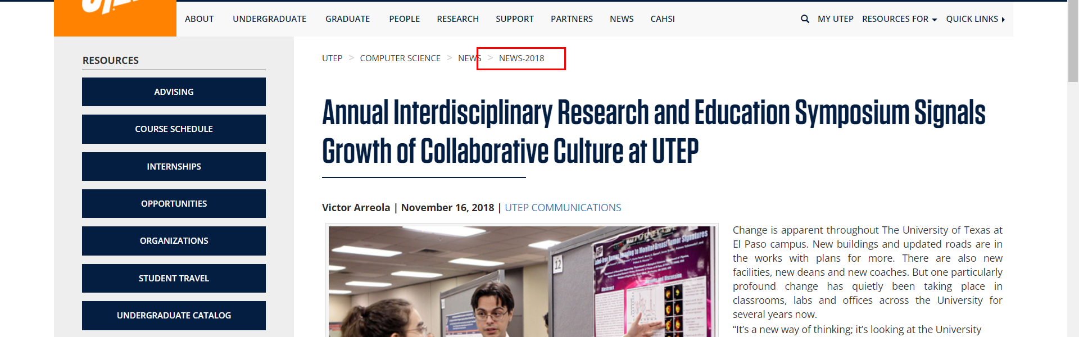

• Broken link on <https://www.utep.edu/cs/news/news-2018/congratulations-dr-ceberio2212112.html> on **Main Content** section, the broken link is displayed as: **UTEP COMMUNICATIONS** and the link is pointing to : <https://www.utep.edu/cs/news/news-2018/%E2%80%9Dhttps:/www.utep.edu/newsfeed/%E2%80%9D>



• Broken link on <https://www.utep.edu/cs/news/news-2018/congratulations-dr-ceberio22121121.html> on **Main Content (Top small navigation)** section, the broken link is displayed as: **news-2018** and the link is pointing to : <https://www.utep.edu/cs/news/news-2018/>

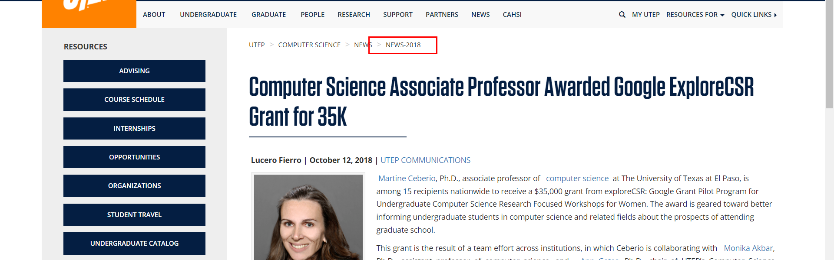

• Broken link on <https://www.utep.edu/cs/news/news-2018/congratulations-dr-ceberio22121121.html> on **Main Content** section, the broken link is displayed as: **UTEP COMMUNICATIONS** and the link is pointing to : <https://www.utep.edu/cs/news/news-2018/%E2%80%9Dhttps:/www.utep.edu/newsfeed/%E2%80%9D>



• Broken link on <https://www.utep.edu/cs/news/news-2018/congratulations-dr-ceberio221211211.html> on **Main Content (Top small navigation)** section, the broken link is displayed as: **news-2018** and the link is pointing to : <https://www.utep.edu/cs/news/news-2018/>

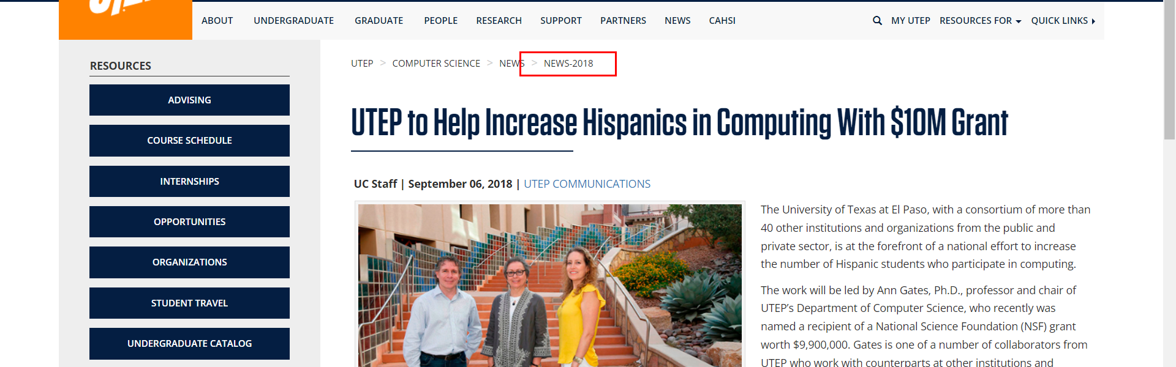

• Broken link on <https://www.utep.edu/cs/news/news-2018/congratulations-dr-ceberio221211211.html> on **Main Content** section, the broken link is displayed as: **UTEP COMMUNICATIONS** and the link is pointing to : <https://www.utep.edu/cs/news/news-2018/%E2%80%9Dhttps:/www.utep.edu/newsfeed/%E2%80%9D>



• Broken link on <https://www.utep.edu/cs/news/news-2018/congratulations-dr-ceberio221211212.html> on **Main Content (Top small navigation)** section, the broken link is displayed as: **news-2018** and the link is pointing to : <https://www.utep.edu/cs/news/news-2018/>

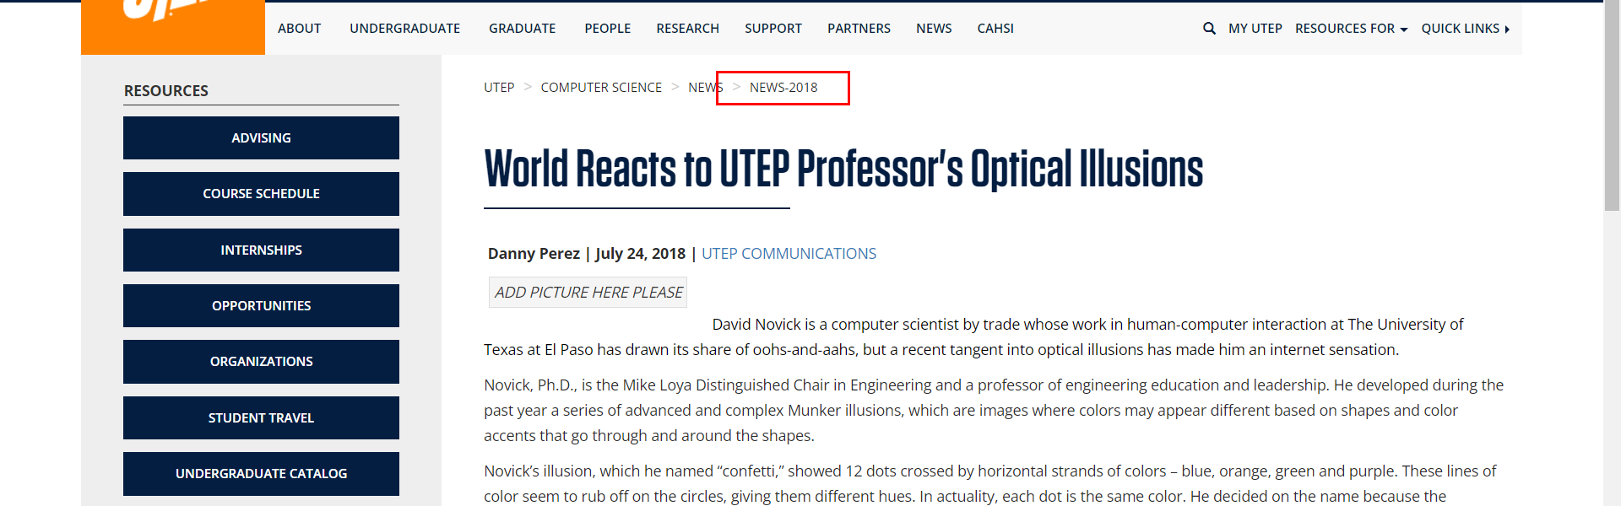

• Broken link on <https://www.utep.edu/cs/news/news-2018/congratulations-dr-ceberio221211212.html> on **Main Content** section, the broken link is displayed as: **UTEP COMMUNICATIONS** and the link is pointing to : <https://www.utep.edu/cs/news/news-2018/%E2%80%9Dhttps:/www.utep.edu/newsfeed/%E2%80%9D>

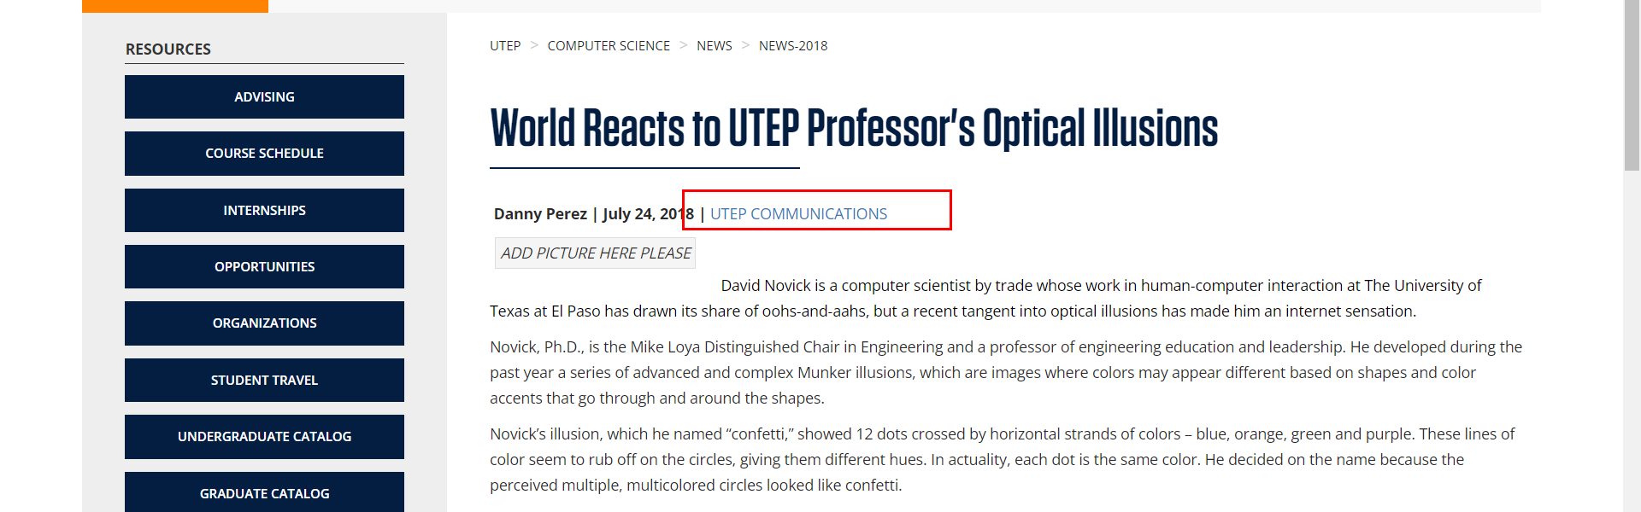

• Broken link on <https://www.utep.edu/cs/news/news-2018/congratulations-dr-ceberio22121122.html> on **Main Content (Top small navigation)** section, the broken link is displayed as: **news-2018** and the link is pointing to : <https://www.utep.edu/cs/news/news-2018/>

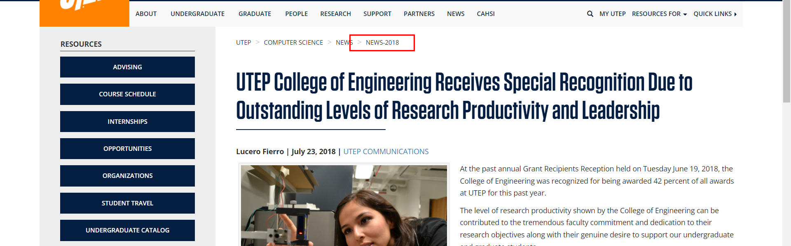

• Broken link on <https://www.utep.edu/cs/news/news-2018/congratulations-dr-ceberio22121122.html> on **Main Content** section, the broken link is displayed as: **UTEP COMMUNICATIONS** and the link is pointing to : <https://www.utep.edu/cs/news/news-2018/%E2%80%9Dhttps:/www.utep.edu/newsfeed/%E2%80%9D>



• Broken link on <https://www.utep.edu/cs/news/news-2018/congratulations-dr-ceberio22121122.html> on **Main Content** section, the broken link is displayed as: **CASSMAR** and the link is pointing to : <http://www.cassmar.com/>

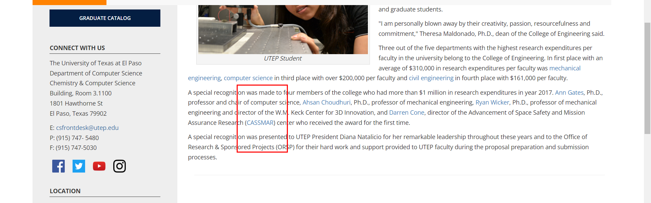

• Broken link on <https://www.utep.edu/cs/news/news-2018/congratulations-dr-ceberio221211221.html> on **Main Content (Top small navigation)** section, the broken link is displayed as: **news-2018** and the link is pointing to : <https://www.utep.edu/cs/news/news-2018/>

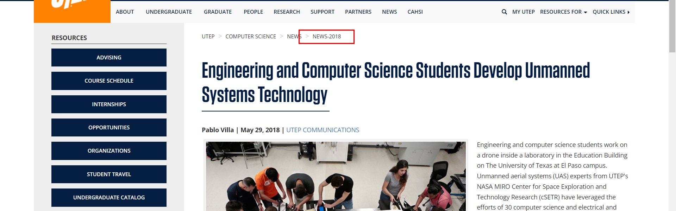

• Broken link on <https://www.utep.edu/cs/news/news-2018/congratulations-dr-ceberio221211221.html> on **Main Content** section, the broken link is displayed as: **UTEP COMMUNICATIONS** and the link is pointing to : <https://www.utep.edu/cs/news/news-2018/%E2%80%9Dhttps:/www.utep.edu/newsfeed/%E2%80%9D>



• Broken link on <https://www.utep.edu/cs/news/news-2018/congratulations-dr-ceberio22121123.html> on **Main Content (Top small navigation)** section, the broken link is displayed as: **news-2018** and the link is pointing to : <https://www.utep.edu/cs/news/news-2018/>

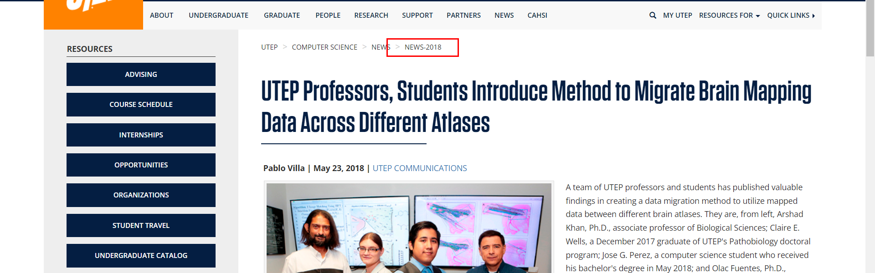

• Broken link on <https://www.utep.edu/cs/news/news-2018/congratulations-dr-ceberio22121123.html> on **Main Content** section, the broken link is displayed as: **UTEP COMMUNICATIONS** and the link is pointing to : <https://www.utep.edu/cs/news/news-2018/%E2%80%9Dhttps:/www.utep.edu/newsfeed/%E2%80%9D>



• Broken link on <https://www.utep.edu/cs/news/news-2018/congratulations-dr-ceberio221211231.html> on **Main Content (Top small navigation)** section, the broken link is displayed as: **news-2018** and the link is pointing to : <https://www.utep.edu/cs/news/news-2018/>

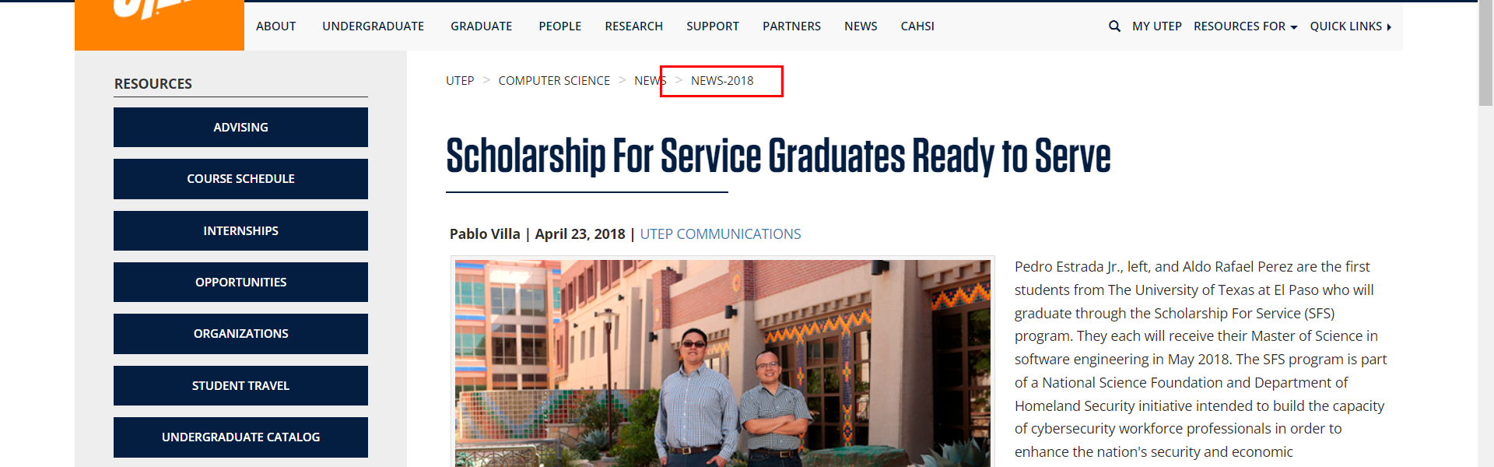

• Broken link on <https://www.utep.edu/cs/news/news-2018/congratulations-dr-ceberio221211231.html> on **Main Content** section, the broken link is displayed as: **UTEP COMMUNICATIONS** and the link is pointing to : <https://www.utep.edu/cs/news/news-2018/%E2%80%9Dhttps:/www.utep.edu/newsfeed/%E2%80%9D>



• Broken link on <https://www.utep.edu/cs/news/news-2019/congratulations-dr-ceberio2212.html> on **Main Content (Top small navigation)** section, the broken link is displayed as: **news-2019** and the link is pointing to : <https://www.utep.edu/cs/news/news-2019/>

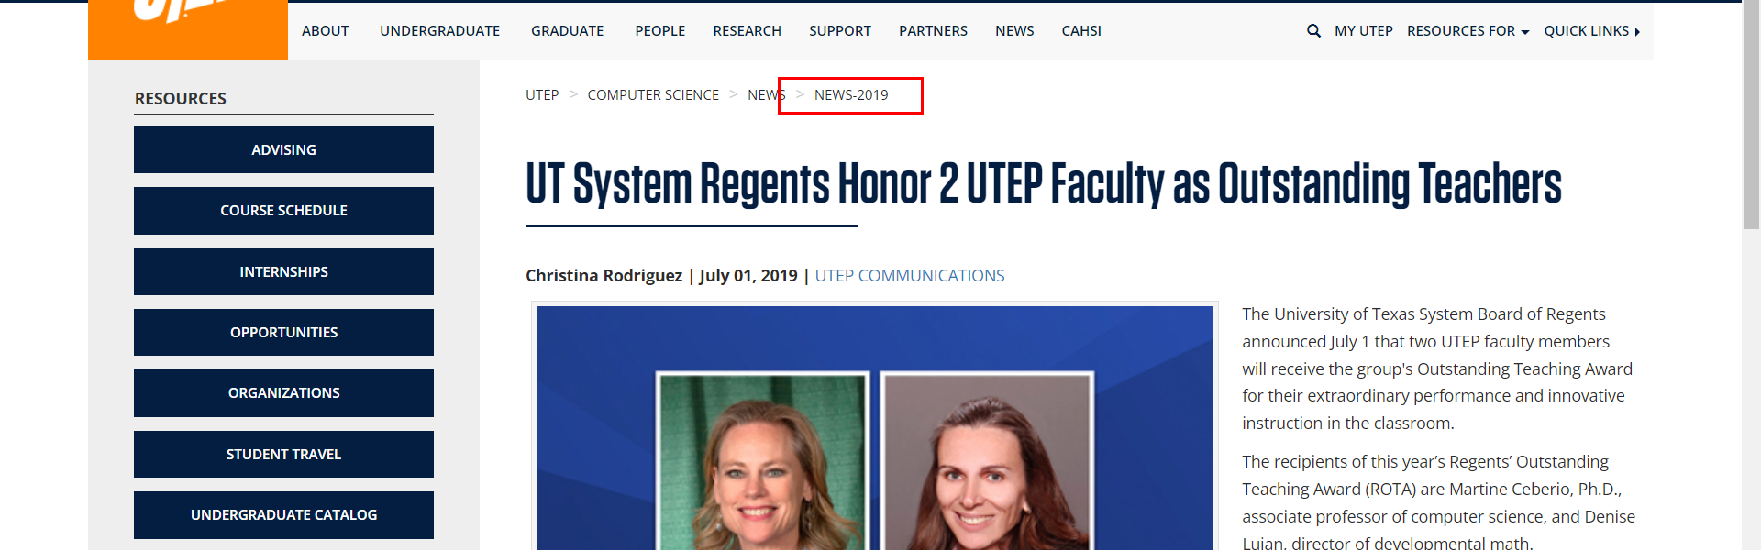

• Broken link on <https://www.utep.edu/cs/news/news-2019/congratulations-dr-ceberio2212.html> on **Main Content** section, the broken link is displayed as: **UTEP COMMUNICATIONS** and the link is pointing to : <https://www.utep.edu/cs/news/news-2019/%E2%80%9Dhttps:/www.utep.edu/newsfeed/%E2%80%9D>

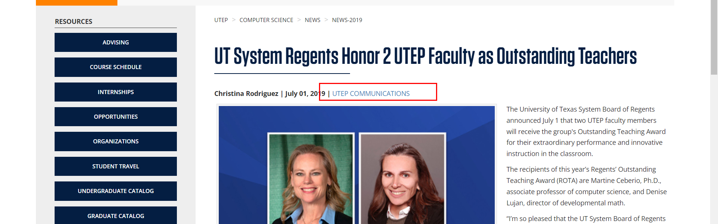

• Broken link on <https://www.utep.edu/cs/news/news-2019/congratulations-dr-ceberio22121.html> on **Main Content (Top small navigation)** section, the broken link is displayed as: **news-2019** and the link is pointing to : <https://www.utep.edu/cs/news/news-2019/>

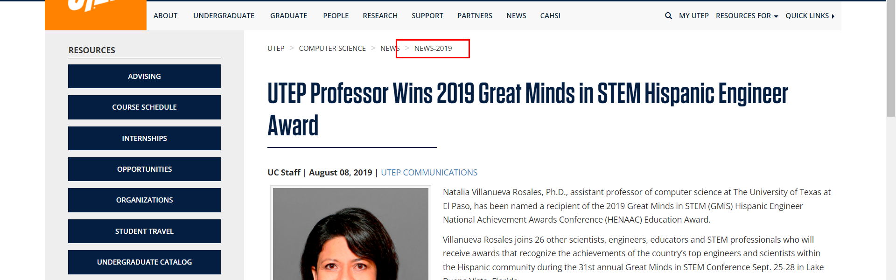

• Broken link on <https://www.utep.edu/cs/news/news-2019/congratulations-dr-ceberio22121.html> on **Main Content** section, the broken link is displayed as: **UTEP COMMUNICATIONS** and the link is pointing to : <https://www.utep.edu/cs/news/news-2019/%E2%80%9Dhttps:/www.utep.edu/newsfeed/%E2%80%9D>

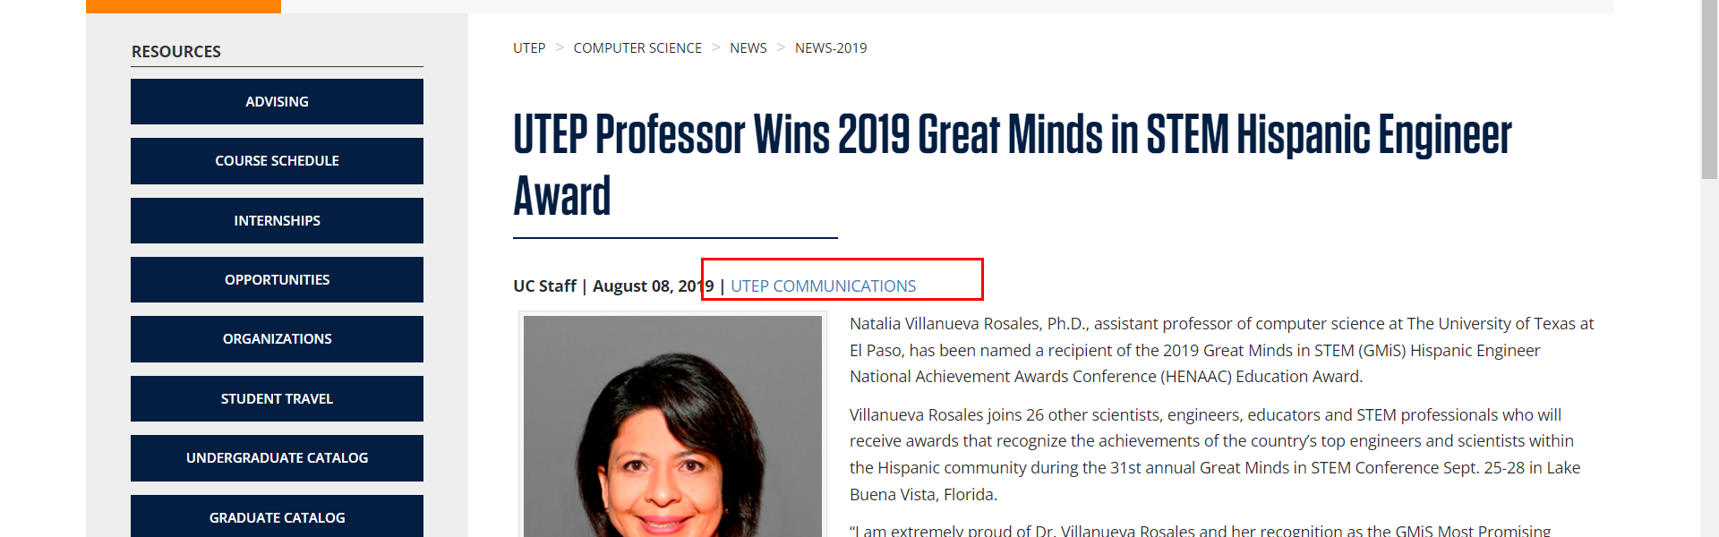

• Broken link on <https://www.utep.edu/cs/news/news-2019/congratulations-dr-ceberio221211.html> on **Main Content (Top small navigation)** section, the broken link is displayed as: **news-2019** and the link is pointing to : <https://www.utep.edu/cs/news/news-2019/>

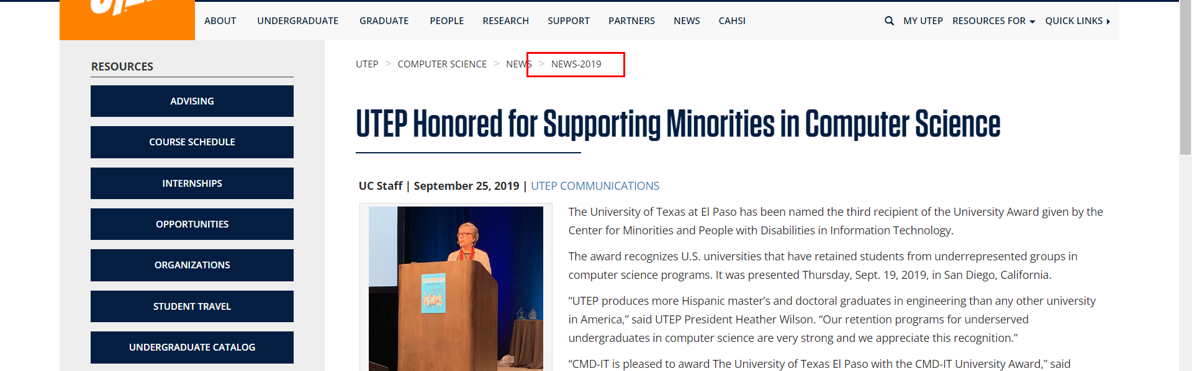

• Broken link on <https://www.utep.edu/cs/news/news-2019/congratulations-dr-ceberio221211.html> on **Main Content** section, the broken link is displayed as: **UTEP COMMUNICATIONS** and the link is pointing to : <https://www.utep.edu/cs/news/news-2019/%E2%80%9Dhttps:/www.utep.edu/newsfeed/%E2%80%9D>

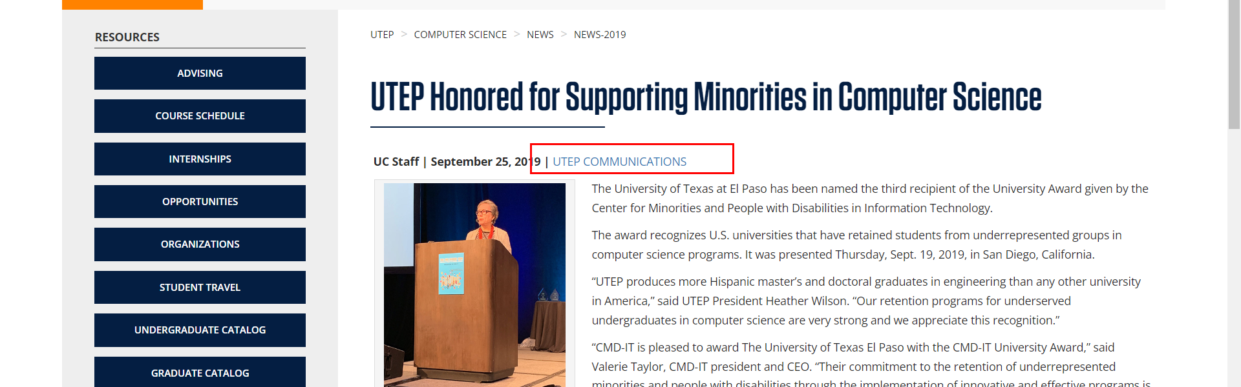

• Broken link on <https://www.utep.edu/cs/news/news-2019/congratulations-dr-ceberio2212111.html> on **Main Content (Top small navigation)** section, the broken link is displayed as: **news-2019** and the link is pointing to : <https://www.utep.edu/cs/news/news-2019/>

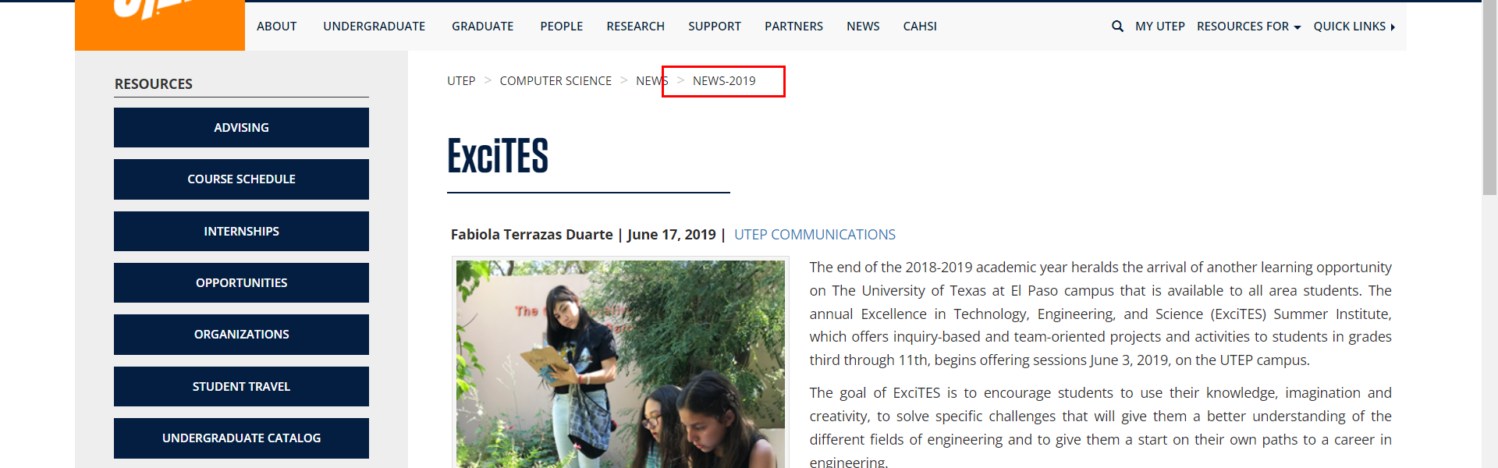

• Broken link on <https://www.utep.edu/cs/news/news-2019/congratulations-dr-ceberio2212111.html> on **Main Content** section, the broken link is displayed as: **UTEP COMMUNICATIONS** and the link is pointing to : <https://www.utep.edu/cs/news/news-2019/%E2%80%9Dhttps:/www.utep.edu/newsfeed/%E2%80%9D>

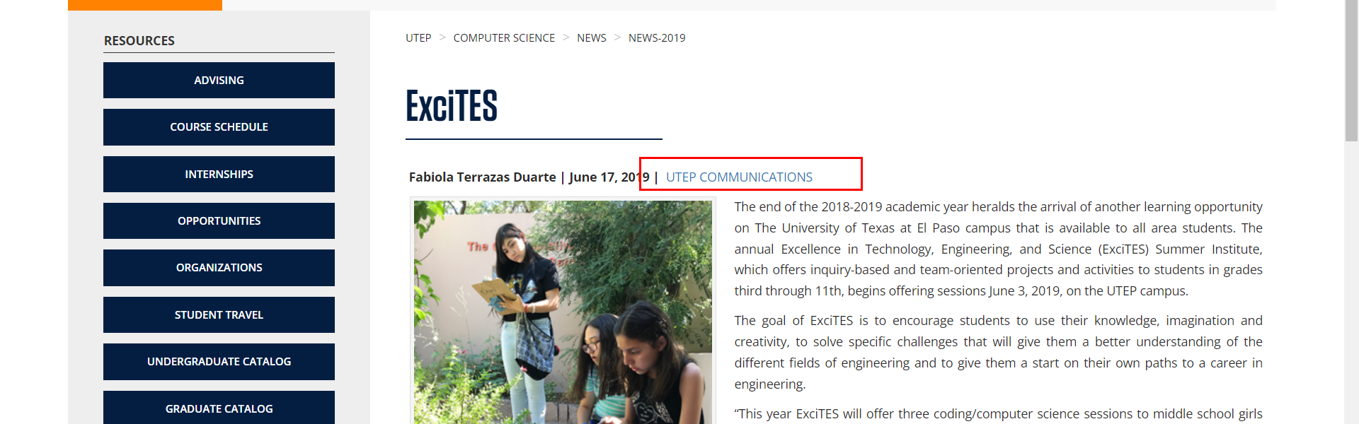

• Broken link on <https://www.utep.edu/cs/news/news-2019/congratulations-dr-ceberio22121111.html> on **Main Content (Top small navigation)** section, the broken link is displayed as: **news-2019** and the link is pointing to : <https://www.utep.edu/cs/news/news-2019/>

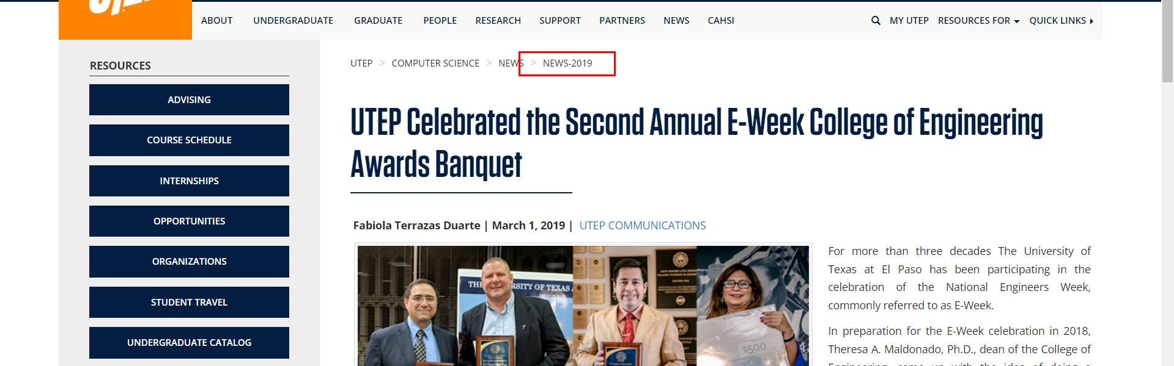

• Broken link on <https://www.utep.edu/cs/news/news-2019/congratulations-dr-ceberio22121111.html> on **Main Content** section, the broken link is displayed as: **UTEP COMMUNICATIONS** and the link is pointing to : <https://www.utep.edu/cs/news/news-2019/%E2%80%9Dhttps:/www.utep.edu/newsfeed/%E2%80%9D>

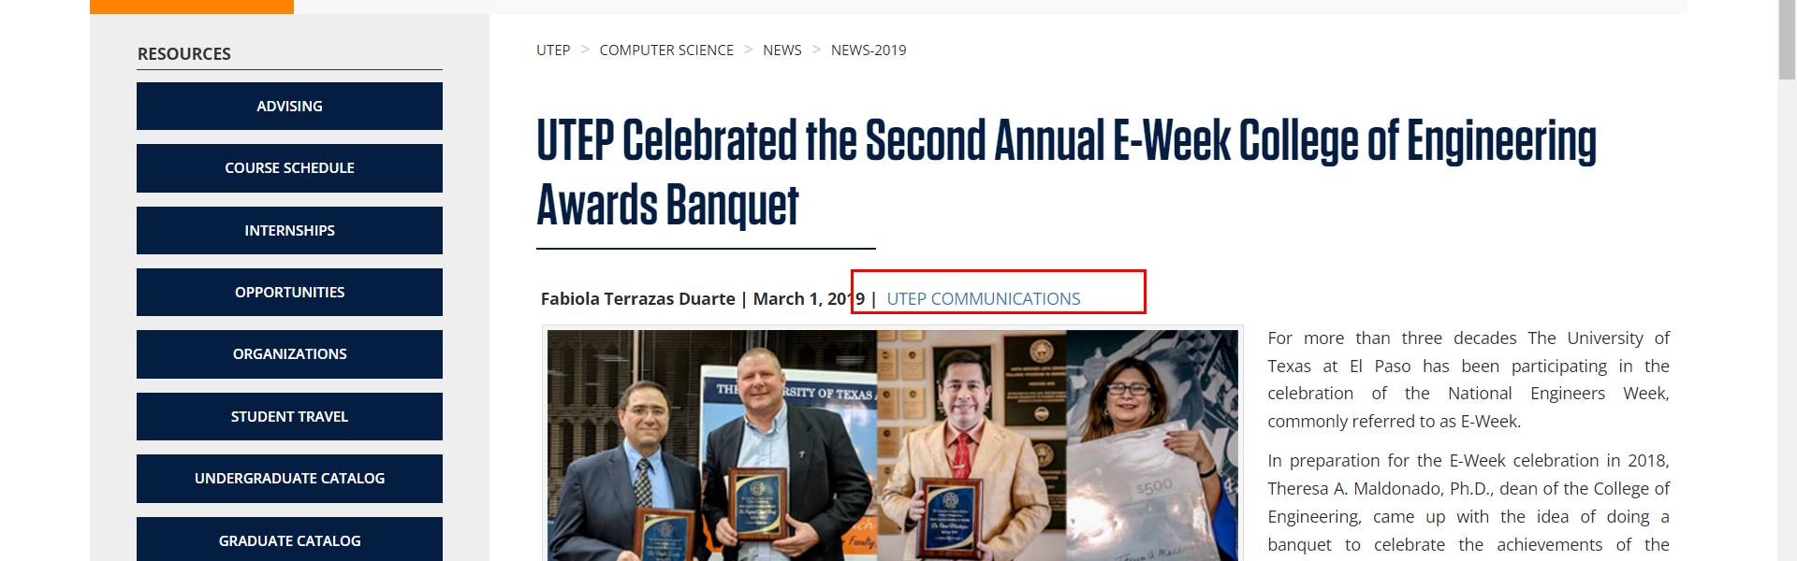

• Broken link on <https://www.utep.edu/cs/news/news-2019/congratulations-dr-ceberio221212.html> on **Main Content (Top small navigation)** section, the broken link is displayed as: **news-2019** and the link is pointing to : <https://www.utep.edu/cs/news/news-2019/>

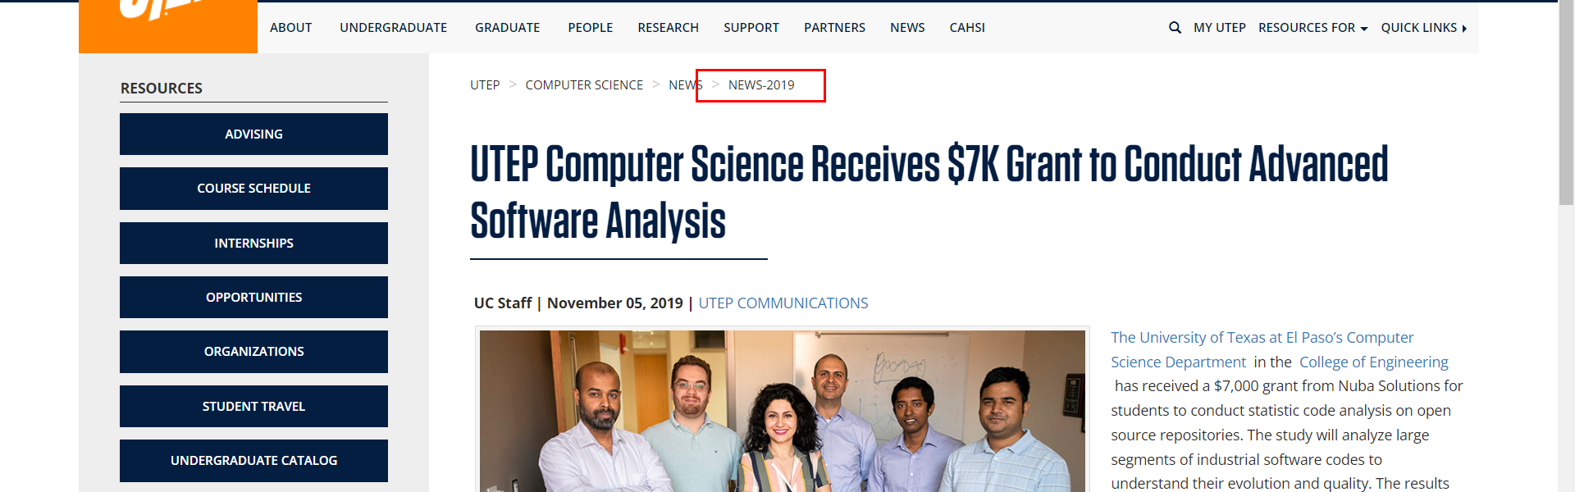

• Broken link on <https://www.utep.edu/cs/news/news-2019/congratulations-dr-ceberio221212.html> on **Main Content** section, the broken link is displayed as: **UTEP COMMUNICATIONS** and the link is pointing to : <https://www.utep.edu/cs/news/news-2019/%E2%80%9Dhttps:/www.utep.edu/newsfeed/%E2%80%9D>

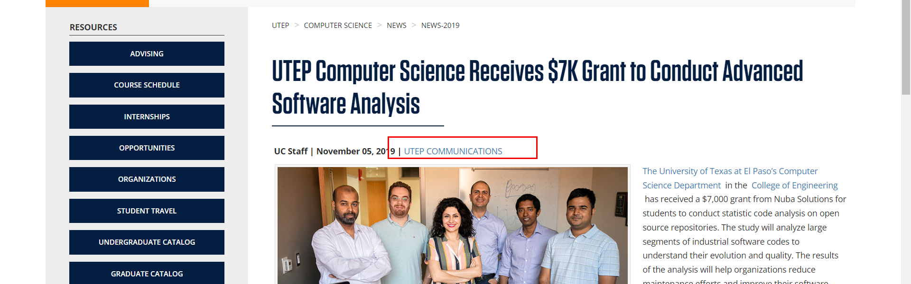

• Broken link on <https://www.utep.edu/cs/news/news-2019/congratulations-dr-ceberio2212121.html> on **Main Content (Top small navigation)** section, the broken link is displayed as: **news-2019** and the link is pointing to : <https://www.utep.edu/cs/news/news-2019/>

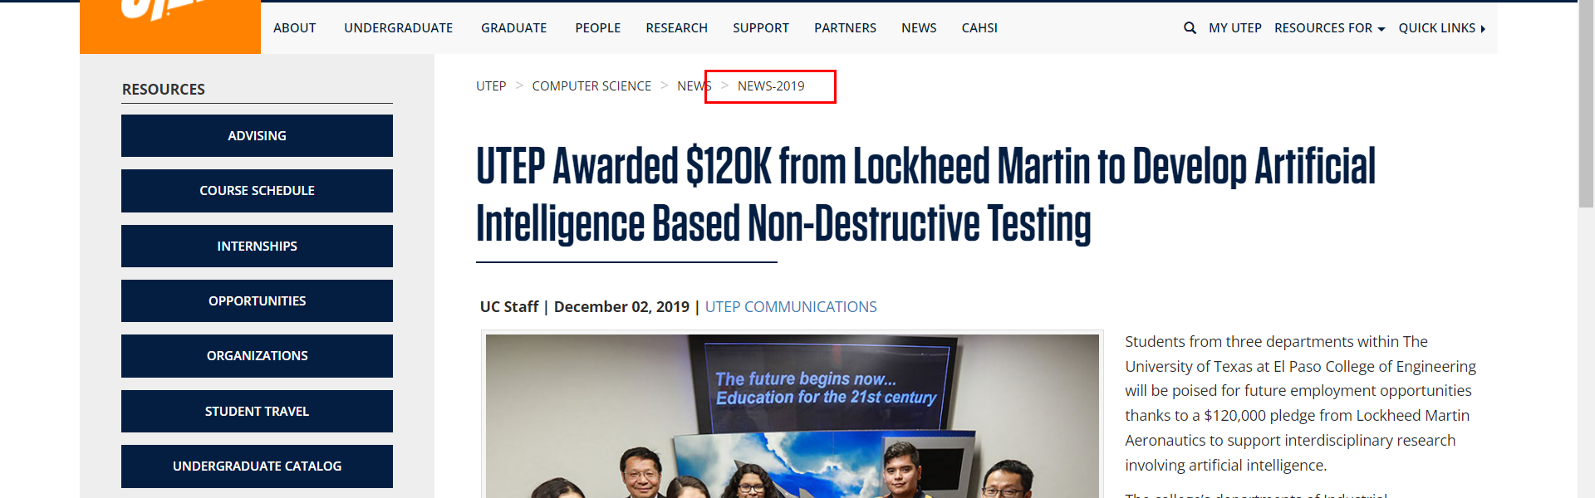

• Broken link on <https://www.utep.edu/cs/news/news-2019/congratulations-dr-ceberio2212121.html> on **Main Content** section, the broken link is displayed as: **UTEP COMMUNICATIONS** and the link is pointing to : <https://www.utep.edu/cs/news/news-2019/%E2%80%9Dhttps:/www.utep.edu/newsfeed/%E2%80%9D>



• Broken link on <https://www.utep.edu/cs/news/news-2019/congratulations-dr-ceberio22122.html> on **Main Content (Top small navigation)** section, the broken link is displayed as: **news-2019** and the link is pointing to : <https://www.utep.edu/cs/news/news-2019/>



• Broken link on <https://www.utep.edu/cs/news/news-2019/congratulations-dr-ceberio22122.html> on **Main Content** section, the broken link is displayed as: **UTEP COMMUNICATIONS** and the link is pointing to : <https://www.utep.edu/cs/news/news-2019/%E2%80%9Dhttps:/www.utep.edu/newsfeed/%E2%80%9D>



• Broken link on <https://www.utep.edu/cs/news/news-2019/congratulations-dr-ceberio22123.html> on **Main Content (Top small navigation)** section, the broken link is displayed as: **news-2019** and the link is pointing to : <https://www.utep.edu/cs/news/news-2019/>

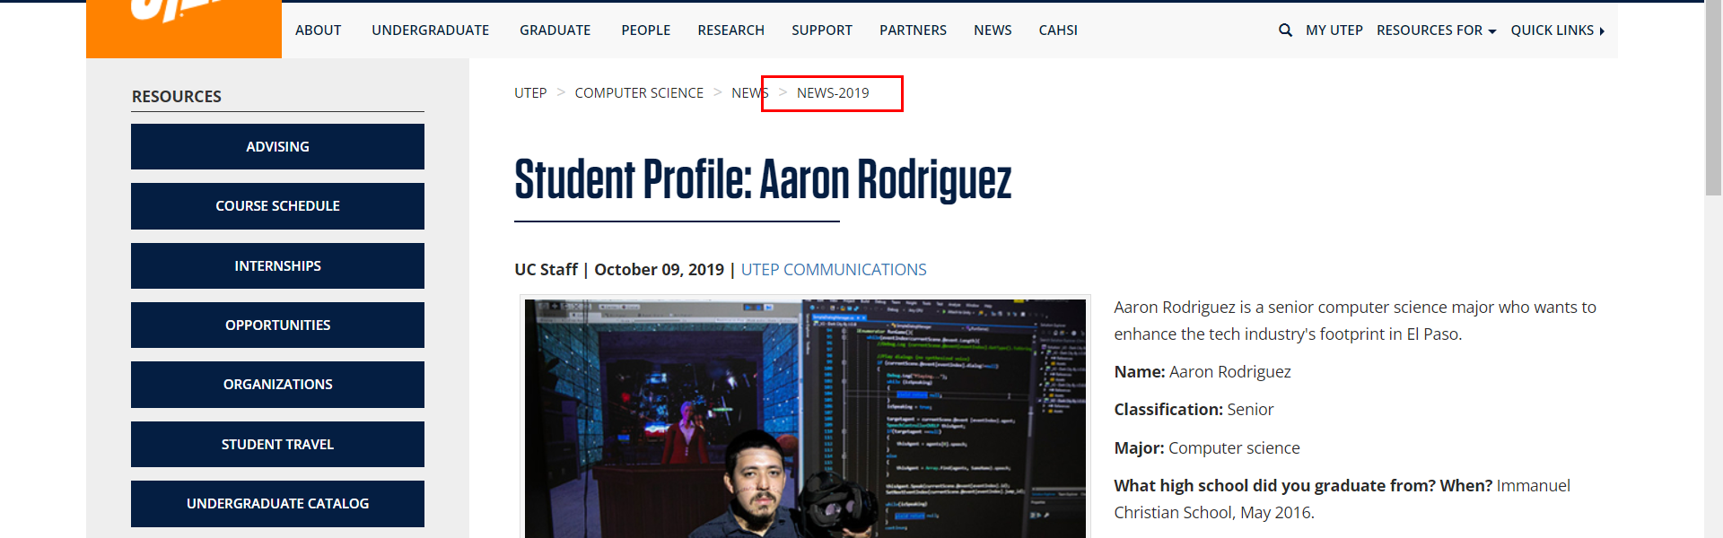

• Broken link on <https://www.utep.edu/cs/news/news-2019/congratulations-dr-ceberio22123.html> on **Main Content** section, the broken link is displayed as: **UTEP COMMUNICATIONS** and the link is pointing to : <https://www.utep.edu/cs/news/news-2019/%E2%80%9Dhttps:/www.utep.edu/newsfeed/%E2%80%9D>



• Broken link on <https://www.utep.edu/cs/news/news-2019/graduate-student-page-example.html> on **Main Content (Top small navigation)** section, the broken link is displayed as: **news-2019** and the link is pointing to : <https://www.utep.edu/cs/news/news-2019/>



• Broken link on <https://www.utep.edu/cs/news/news-2019/graduate-student-page-example.html> on **Main Content** section, the broken link is displayed as: **UTEP COMMUNICATIONS** and the link is pointing to : <https://www.utep.edu/cs/news/news-2019/%E2%80%9Dhttps:/www.utep.edu/newsfeed/%E2%80%9D>



• Broken link on <https://www.utep.edu/cs/news/news-2019/test-graduation.html> on **Main Content (Top small navigation)** section, the broken link is displayed as: **news-2019** and the link is pointing to : <https://www.utep.edu/cs/news/news-2019/>

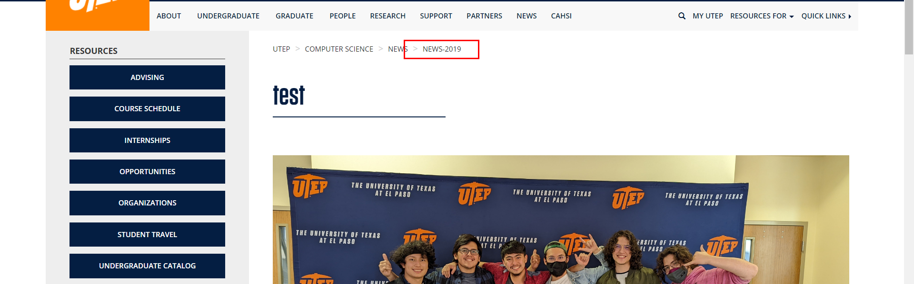

• Broken link on <https://www.utep.edu/cs/news/news-2020/congratulations-dr-ceberio2212.html> on **Main Content (Top small navigation)** section, the broken link is displayed as: **news-2020** and the link is pointing to : <https://www.utep.edu/cs/news/news-2020/>

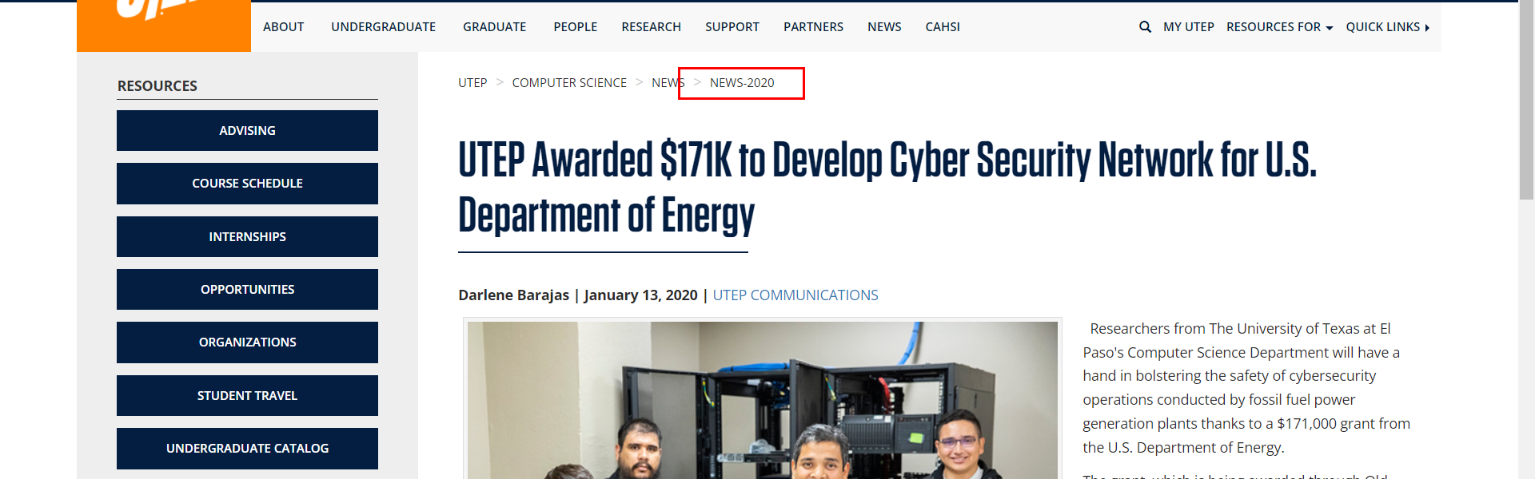

• Broken link on <https://www.utep.edu/cs/news/news-2020/congratulations-dr-ceberio2212.html> on **Main Content** section, the broken link is displayed as: **UTEP COMMUNICATIONS** and the link is pointing to : <https://www.utep.edu/cs/news/news-2020/%E2%80%9Dhttps:/www.utep.edu/newsfeed/%E2%80%9D>

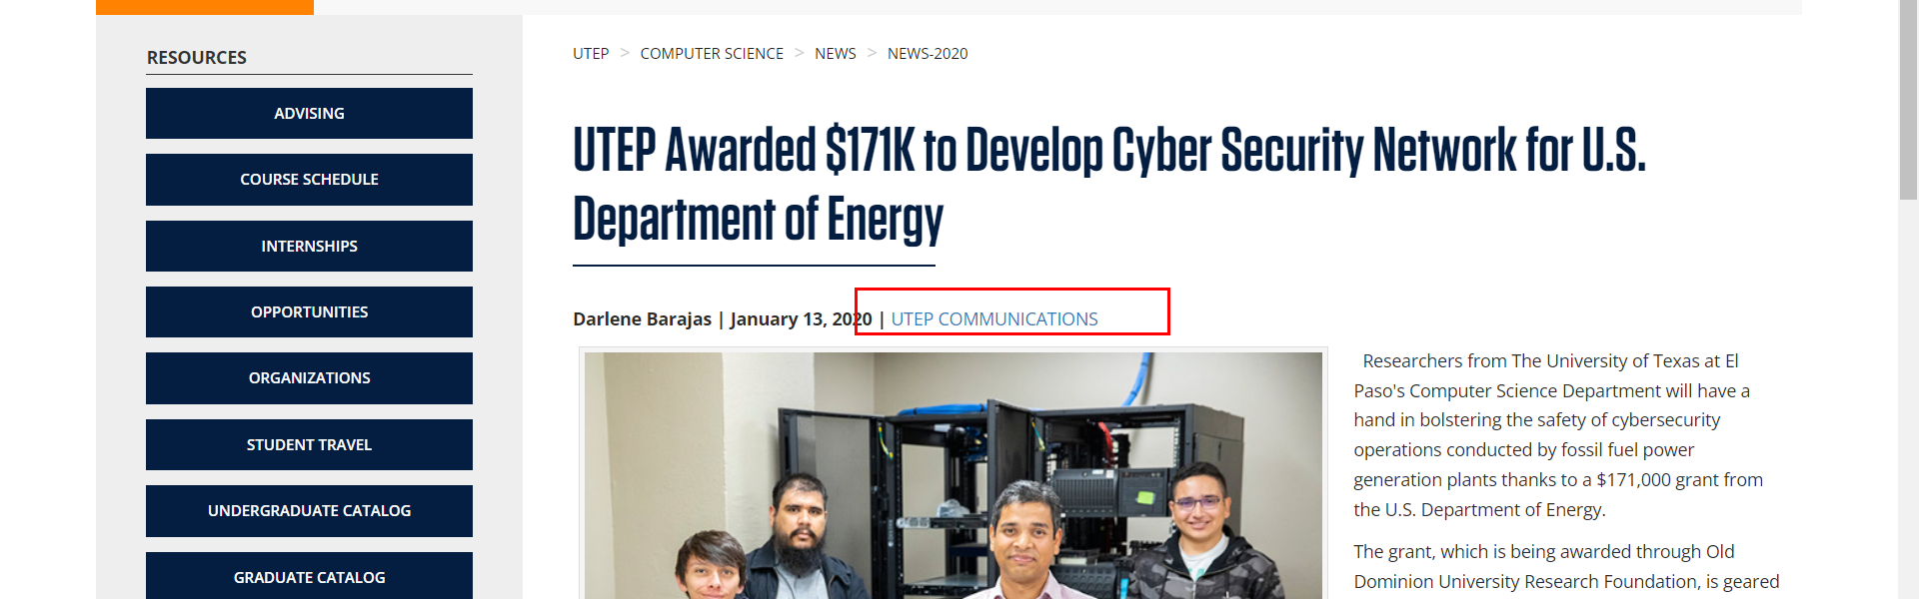

• Broken link on <https://www.utep.edu/cs/news/news-2020/congratulations-dr-ceberio22121.html> on **Main Content (Top small navigation)** section, the broken link is displayed as: **news-2020** and the link is pointing to : <https://www.utep.edu/cs/news/news-2020/>

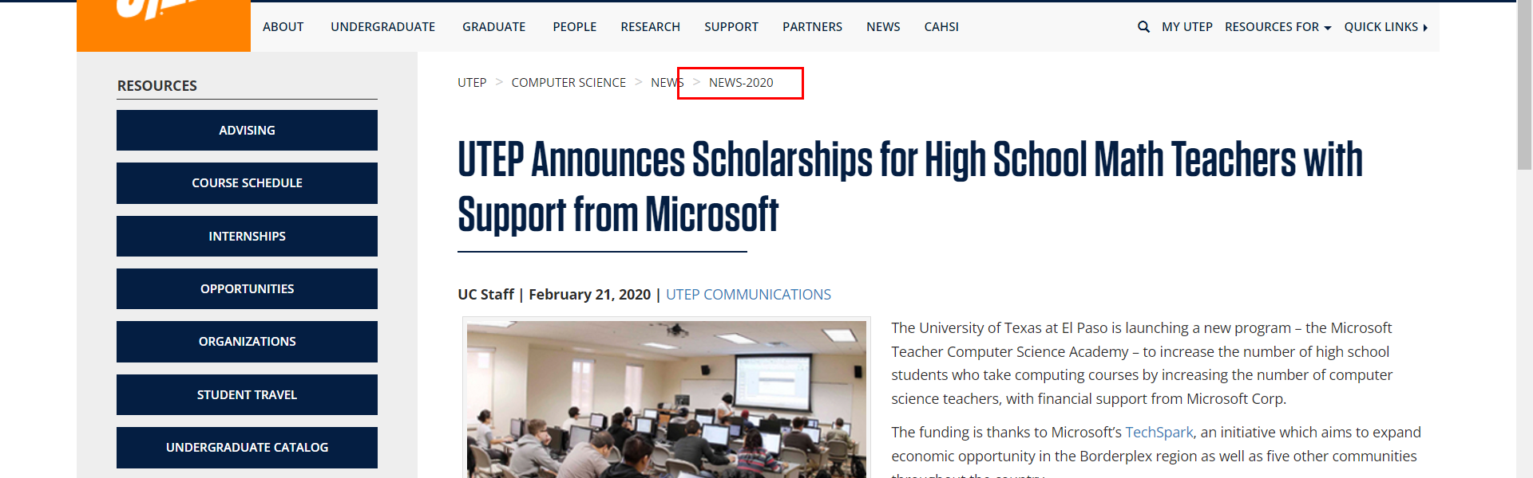

• Broken link on <https://www.utep.edu/cs/news/news-2020/congratulations-dr-ceberio22121.html> on **Main Content** section, the broken link is displayed as: **UTEP Computer Science webpage** and the link is pointing to : <https://www.utep.edu/newsfeed/campus/utep.edu/cs/news/microsoft-computer-science-teacher-academy.html>

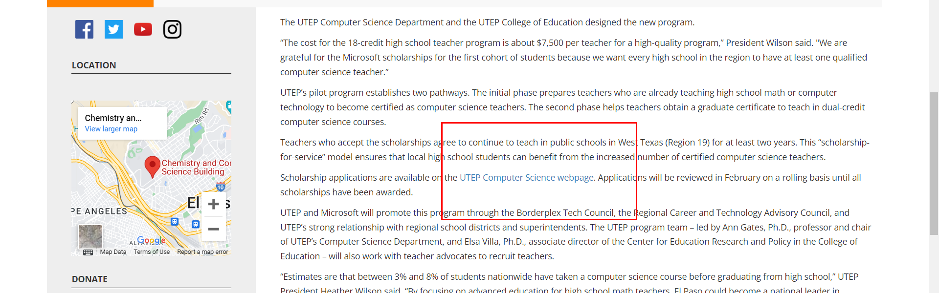

• Broken link on <https://www.utep.edu/cs/news/news-2020/congratulations-dr-ceberio22121.html> on **Main Content** section, the broken link is displayed as: **UTEP COMMUNICATIONS** and the link is pointing to : <https://www.utep.edu/cs/news/news-2020/%E2%80%9Dhttps:/www.utep.edu/newsfeed/%E2%80%9D>



• Broken link on <https://www.utep.edu/cs/news/news-2020/congratulations-dr-ceberio221211.html> on **Main Content (Top small navigation)** section, the broken link is displayed as: **news-2020** and the link is pointing to : <https://www.utep.edu/cs/news/news-2020/>

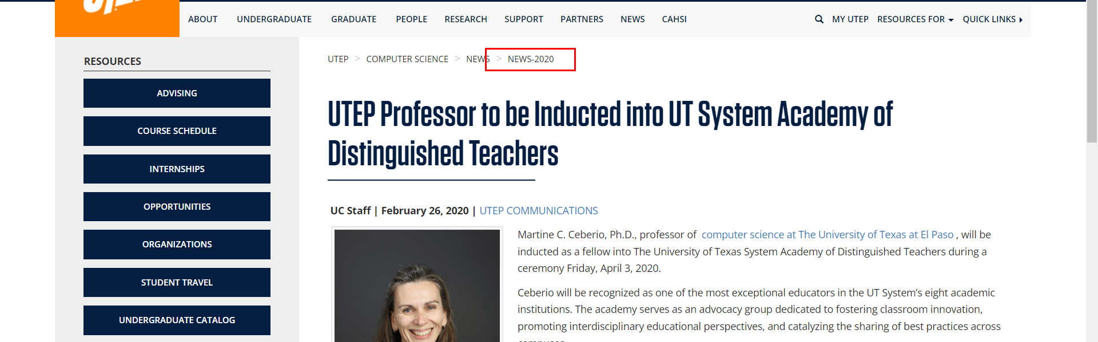

• Broken link on <https://www.utep.edu/cs/news/news-2020/congratulations-dr-ceberio221211.html> on **Main Content** section, the broken link is displayed as: **UTEP COMMUNICATIONS** and the link is pointing to : <https://www.utep.edu/cs/news/news-2020/%E2%80%9Dhttps:/www.utep.edu/newsfeed/%E2%80%9D>



• Broken link on <https://www.utep.edu/cs/news/news-2020/congratulations-dr-ceberio221211211.html> on **Main Content (Top small navigation)** section, the broken link is displayed as: **news-2020** and the link is pointing to : <https://www.utep.edu/cs/news/news-2020/>

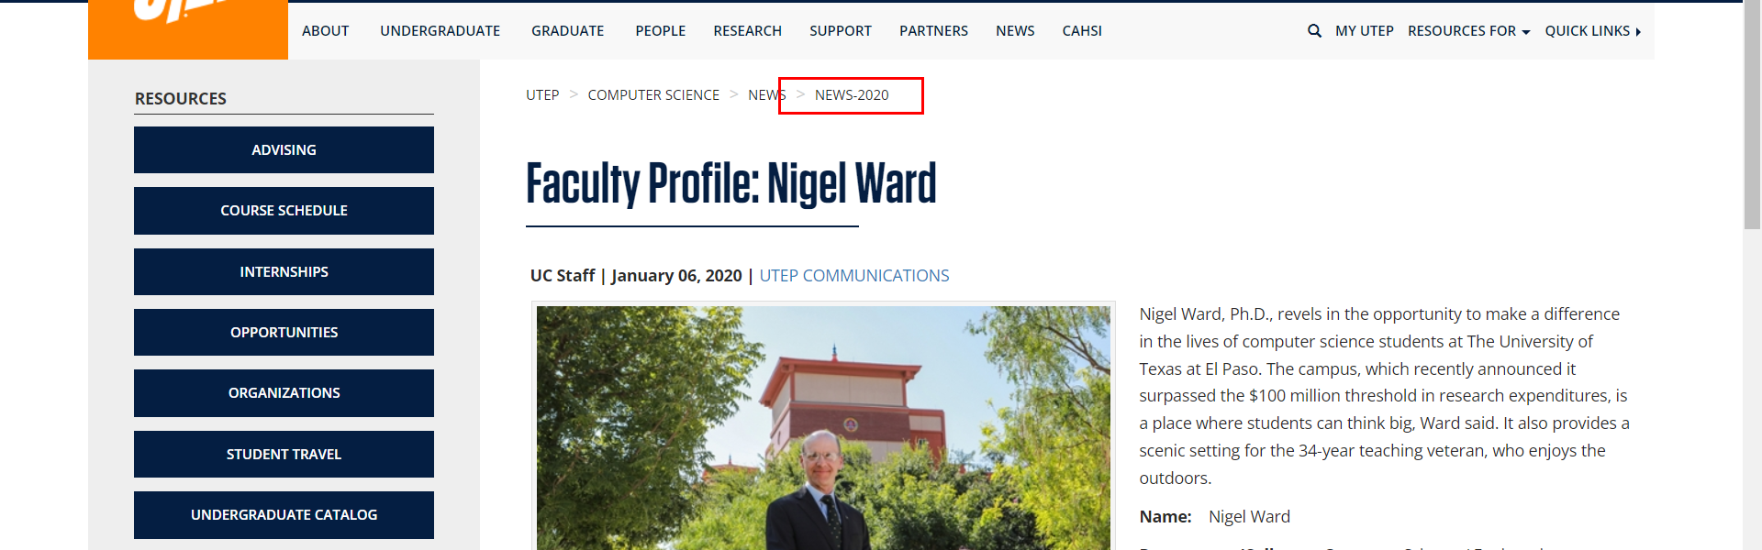

• Broken link on <https://www.utep.edu/cs/news/news-2020/congratulations-dr-ceberio221211211.html> on **Main Content** section, the broken link is displayed as: **UTEP COMMUNICATIONS** and the link is pointing to : <https://www.utep.edu/cs/news/news-2020/%E2%80%9Dhttps:/www.utep.edu/newsfeed/%E2%80%9D>

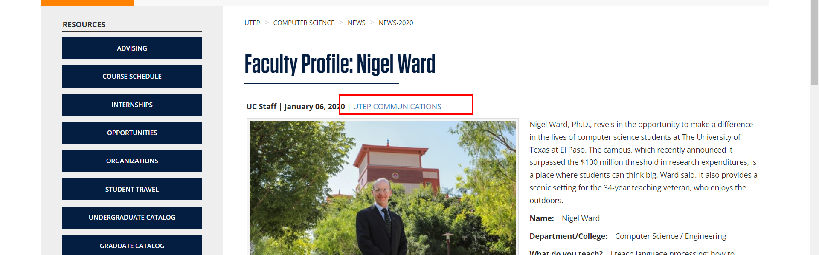

• Broken link on <https://www.utep.edu/cs/news/news-2020/congratulations-dr-ceberio221212.html> on **Main Content (Top small navigation)** section, the broken link is displayed as: **news-2020** and the link is pointing to : <https://www.utep.edu/cs/news/news-2020/>

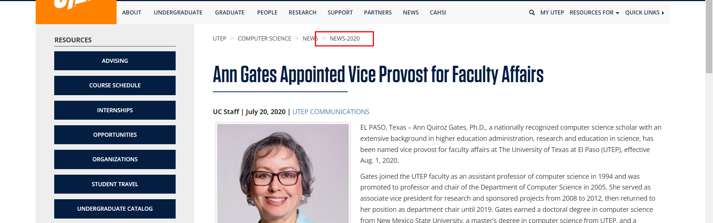

• Broken link on <https://www.utep.edu/cs/news/news-2020/congratulations-dr-ceberio221212.html> on **Main Content** section, the broken link is displayed as: **UTEP COMMUNICATIONS** and the link is pointing to : <https://www.utep.edu/cs/news/news-2020/%E2%80%9Dhttps:/www.utep.edu/newsfeed/%E2%80%9D>

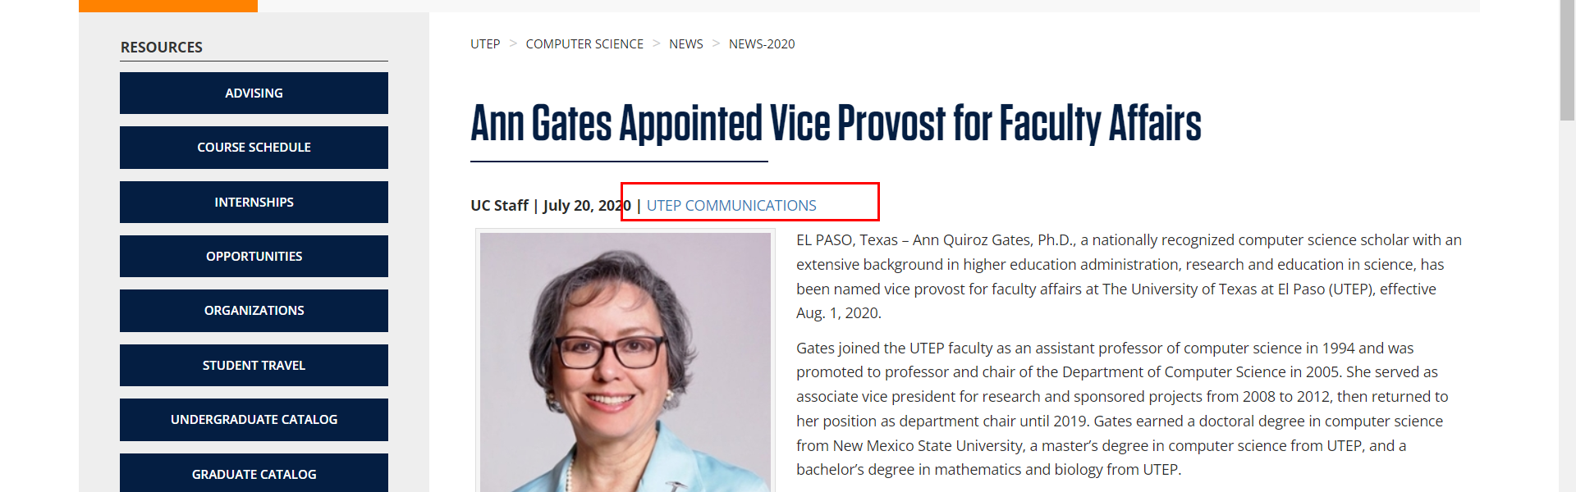

• Broken link on <https://www.utep.edu/cs/news/news-2020/congratulations-dr-ceberio2212121.html> on **Main Content (Top small navigation)** section, the broken link is displayed as: **news-2020** and the link is pointing to : <https://www.utep.edu/cs/news/news-2020/>

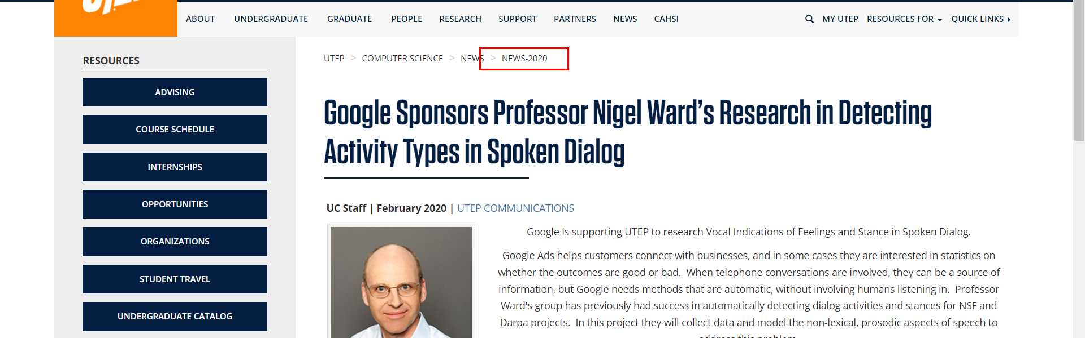

• Broken link on <https://www.utep.edu/cs/news/news-2020/congratulations-dr-ceberio2212121.html> on **Main Content** section, the broken link is displayed as: **UTEP COMMUNICATIONS** and the link is pointing to : <https://www.utep.edu/cs/news/news-2020/%E2%80%9Dhttps:/www.utep.edu/newsfeed/%E2%80%9D>

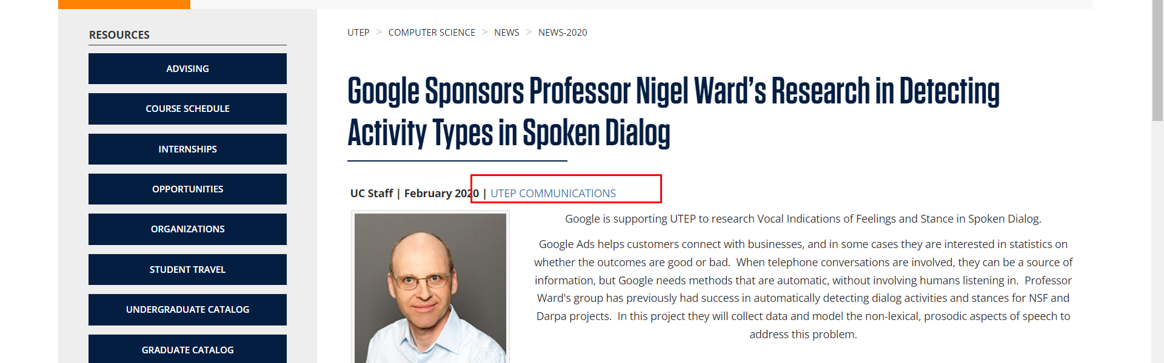

• Broken link on <https://www.utep.edu/cs/news/news-2020/congratulations-dr-ceberio2212122.html> on **Main Content (Top small navigation)** section, the broken link is displayed as: **news-2020** and the link is pointing to : <https://www.utep.edu/cs/news/news-2020/>

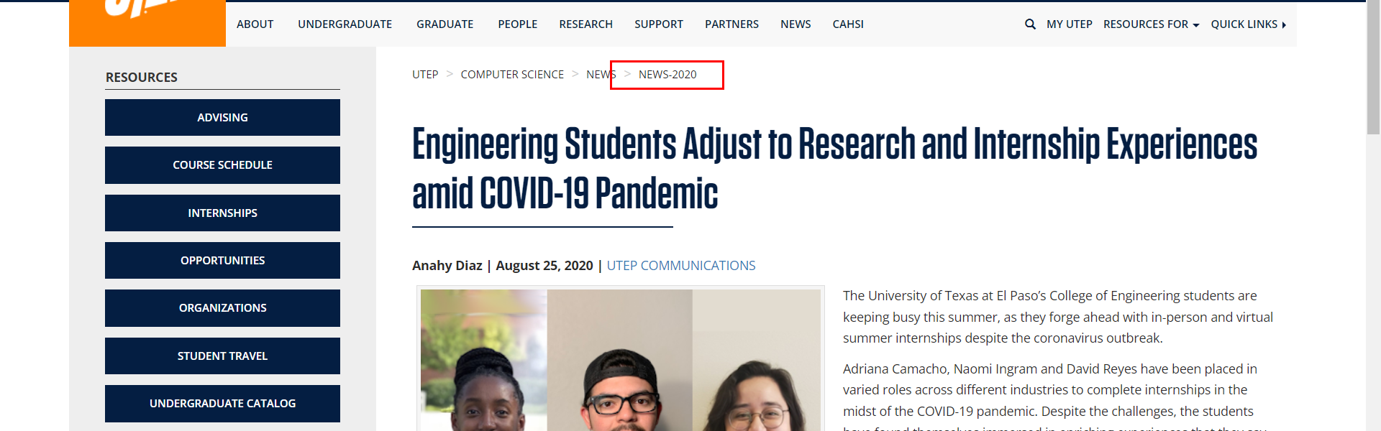

• Broken link on <https://www.utep.edu/cs/news/news-2020/congratulations-dr-ceberio2212122.html> on **Main Content** section, the broken link is displayed as: **UTEP COMMUNICATIONS** and the link is pointing to : <https://www.utep.edu/cs/news/news-2020/%E2%80%9Dhttps:/www.utep.edu/newsfeed/%E2%80%9D>

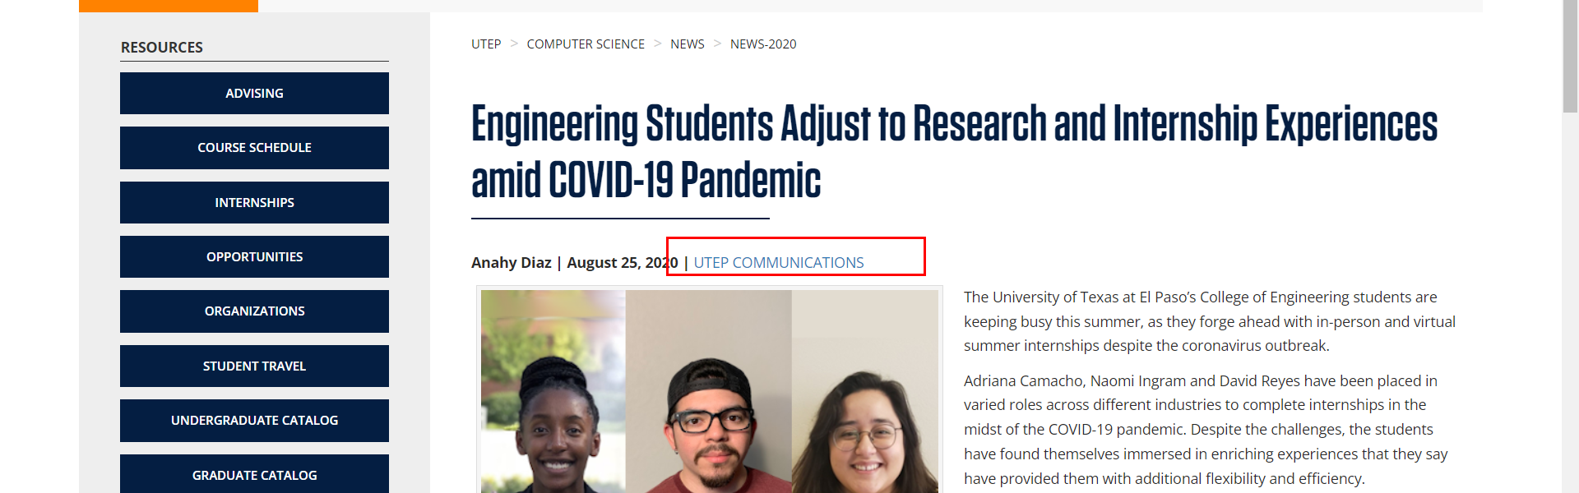

• Broken link on <https://www.utep.edu/cs/news/news-2020/congratulations-dr-ceberio22121221.html> on **Main Content (Top small navigation)** section, the broken link is displayed as: **news-2020** and the link is pointing to : <https://www.utep.edu/cs/news/news-2020/>

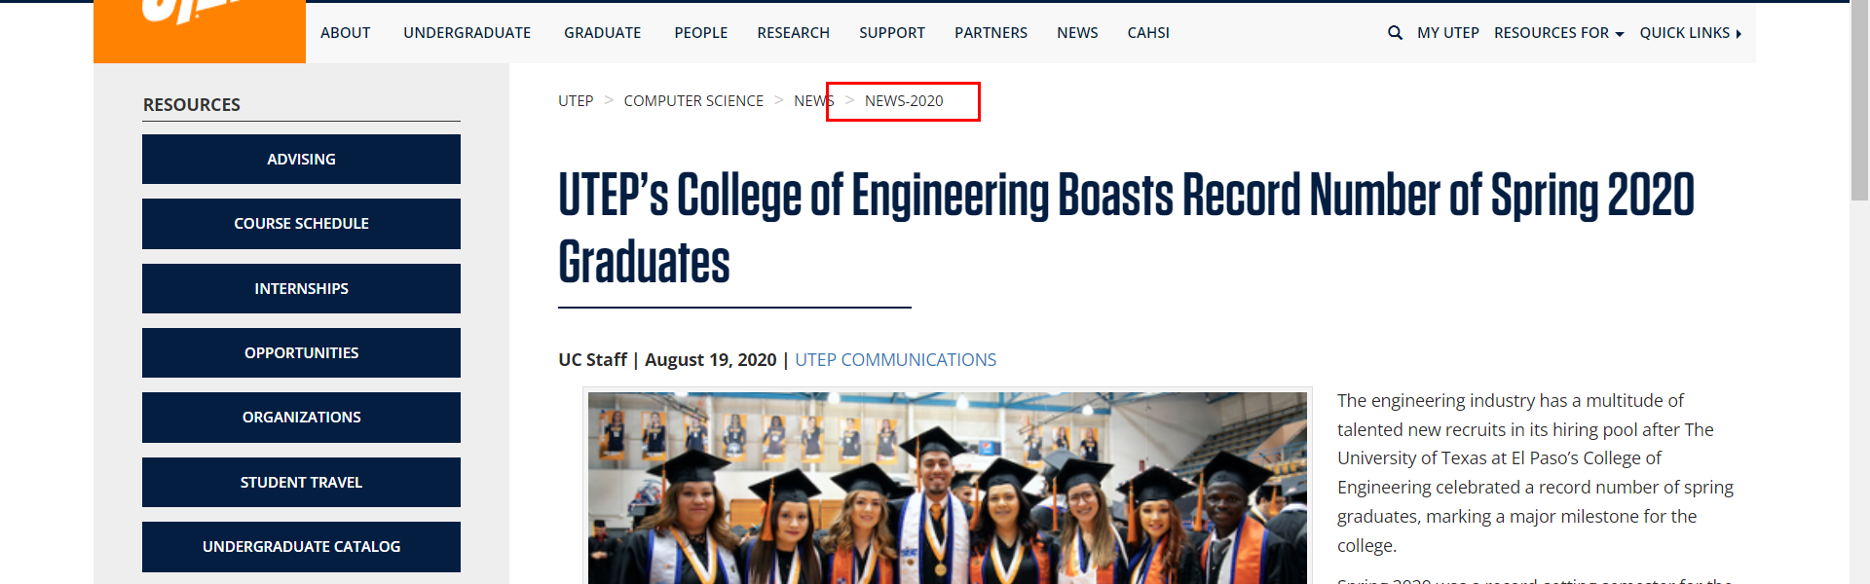

• Broken link on <https://www.utep.edu/cs/news/news-2020/congratulations-dr-ceberio22121221.html> on **Main Content** section, the broken link is displayed as: **UTEP COMMUNICATIONS** and the link is pointing to : <https://www.utep.edu/cs/news/news-2020/%E2%80%9Dhttps:/www.utep.edu/newsfeed/%E2%80%9D>



• Broken link on <https://www.utep.edu/cs/news/news-2020/congratulations-dr-ceberio221212211.html> on **Main Content (Top small navigation)** section, the broken link is displayed as: **news-2020** and the link is pointing to : <https://www.utep.edu/cs/news/news-2020/>

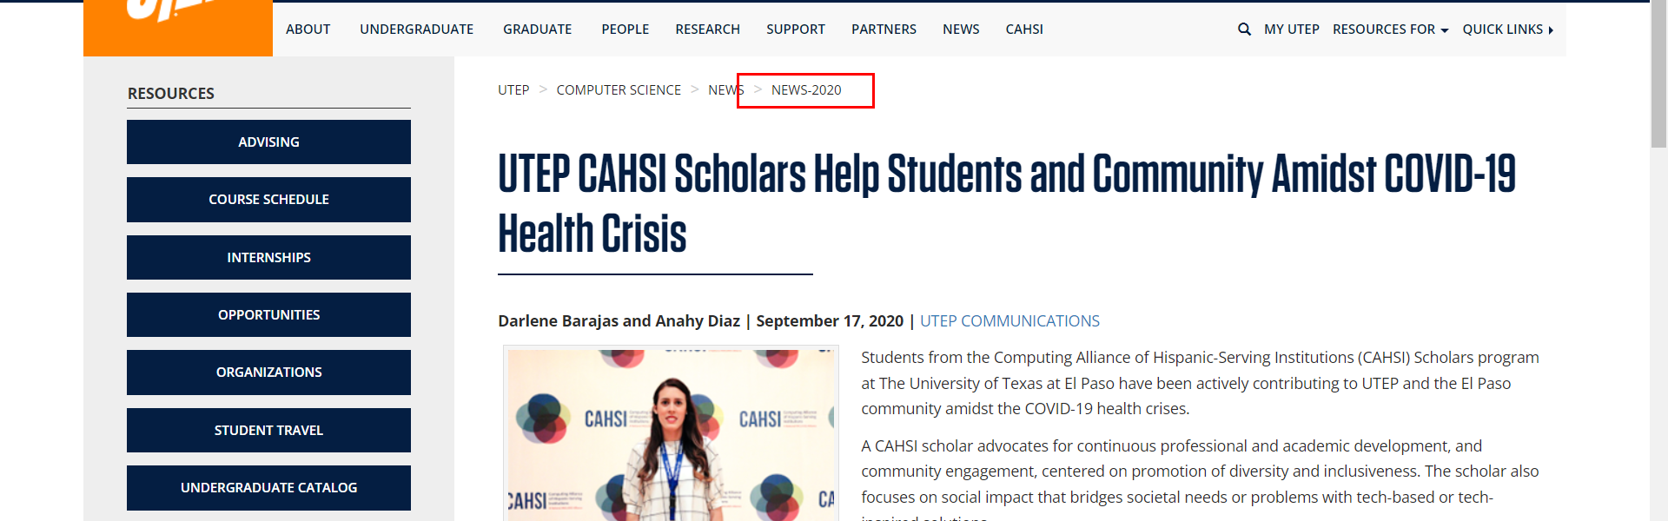

• Broken link on <https://www.utep.edu/cs/news/news-2020/congratulations-dr-ceberio221212211.html> on **Main Content** section, the broken link is displayed as: **UTEP COMMUNICATIONS** and the link is pointing to : <https://www.utep.edu/cs/news/news-2020/%E2%80%9Dhttps:/www.utep.edu/newsfeed/%E2%80%9D>



• Broken link on <https://www.utep.edu/cs/news/news-2020/congratulations-dr-ceberio22121222.html> on **Main Content (Top small navigation)** section, the broken link is displayed as: **news-2020** and the link is pointing to : <https://www.utep.edu/cs/news/news-2020/>



• Broken link on <https://www.utep.edu/cs/news/news-2020/congratulations-dr-ceberio22121222.html> on **Main Content** section, the broken link is displayed as: **UTEP COMMUNICATIONS** and the link is pointing to : <https://www.utep.edu/cs/news/news-2020/%E2%80%9Dhttps:/www.utep.edu/newsfeed/%E2%80%9D>



• Broken link on <https://www.utep.edu/cs/news/news-2020/congratulations-dr-ceberio22122.html> on **Main Content (Top small navigation)** section, the broken link is displayed as: **news-2020** and the link is pointing to : <https://www.utep.edu/cs/news/news-2020/>

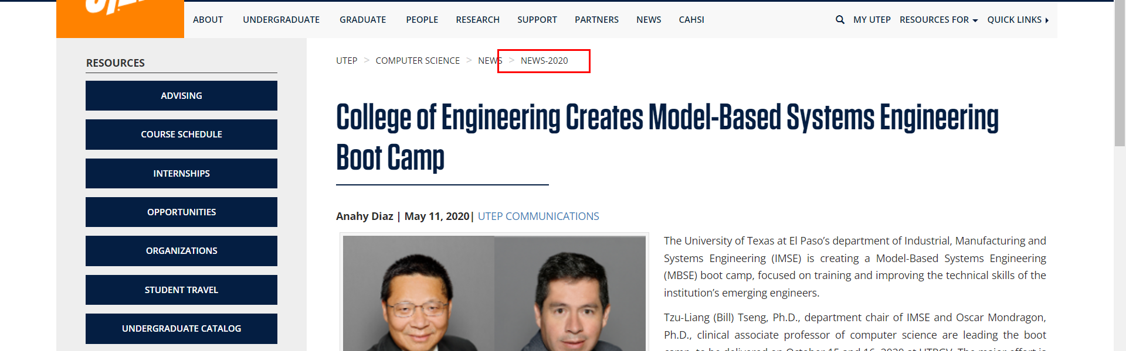

• Broken link on <https://www.utep.edu/cs/news/news-2020/congratulations-dr-ceberio22122.html> on **Main Content** section, the broken link is displayed as: **UTEP COMMUNICATIONS** and the link is pointing to : <https://www.utep.edu/cs/news/news-2020/%E2%80%9Dhttps:/www.utep.edu/newsfeed/%E2%80%9D>



• Broken link on <https://www.utep.edu/cs/news/news-2020/congratulations-dr-ceberio22123.html> on **Main Content (Top small navigation)** section, the broken link is displayed as: **news-2020** and the link is pointing to : <https://www.utep.edu/cs/news/news-2020/>

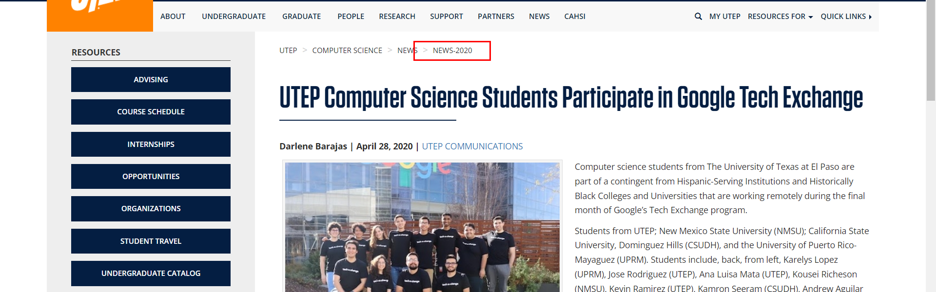

• Broken link on <https://www.utep.edu/cs/news/news-2020/congratulations-dr-ceberio22123.html> on **Main Content** section, the broken link is displayed as: **UTEP COMMUNICATIONS** and the link is pointing to : <https://www.utep.edu/cs/news/news-2020/%E2%80%9Dhttps:/www.utep.edu/newsfeed/%E2%80%9D>

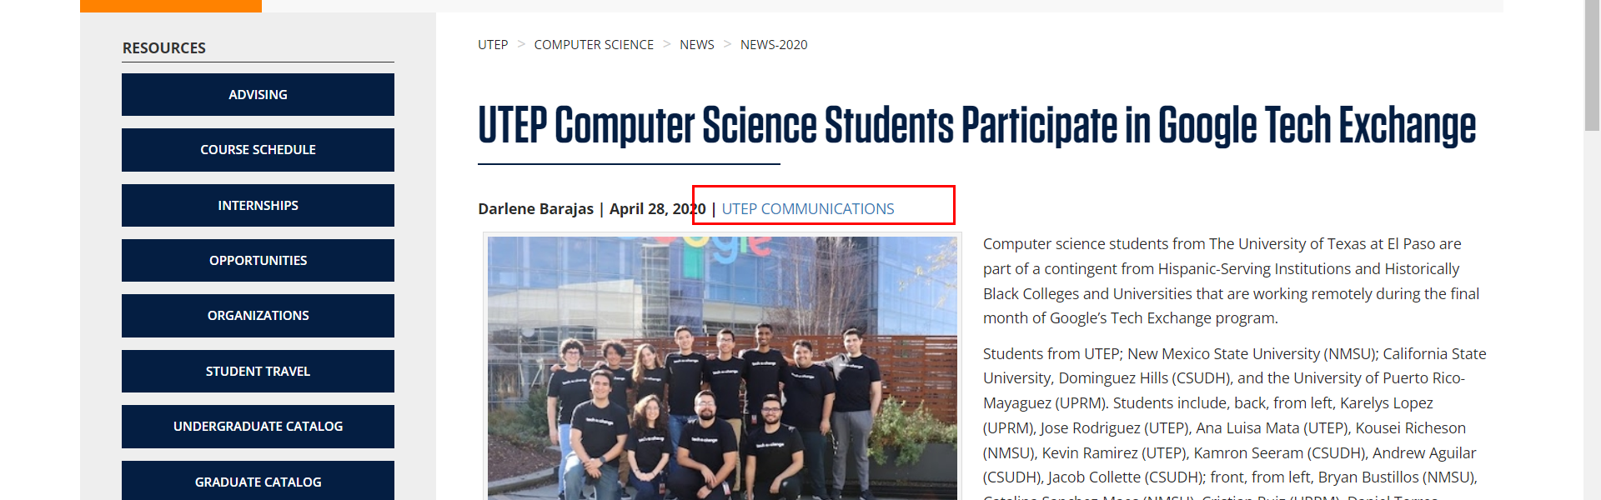

• Broken link on <https://www.utep.edu/cs/news/news-2020/congratulations-dr-ceberio221231.html> on **Main Content (Top small navigation)** section, the broken link is displayed as: **news-2020** and the link is pointing to : <https://www.utep.edu/cs/news/news-2020/>



• Broken link on <https://www.utep.edu/cs/news/news-2020/congratulations-dr-ceberio221231.html> on **Main Content** section, the broken link is displayed as: **UTEP COMMUNICATIONS** and the link is pointing to : <https://www.utep.edu/cs/news/news-2020/%E2%80%9Dhttps:/www.utep.edu/newsfeed/%E2%80%9D>



• Broken link on <https://www.utep.edu/cs/news/news-2021/2021-registration-process.html> on **Main Content (Top small navigation)** section, the broken link is displayed as: **news-2021** and the link is pointing to : <https://www.utep.edu/cs/news/news-2021/>

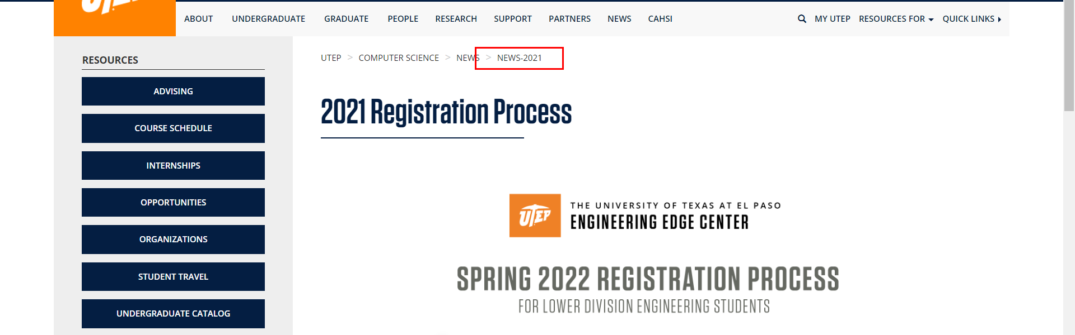

• Broken link on <https://www.utep.edu/cs/news/news-2021/registration-process-2021.html> on **Main Content (Top small navigation)** section, the broken link is displayed as: **news-2021** and the link is pointing to : <https://www.utep.edu/cs/news/news-2021/>

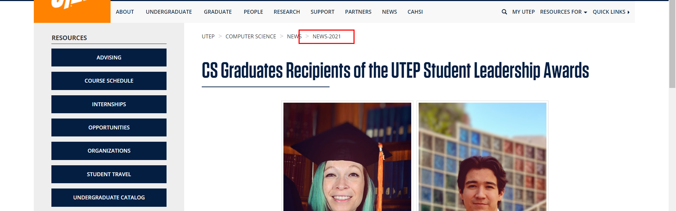

• Broken link on <https://www.utep.edu/cs/news/news-2021/registration-process.html> on **Main Content (Top small navigation)** section, the broken link is displayed as: **news-2021** and the link is pointing to : <https://www.utep.edu/cs/news/news-2021/>



• Broken link on <https://www.utep.edu/cs/news/news-2023/congratulations-daniela-guel-valenzuela.html> on **Main Content (Top small navigation)** section, the broken link is displayed as: **news-2023** and the link is pointing to : <https://www.utep.edu/cs/news/news-2023/>

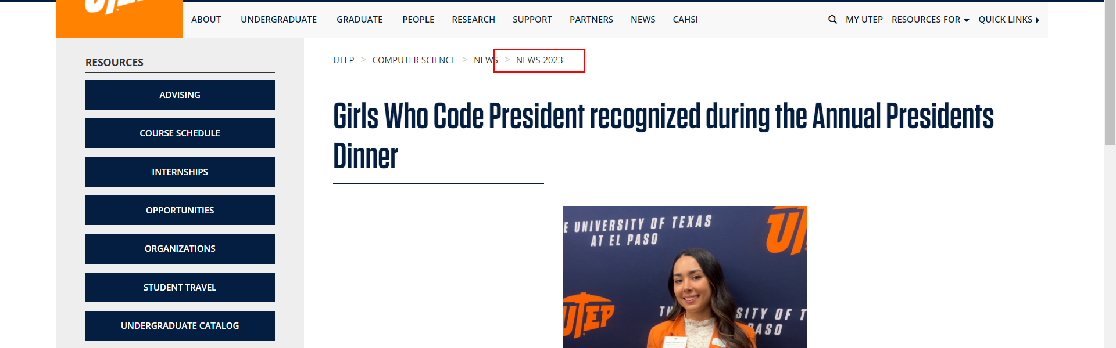

• Broken link on <https://www.utep.edu/cs/news/news-2023/mseip-afrl-summer-2023.html> on **Main Content (Top small navigation)** section, the broken link is displayed as: **news-2023** and the link is pointing to : <https://www.utep.edu/cs/news/news-2023/>

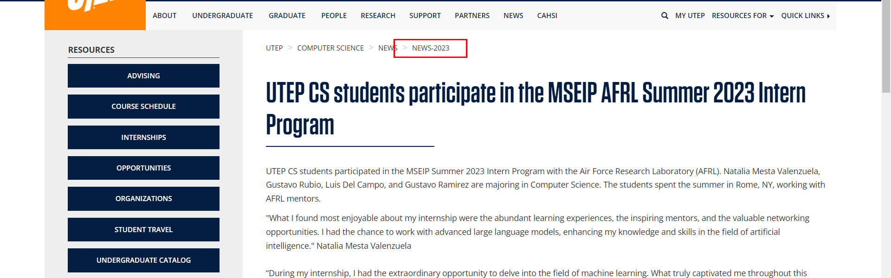

• Broken link on <https://www.utep.edu/cs/news/TEST/congratulations-dr-ceberio221211211.html> on **Main Content (Top small navigation)** section, the broken link is displayed as: **TEST** and the link is pointing to : <https://www.utep.edu/cs/news/TEST/>

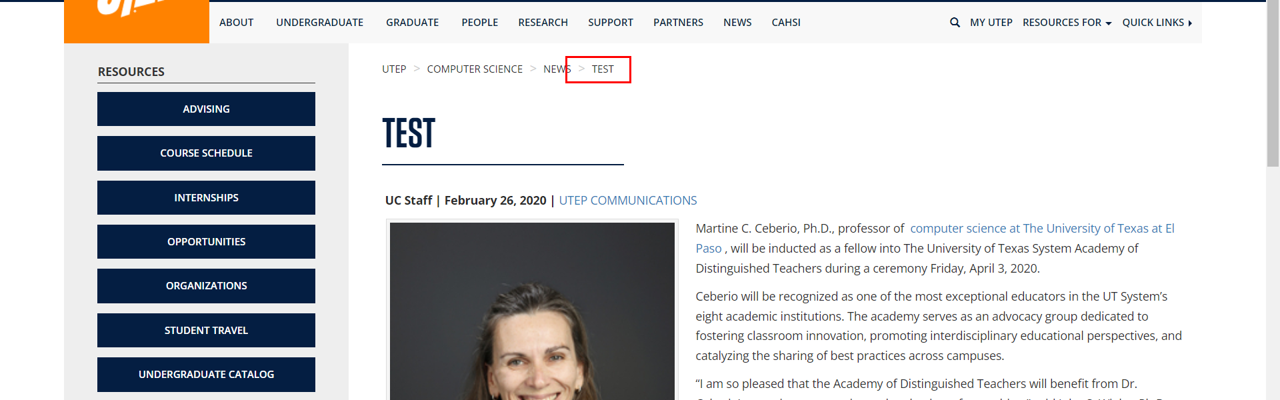

• Broken link on <https://www.utep.edu/cs/news/TEST/congratulations-dr-ceberio221211211.html> on **Main Content** section, the broken link is displayed as: **UTEP COMMUNICATIONS** and the link is pointing to : <https://www.utep.edu/cs/news/TEST/%E2%80%9Dhttps:/www.utep.edu/newsfeed/%E2%80%9D>

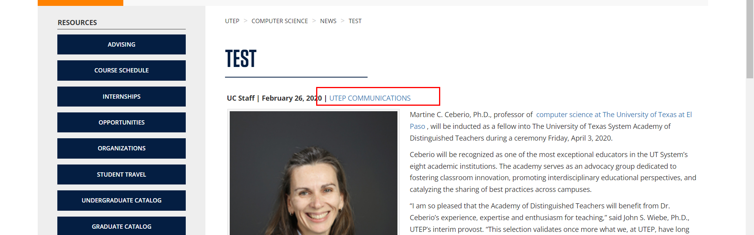

• Broken link on <https://www.utep.edu/cs/news/TEST/congratulations-dr-ceberio2212112111.html> on **Main Content (Top small navigation)** section, the broken link is displayed as: **TEST** and the link is pointing to : <https://www.utep.edu/cs/news/TEST/>



• Broken link on <https://www.utep.edu/cs/news/TEST/congratulations-dr-ceberio2212112111.html> on **Main Content** section, the broken link is displayed as: **UTEP COMMUNICATIONS** and the link is pointing to : <https://www.utep.edu/cs/news/TEST/%E2%80%9Dhttps:/www.utep.edu/newsfeed/%E2%80%9D>



• Broken link on <https://www.utep.edu/cs/news/TEST/full-width-template.html> on **Main Content: Section ID: No ID** section, the broken link is displayed as: **Demo** and the link is pointing to : <https://www.utep.edu/sunbowlproject/index.html>

